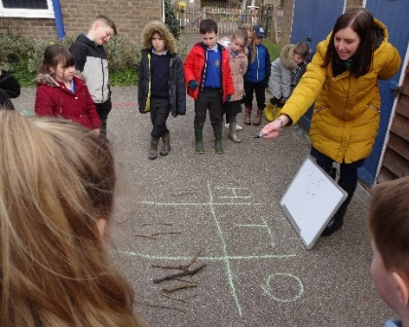
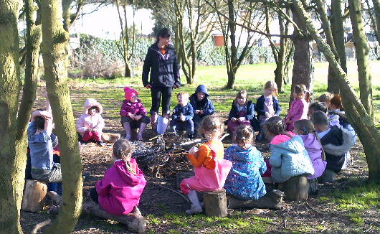

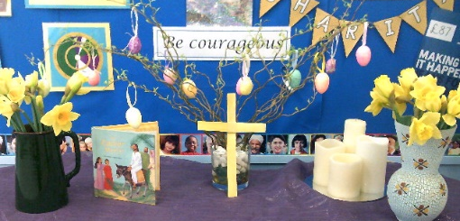

Chelmondiston Church of England Primary School
It was wonderful to be able to welcome all our children back to school on Monday. We are extremely grateful for the high level of commitment by parents to support children with remote learning since January and we had high levels of engagement with work every week. The children settled very quickly to lessons and at break the sun came out just as children dashed out onto the field to play with their friends for the first time in several weeks.
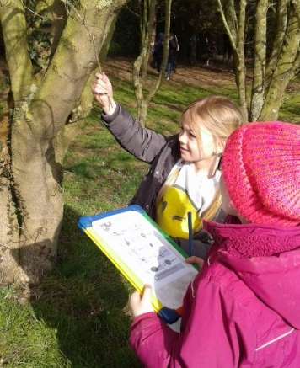
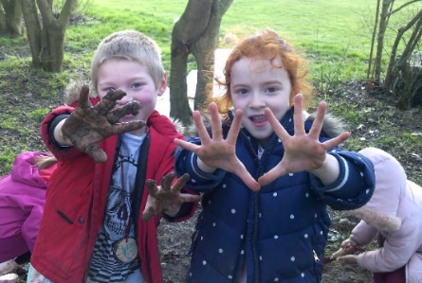
We know that continuing our focus on Outdoor Learning has been just the right thing to do and just two days in, our pupils are already reaping the benefits. Engaging with nature in a social context provides a perfect opportunity for children to enjoy the social interaction with each other that they have missed during lockdown. We have doubled the number of classes participating in the Forest Schools programme and every class has spent some lessons outside already, as well as having increased time participating in physical activity. We want our children to nurture a love of nature and learn the importance of respecting and protecting our environment. On Friday we are looking forward to our ‘hands on’ Science Day as part of marking National Science Week.
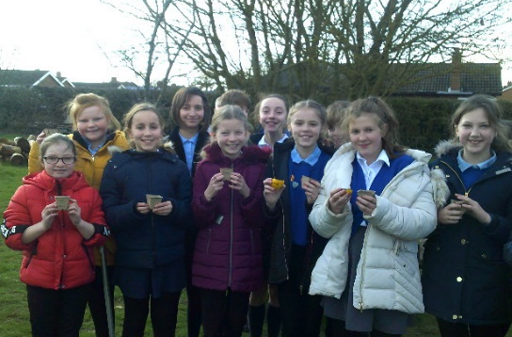
Alongside our love of the outdoors, we continue ensure pupils have plenty of opportunity to experience high quality fiction, build on Maths fluency and mastery skills and enjoy a broad, rich curriculum, unique to our school. Our Christian values provide a nurturing approach to developing the whole child, instilling in our pupils a love of learning that extends beyond their primary years, equipping them with the skills for their future and developing them as creative, responsible and self-aware individuals. Find out more about our school at https://www.chelmondiston.suffolk.sch.uk/

