Morland celebrated Queen Elizabeth’s Platinum Jubilee on Tuesday 8th June. The children arrived dressed in red, white and blue and enjoyed a variety of Jubilee inspired activities. They designed a new crown for Her Majesty and followed a treasure hunt around the field to decode a jubilee code. Our courtyard windows were transformed into an art gallery with the best examples of the Queen’s portrait or jubilee inspired art for all to share and enjoy.

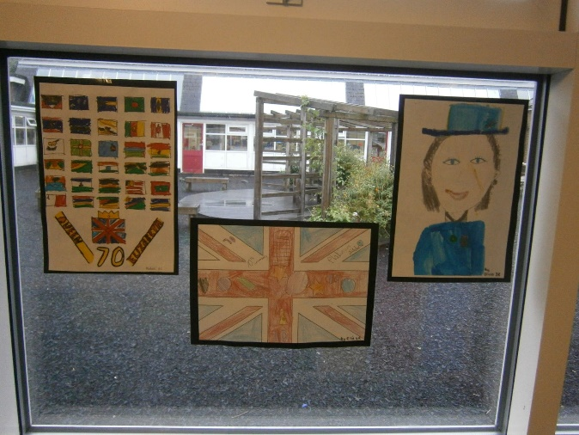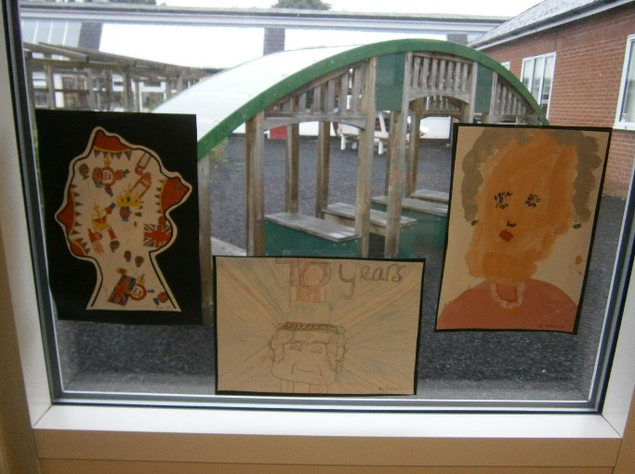
Mixed amongst the artwork were facts about the queen with maths related questions to answer.
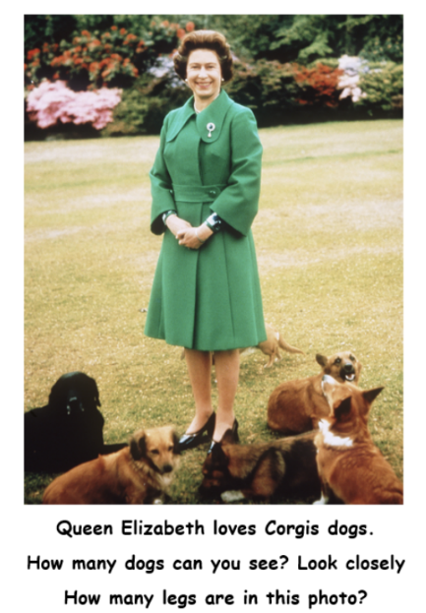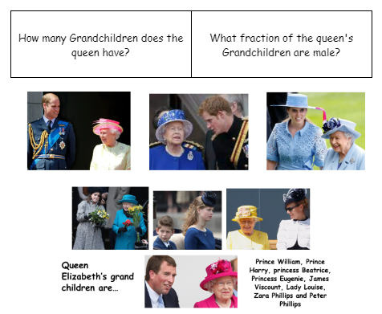

In the afternoon, the whole school came together for a celebration assembly to honour the Queen. Year 2 to 6 stood to sing the National Anthem.

A comparison of the Queen’s work life to our school values formed the message of the assembly before closing with a prayer.
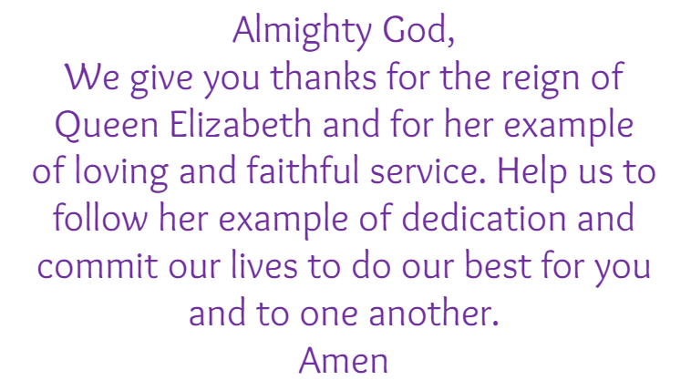
The close of our celebration were Street Parties. Bunting, music and plenty of cakes ensured a good time was had by one and all!
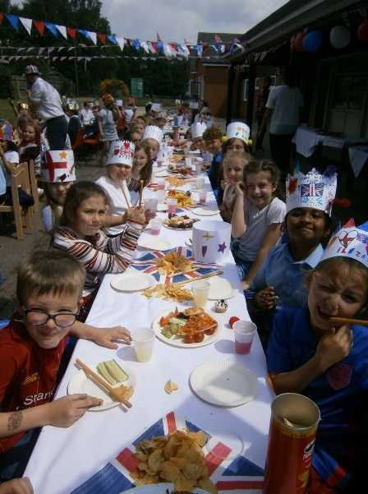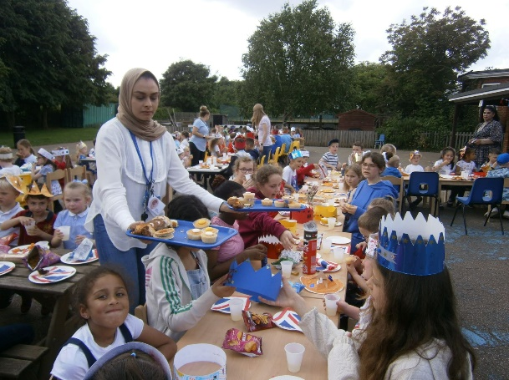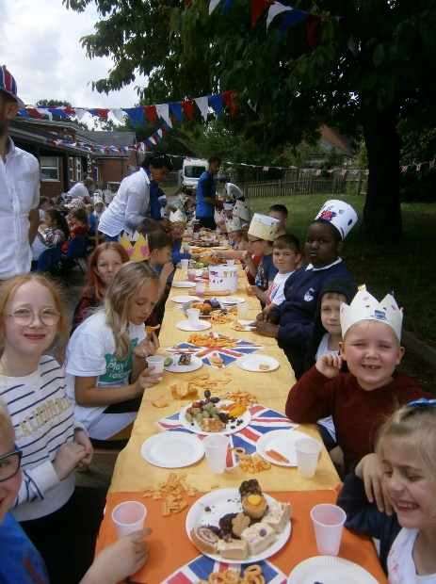
“It was lots of fun. I liked the street party and doing the maths quiz. Our queen has been a good queen
and it’s to celebrate her.” Jacob
“At the street parties we were with the little children. It was good talking to them. We are all
Morland and we are a community.” Lilly
“Not everyone knew what the queen has done, so it was important to learn about her. She’s worked
hard for 70 years. That’s special and it won’t happen again.” Evie

