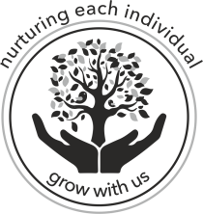
Ringsfield CofE Primary School

The mustard seed “is the smallest of all seeds, but it becomes the largest of garden plants; it grows into a tree, and birds come and make nests in its branches.”
Matthew 13:31-32 (New Living bible)

Platinum Jubilee Celebrations at Ringsfield!
The staff and children at Ringsfield Primary celebrated the Queen’s Platinum Jubilee together on Friday 27th May. The school was decorated with flags and bunting, and the weather was fine!
Everyone came to school dressed in red, white and blue and we started the day with a collective worship with the Reverend Phil. We sang some of our favourite hymns and the National Anthem. Then Reverend Phil then told us all about the Queen’s family and her role as head of the Church of England. At lunch time we ate outside in the playground, in street party style!
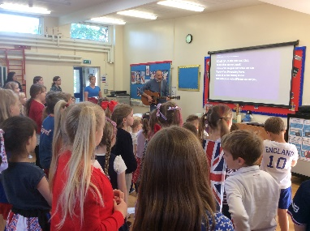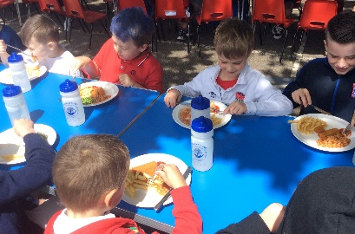
After lunch the children completed a carousel of jubilee themed activities including a jubilee quiz, jubilee crafts, our jubilee art gallery including The Jubilee River of Hope and some traditional games on the field. The parents were invited to complete the activities with the children, it was so lovely to have them back in the school again! Our wonderful PFA also ran a cream tea stall and a raffle for the parents.
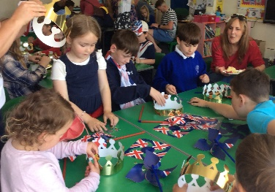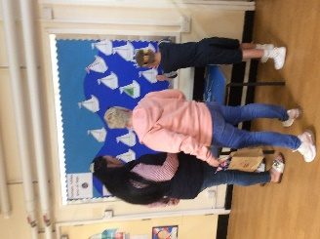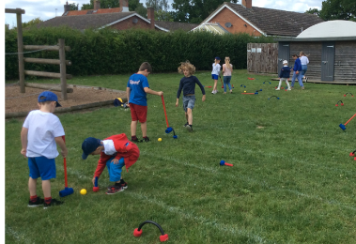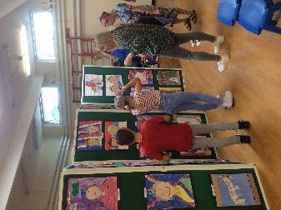
We finished our Platinum Jubilee celebration day by performing dances from the different decades of the Queen’s reign. The Reception Class represented the 1950s by rocking and rolling to Rock Around the Clock. Year 5 and 6 celebrated the 1960s in style by dancing to Surfing USA, complete with surfboards! The KS2 girls did a super dance to Waterloo from the 1970s. From the 1980s, Year 1 and 2 did a terrific class dance to the Birdy Song! The dance selected for the 1990s was the Macarena, which was skilfully performed, by Year 3 and 4. The Nursery class brought us up to date with a with their dance to Frozen, representing 2000 to the present day. We rounded off this amazing day by singing the Platinum Jubilee Anthem!

