News from St Mary’s C of E School, Hadleigh
Despite it being a short half-term, we have packed in a lot of activities since Easter. Of course, the Jubilee has been a historic time which we hope the children will remember from both activities in school and the local community. Our chef, Mrs King, made some amazing cakes for everyone to share on the field and give three cheers for her majesty. We had a few kings and queens on the playground to help us feel a little more royal. Hadleigh Show coming back also gave us the opportunity to get involved and we won awards for our art and poetry.
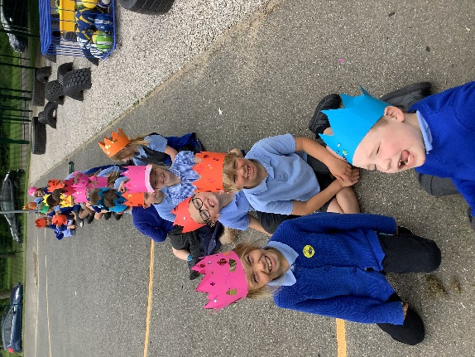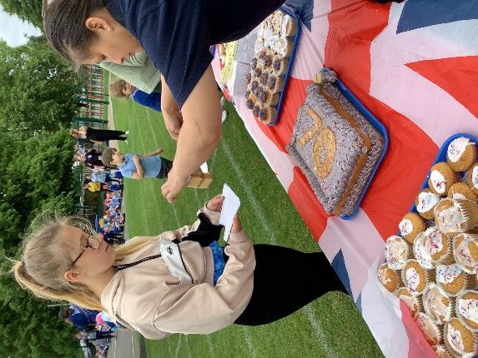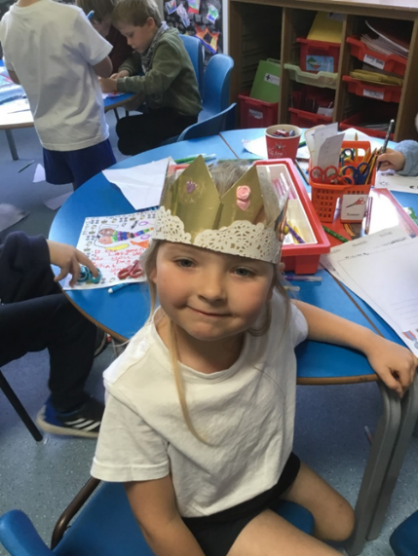
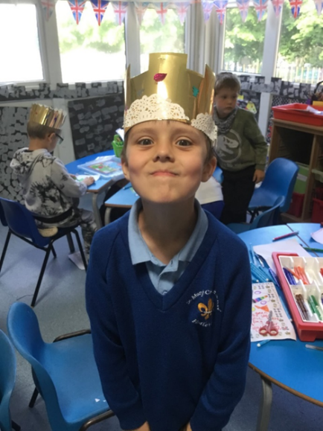

Year One
Year One are looking forward to continuing their learning about royalty with a visit to Hedingham Castle in the next couple of weeks – a great reward for all their classroom learning.
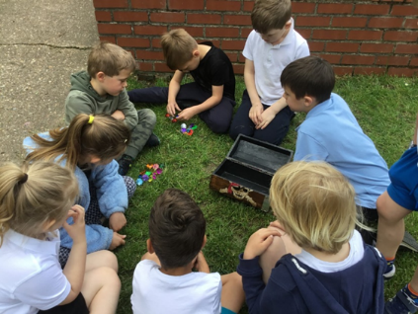 They’ve been taking their lessons outside as much as possible!
Year Two
Miss Brinkley’s class have been learning about Kenya as part of their topic work and have worked very hard to complete their KS1 assessments. They’ve been kept busy learning some great painting / mark making skills too.
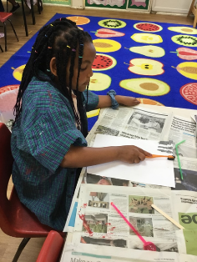 They’re looking forward to a visit to Hollow Trees Farm at the end of the month!

Year Three
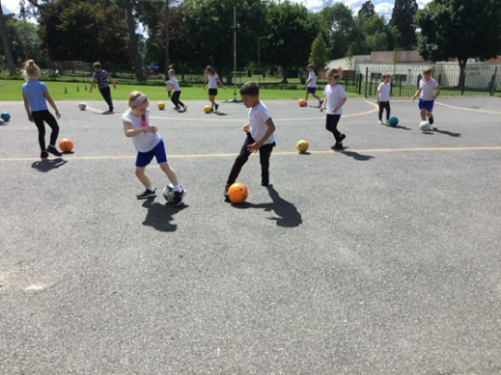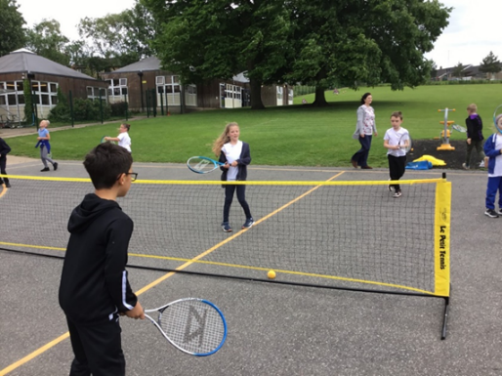
Beech Class have been doing a great job at improving their football and tennis skills.
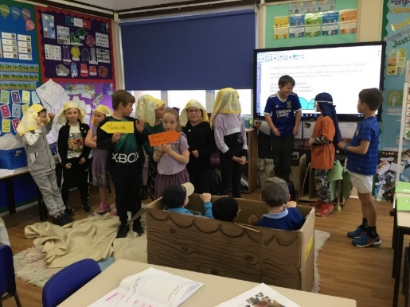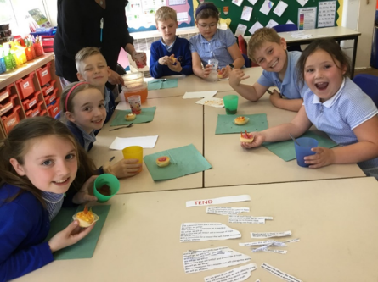
RE has included an exciting re-telling of Jonah’s story and an actual Pentecost party! Which we’ve also linked to making some amazing mosaic pictures in art.
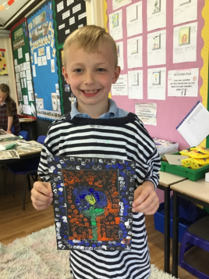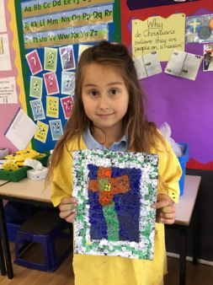
Year Four
Our year four girls have enjoyed great success and been an amazing team at football festivals this term and other members of the class have made a great start litter-picking, as members of the lunch time Eco-Club.

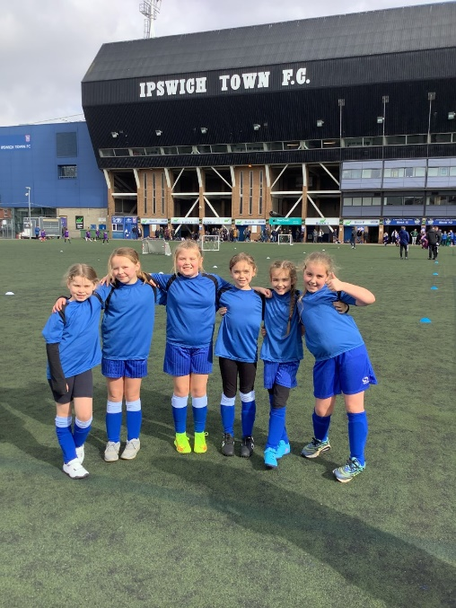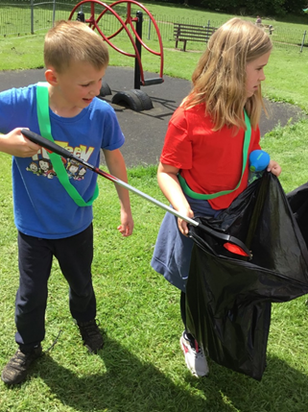

Year Five
Year Five were extremely successful in completing their Bikeability training, whilst our Junior Road Safety Officers planned and delivered a brilliant road safety session to the youngest members of the school. They’ve also been getting creative in making figures in the style of Giacometti, linking this to some of the sports we’ll soon see at the Commonwealth Games.
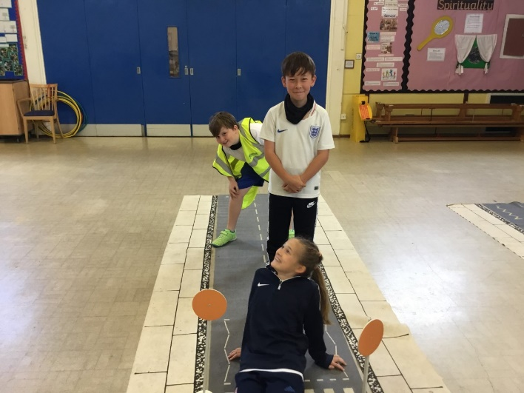

Year Six
Working hard to prepare for the KS2 SATs hasn’t prevented Year 6 from competing in tournaments, such as netball. They’re now preparing their end of term performance and looking forward to activity days, as they complete their time at St Mary’s.

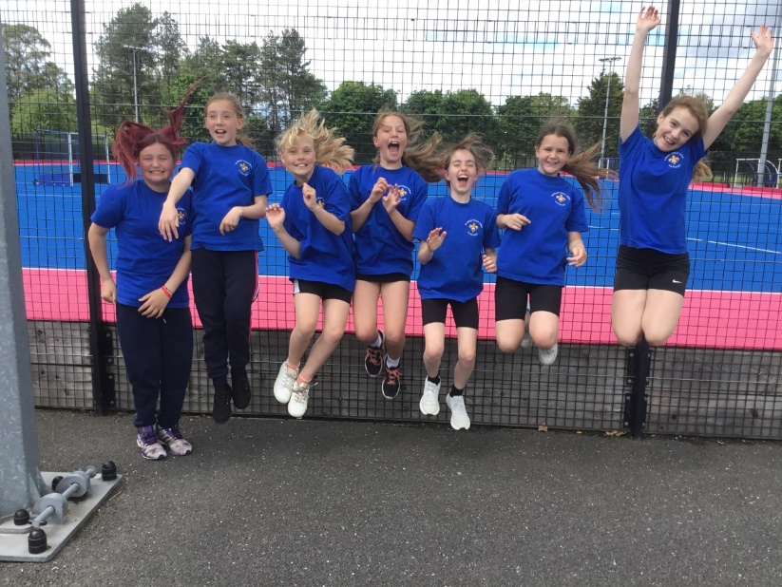

The whole school has also enjoyed assemblies from military personnel. SSgt Mills and LCpl Marsh spoke with the children about looking after the helicopters at Wattisham Airfield, whilst Sgt Hargreaves has visited to talk about Armed Forces Day. The children are now busy preparing competition entries to help celebrate.
Closer to home, we now have a little orchard planted on the field and children have been challenged to create a ‘Greened Up Patch’ for their class, with planted up re-cycled containers. We look forward to seeing what they can grow by the end of term!

