**News from Stoke by Nayland C of E Primary School – June 2022**

# The Suffolk Show - Suffolk Farming School of the Year Winners!

As part of the preparations for the Suffolk Show this year, children in Years 3 and 4 attended the Suffolk Schools Farm Fair. They were given opportunities to try different foods and to learn about the roles of animals and people in rural Suffolk. The children had an amazing time meeting cows, calves, sheep, lambs, hounds and their puppies, as well as finding out how to care for them.

Oak Class entered the Suffolk Show’s 2022 ‘Suffolk Farming School of the Year’ competition, which focused on pollination, with learning opportunities for food chains, plant life cycles, habitats and the environment. The competition was kindly sponsored by the Felix Cobbold Trust, and consists of three rounds.

The first round was to design and build a model of a bee, using recyclable packaging. With the

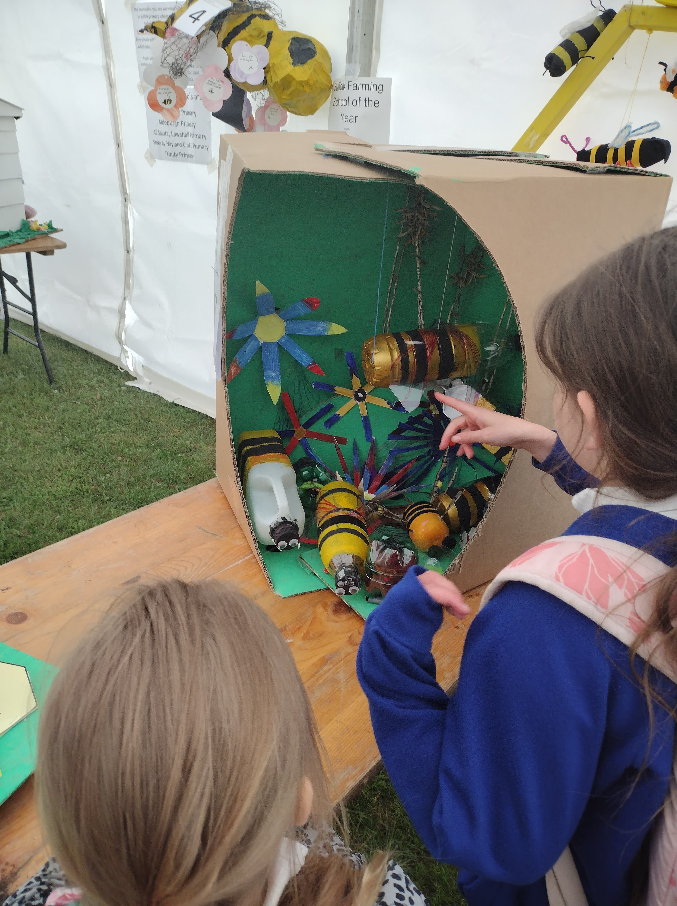support of Miss Moore, our wonderful Forest School specialist, the children created a diorama to illustrate the importance of bees. They learned about how bees help to pollinate crops and ensure that there is enough food to eat. They entered this into the competition against other Suffolk schools and were lucky enough to get through to the semi-finals. Having reached this stage, the children were then invited to attend a learning day in Ipswich at Trinity Park, in May, to discover more about food and farming through interactive workshops hosted by industry experts.

# During the day, the children were judged on their enthusiasm, engagement, knowledge of bees and their ability to retain the information that they learned during the workshops.

We made it through to the finals!

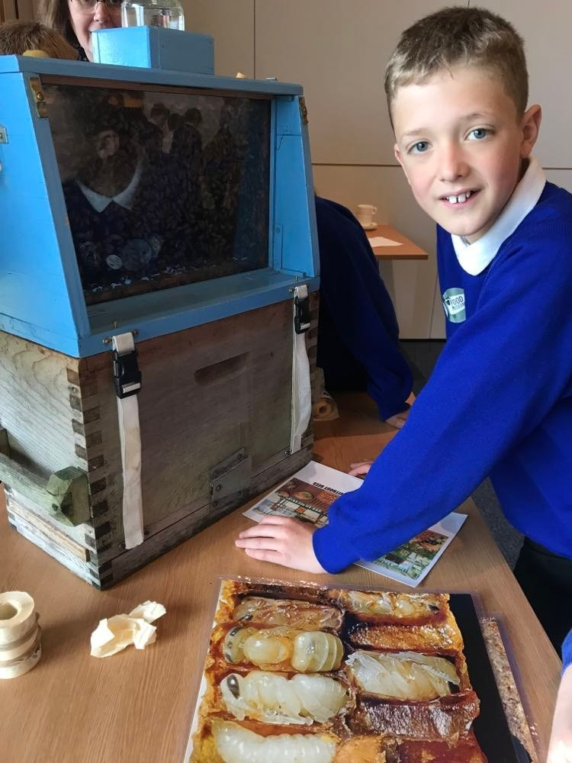

Our children were absolutely amazing. During the day they recreated and labelled flowers, made granola bars using honey, learnt about rapeseed oil toproduction, made seed bombs and encountered beehives, learning about how to keep bees. They asked lots of questions of the volunteers in each workshop, and were able to answer many of the questions that they, themselves, were asked. Their behaviour was exemplary and we received several comments about how polite they were. We are so very proud of you all, a huge ‘well done!’

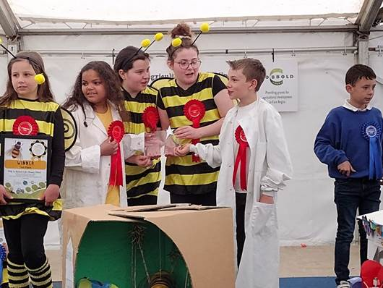Alongside two other finalists, Stoke by Nayland was invited to the Suffolk Show. Five children represented the class, and they had to do a presentation about bees on a stage for eight minutes. The children told a story about bees, which demonstrated their knowledge about bees. It was incredible to see the children’s confidence and supportive team-work. Their terrific presentation reflected the hard work of the whole class and the staff members who had worked with them on their bee project. It was amazing to be declared the winners! It was such a lovely experience that the children stayed and enjoyed the Suffolk Show throughout the whole day. **We are really proud of the children and delighted to be the Suffolk Farming School of the Year!**

**Red Nose Day**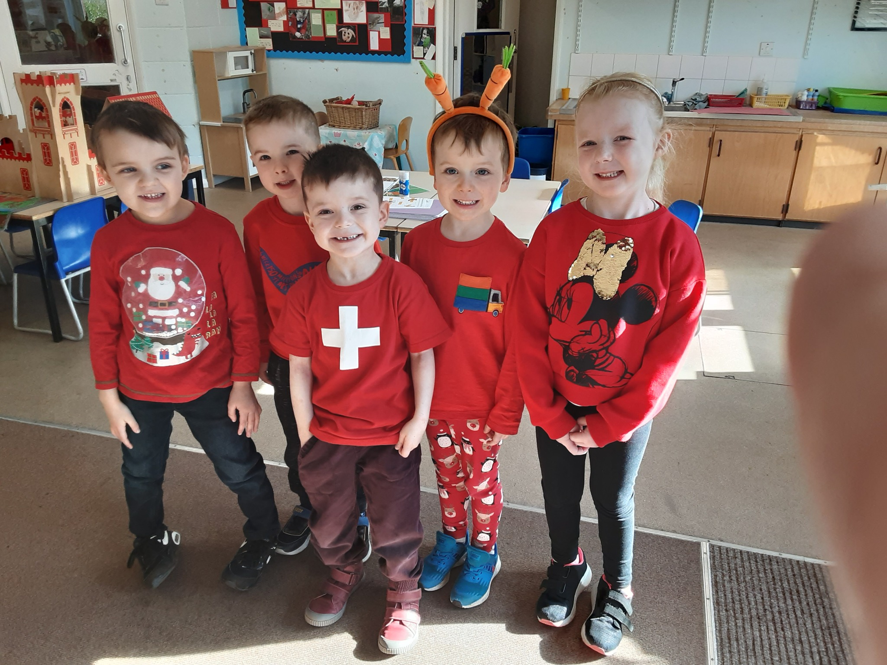

The children thoroughly enjoyed dressing up in red, in support of Red Nose Day this year. Thank you to everyone who sent in their donations. This year Comic Relief is also helping to fund organisations that are supporting people in Ukraine. Thank you everyone for your support.

**Teeth Cleaning**

Oak class have been busy learning about cleaning their teeth. They used disclosing tablets, which made their mouths and teeth go purple, but they do now know how to brush properly!

**Choir**

Well done to our Key Stage 2 Choir who performed Rollerghoster, and Supercalifragilisticexpialidocious to the whole school. Their performance was amazing. Thank you, also, to Mrs Whymark for coming in in her free time to play the piano and accompany us. We will be hearing more from our Choir during the summer term and there will be an event for parents to attend, so please watch this space.

**Junior Road Safety Officers**

Our Junior Road Safety Officers have been very busy teaching the younger children how to stay safe on the roads. Lots of fun was had by all of the children and the playground has lots of road markings in chalk for the younger ones to follow with their trikes. Now, the three JRSOs have set up a competition to design a road sign.

**Ash Wednesday**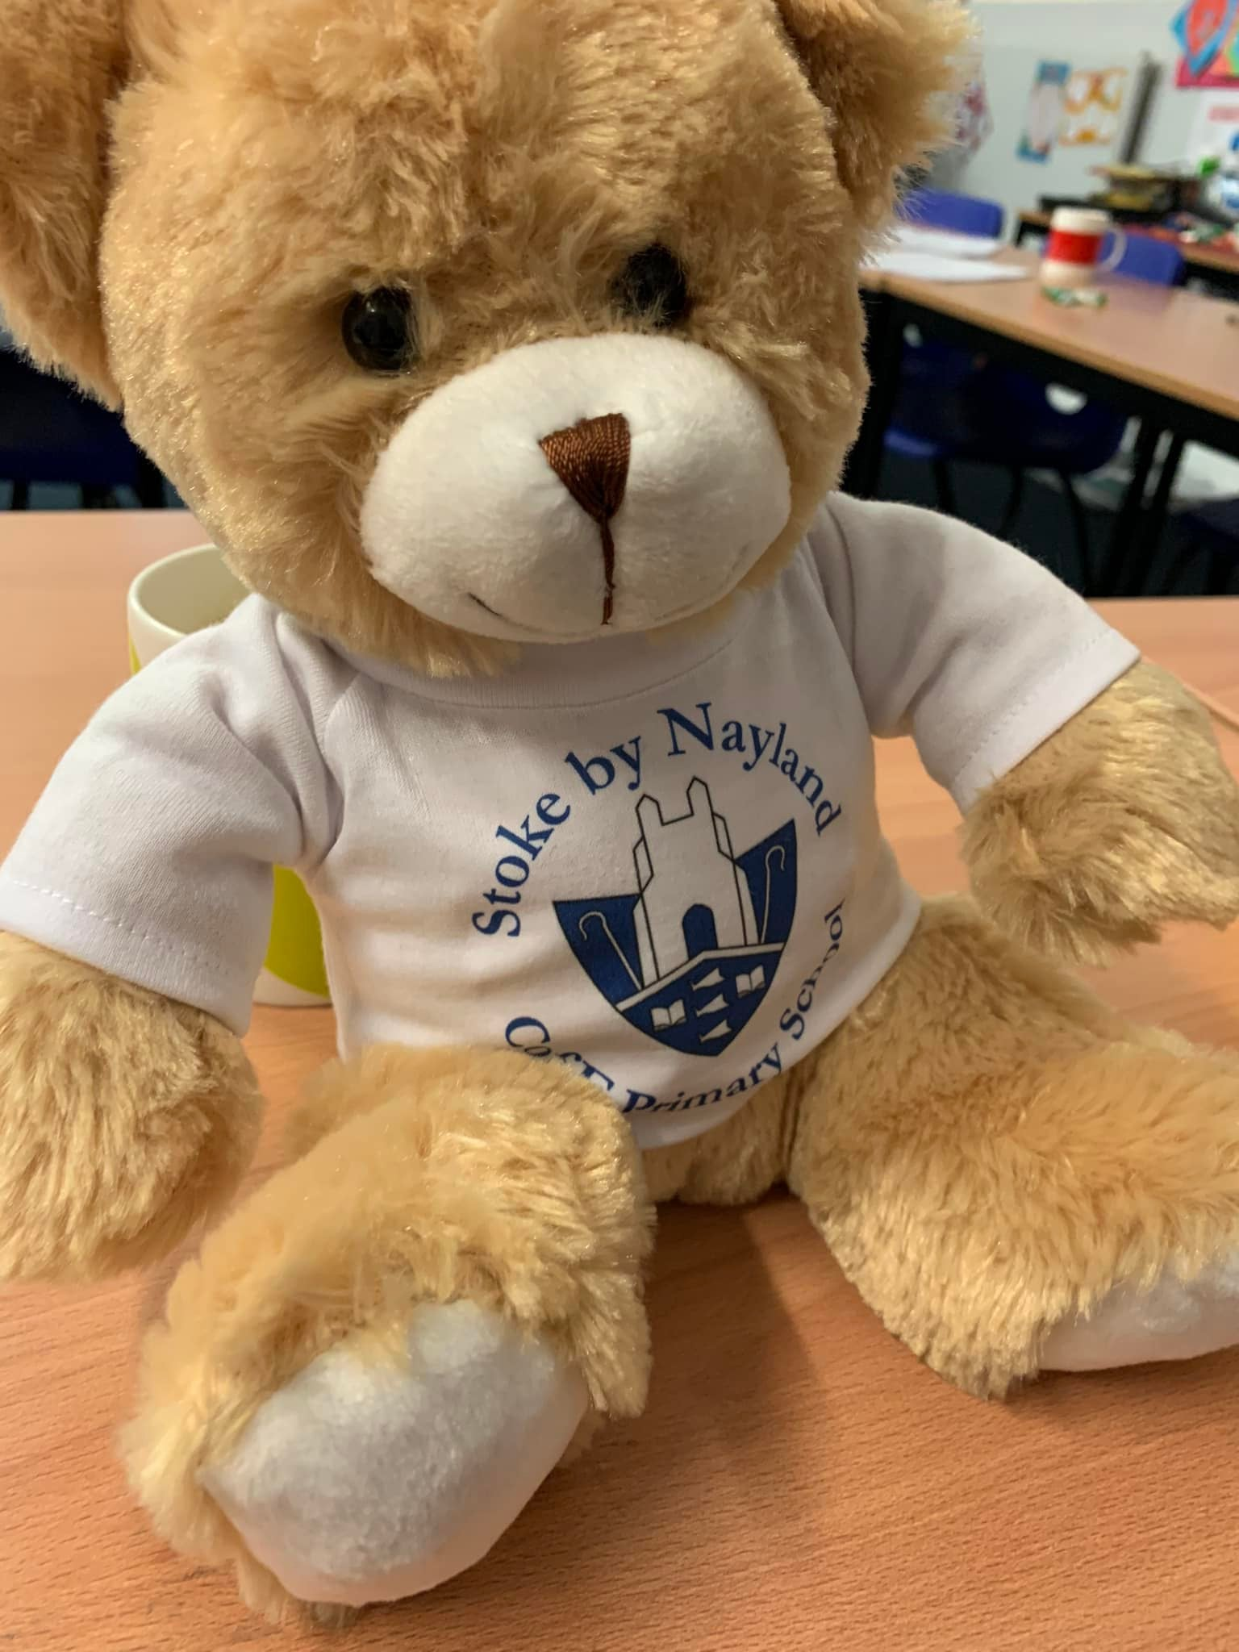

We celebrated Ash Wednesday during our Collective Worship with Rev. Val, who explained the significance of this day in the church calendar, and she marked our foreheads with ash in the shape of a cross.

**Colchester United**

Yesterday, Colchester United visited us to share some exciting reading opportunities. As part of the afternoon, all children received a book to keep and a child from each year group was picked for a small prize. These children stayed focused throughout the session and really did their best. We also had a visit from Eddie the Eagle!

**Teddies**

This gorgeous teddy sat in on a recent governors' meeting. He is one of several teddies that will go to each class, for the children to take home from week to week, and some will also be sent out to local nurseries.

**Platinum Jubilee**

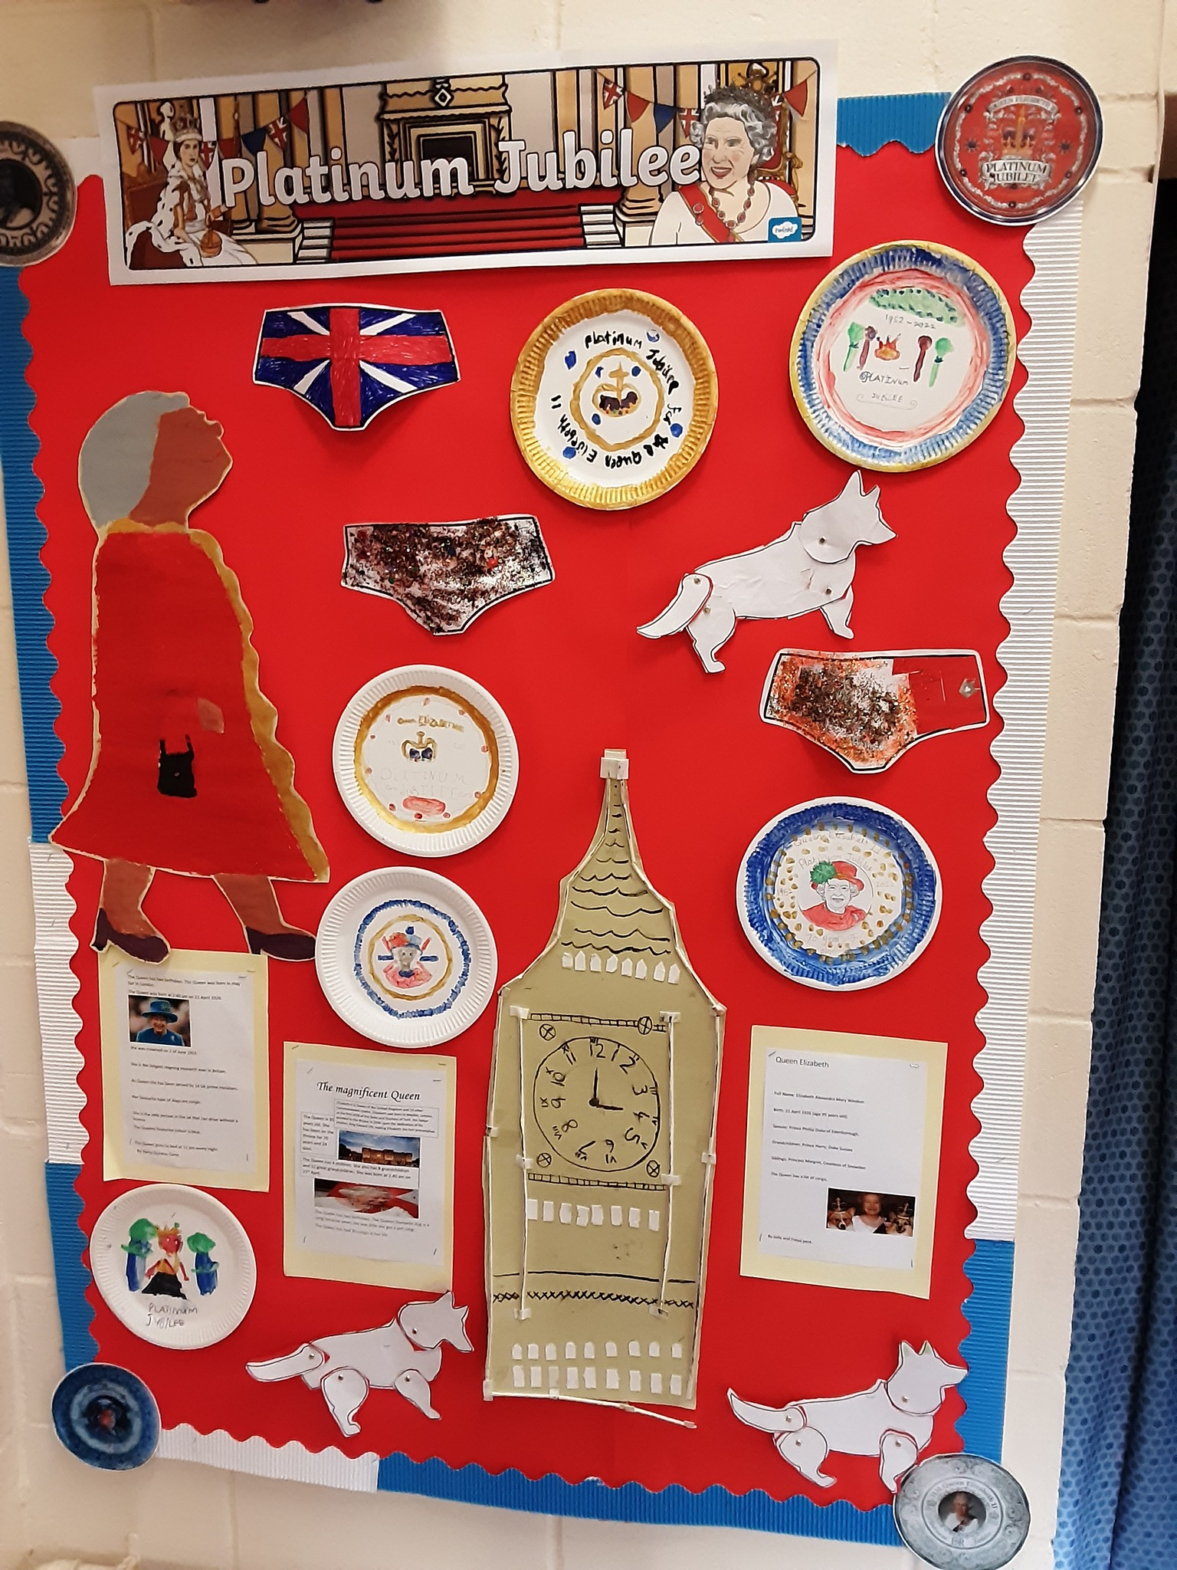Our Platinum Jubilee celebrations included two really exciting experiences involving the local community. Firstly, the whole school were involved in tree and wild flower garden planting for the village. The wild flowers we planted had been grown from seeds by the Eco Club, so it will be amazing to watch these grow into a beautiful garden! The planting took place on the recreation ground alongside members of the local community and Parish Council. Everyone got a bit wet, so all the children had hot chocolate when they returned to school!

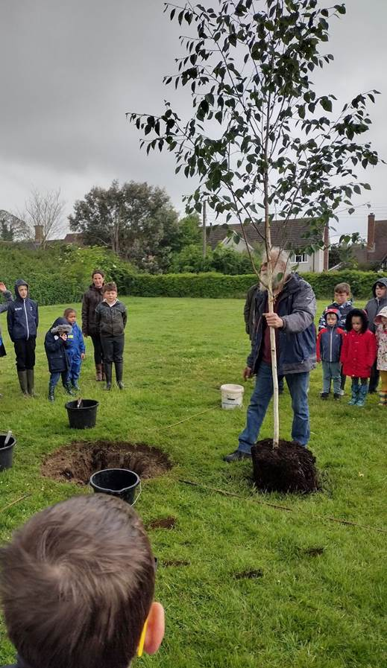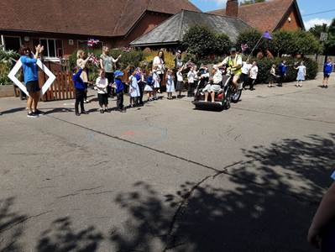Later in the week, the Suffolk Jubilee Torch Relay came through the school playground. This was a really special event for us because the torch-bearer was Joan Sheppard, a former teacher at the school, who has just celebrated her 100th birthday! A huge Well done to three Year 6 children, who presented a card to her for her special day. Whilst they were there, they sang a beautiful rendition of Happy Birthday in front of Joan's friends and family. Well done, girls, you were amazing!

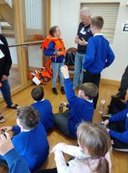**Crucial Crew**

The trip to Crucial Crew alongside other schools is always an important part of developing children’s understanding of personal safety. The children learned about various aspects of keeping safe, including water safety, staying safe online, how to do CPR and how to make a 999 call. One of the highlights was the drama workshop with students from Thomas Gainsborough High School about how to deal with bullying. Children also learned about being socially responsible through recycling. This was such a valuable experience for the children. Many thanks to the volunteers who led the workshops.

**Suffolk Farm Fair**

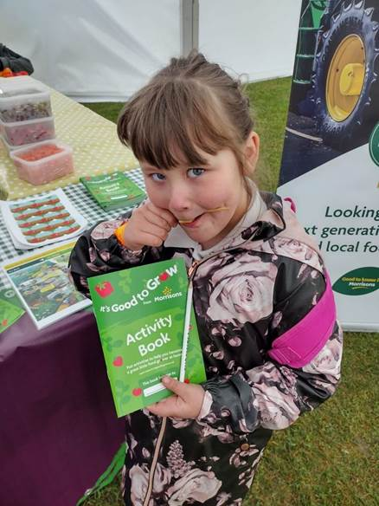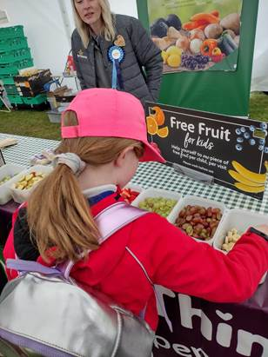Years 3 and 4 enjoyed an educational trip to Suffolk Farm Fair, supported by the Suffolk Farm Association. The aim of the day was to develop children’s understanding of rural life, the local area and jobs in farming. Many thanks to the members of the Suffolk farming community who share the children round.

There were lots of exciting activities, such as making fruit kebabs, exploring different types of food, seeing modern combine harvesters close-up and exploring jobs in dairy farming and the meat industry. The children particularly enjoyed meeting the animals, including sheep, goats, cows, sheep dogs and Suffolk Punch horses, the oldest English breed of working horses. It was a fabulous day and the children learned a lot!