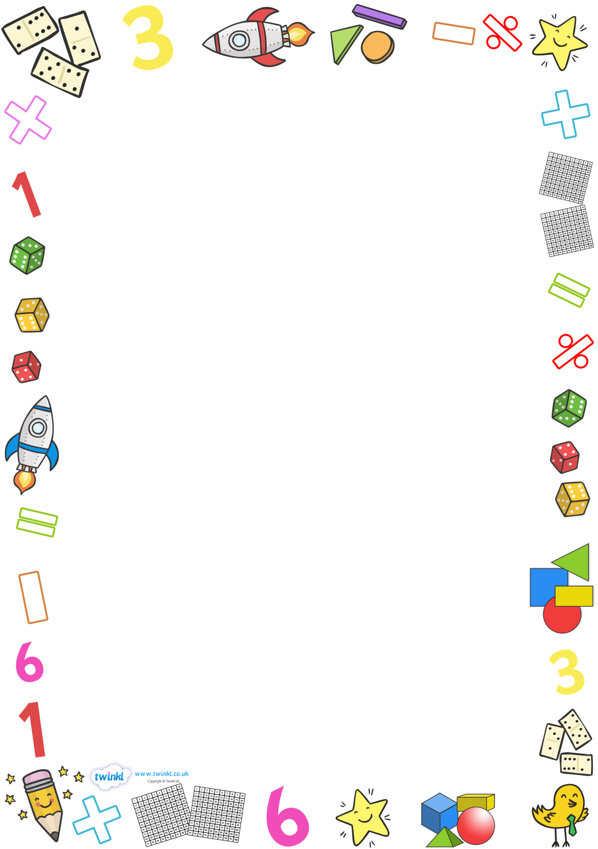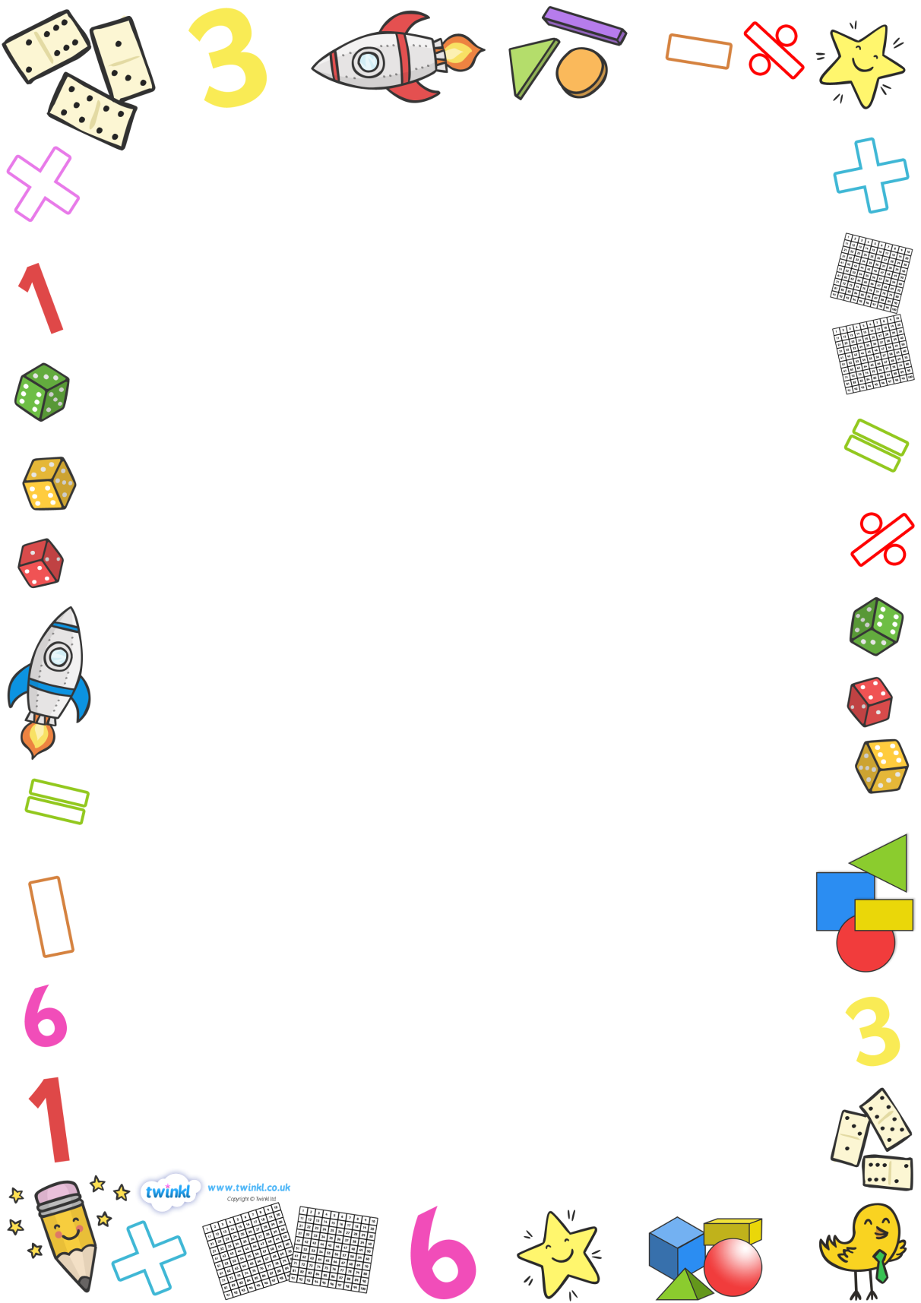

**At All Saints’ CE Primary, we are ‘Children of God’. We wear our crowns with pride.**

**Together we are Included, Involved and Inspired.**



**INCLUDED**

This half term at All Saints' we had a special whole school ‘Maths outdoors’ week, where we took the children outdoors and used the endless amount of space to explore how the usual classroom aesthetics can be adapted with nature.

In Collective Worship the whole school worked together to think of where we might find maths in and around our school.

Following on from this, we had a local theatre company in to perform an adaptation of ‘Jack and the beanstalk’. In the middle of the performance, Jack worked with the whole school to create a song to help us remember our 3 times table. This song stuck in our heads all day!

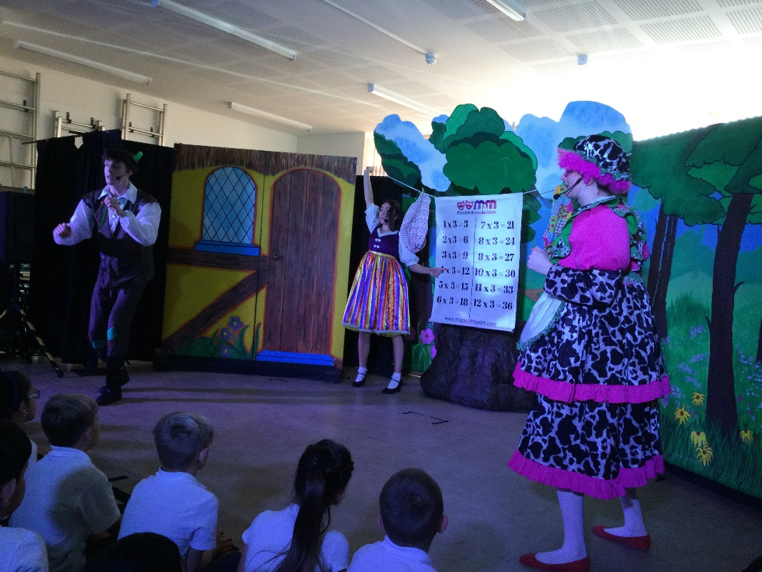

**INVOLVED**

Throughout the week, each class enjoyed the sunny weather and the freedom of the outdoors and participated in a great selection of different maths activities, puzzles and games.

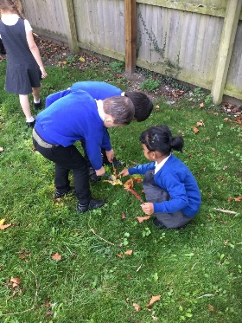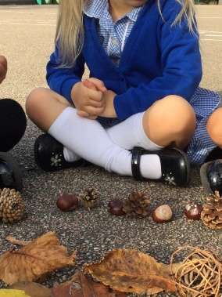

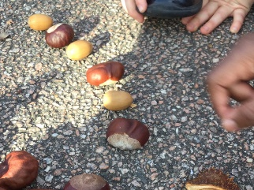

**Reception** started the week by making counting sticks and using them to count leaves, conkers, trees etc.  We then looked outside for examples of repeating patterns and then copied, continued and made up our own repeating patterns using natural objects, conkers, acorns, leaves, cones, sycamore keys etc outside.

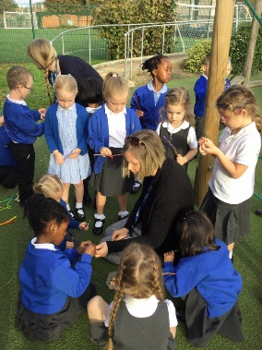

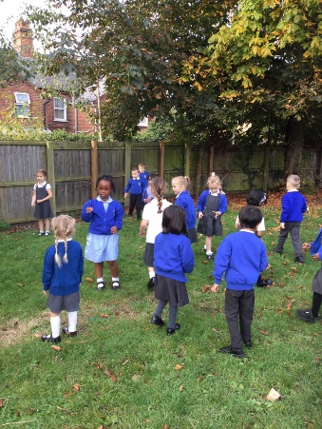

**Year 1** enjoyed their student teacher planning some learning outside for Maths but the rain came down and they did it in the hall instead. The children applied their learning from last week linking numerals and words and went on an animal hunt (linked to our topic), finding different animal pictures around the hall and recording the number and word on a sheet. The children loved being able to move around to do their Maths and using clipboards made it exciting too. Miss Baker was pleased that year 1 managed to find all the animals to write 0-10 in numbers and words.

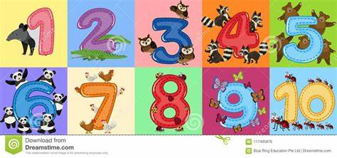

**

**Year 2** had a fabulous afternoon counting in 3s! First, they filled in missing numbers on a massive hundred square in the Hall. Then, they jumped along the hundred square, counting in 3s. They did a brilliant job and really enjoyed combining Maths with PE.

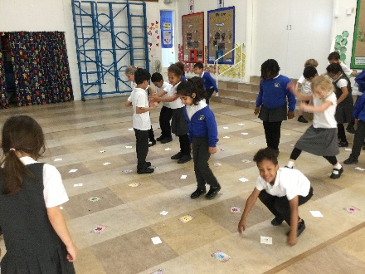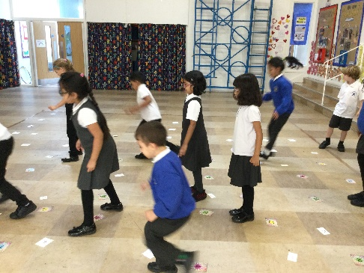

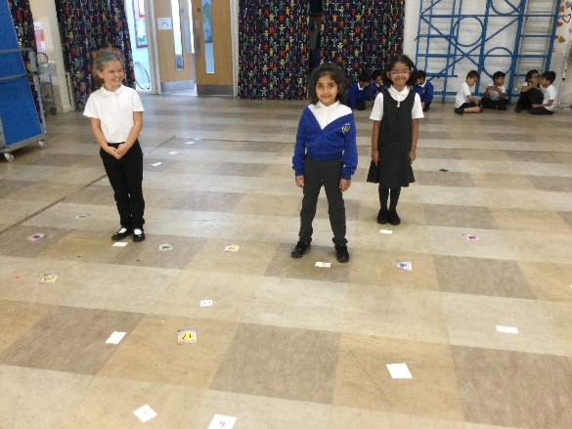

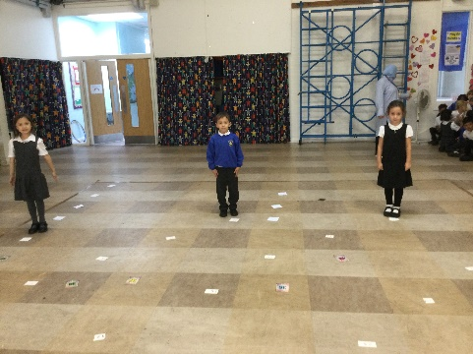

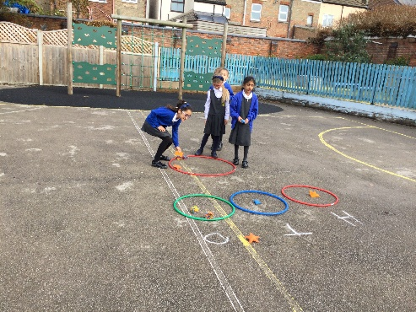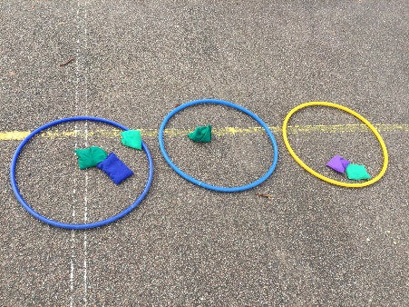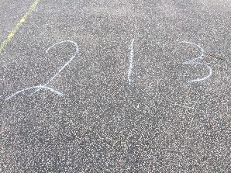

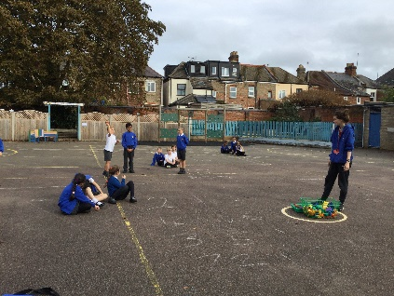

**Year 3** had a fantastic time outside exploring ways of making 3-digit numbers. The class were set the target task of showing hundreds, tens and ones. The adults wrote 3-digit numbers on the floor next to the hoops, the children had to throw the bean bags into the correct hoop to show the partitioned number**.**

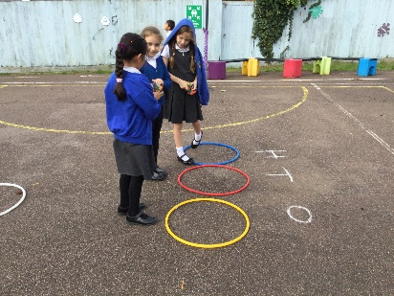



**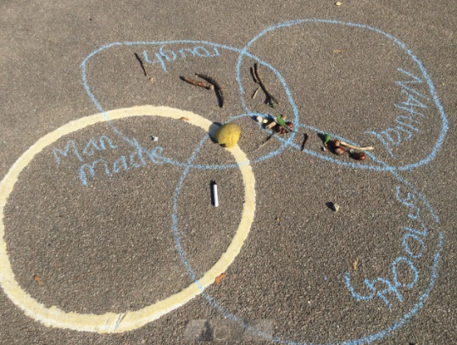

**Year 4**

**Year 4** were looking at different ways of recording data. They collected objects from the playground and sorted them into venn diagrams and tables. The class discussed which categories to use and which way of recording data was easiest to understand.

**

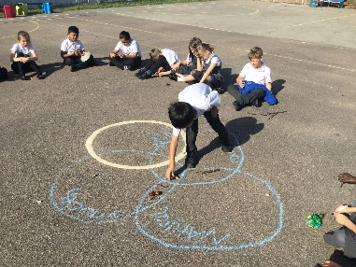

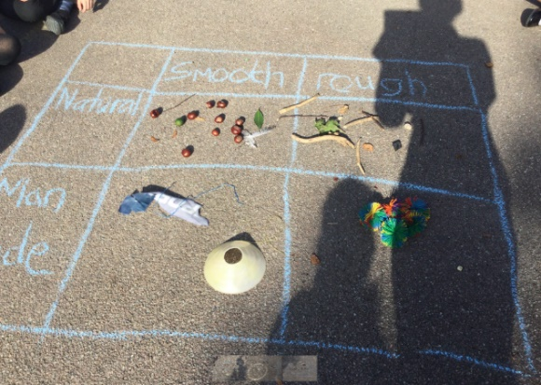

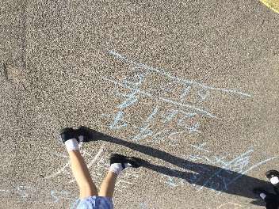



**Year 5** worked together in small groups to take part in outdoor problem-solving tasks. They applied their knowledge of place value to add 4- and 5-digit numbers. Some children investigated links between the length of fallen sticks. Finally, children had to work out how much Mrs Rodel had spent on painting the lines on the KS2 playground. This involved measuring the length of all the lines and multiplying this by a cost per metre.

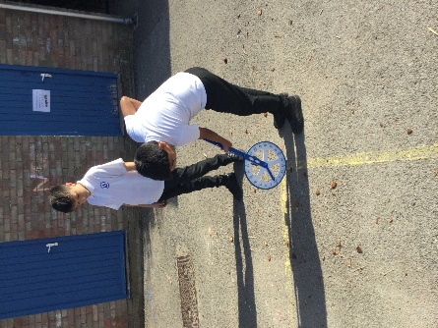

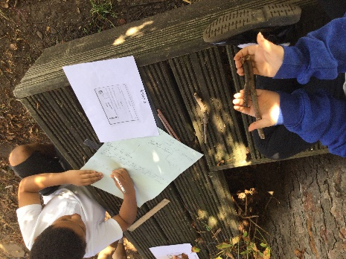

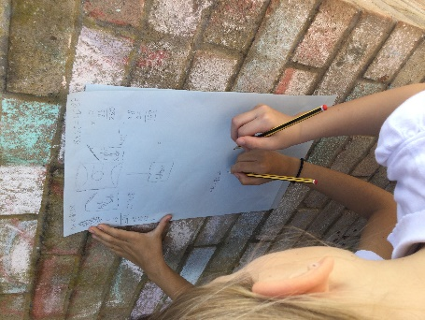

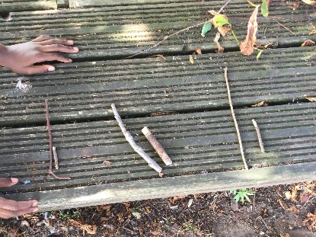

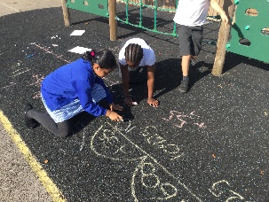

**

**Year 6** were asked to collect 6 items from the playground and work in teams of 6 meaning that each team should have a total of 36 items. Groups were challenged to think of how they could apply this to making pie charts and circles. Sebastian then said “there are 360 degrees in a circle”, this then allowed us to recognise that each item will take up 10 degrees of our part chart. Interestingly, items that students collected double or more than 2 of such as conkers, leaves and feathers meant that they needed to create a segment that is larger for that item.

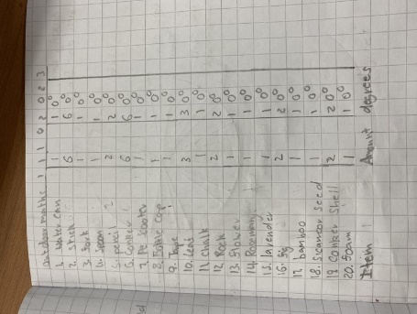

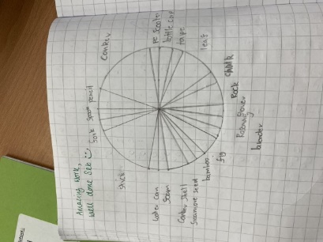

**INSPIRED**

Thank you to all the staff at All Saints’ for the effort and inspiring activities that made our ‘Maths outdoors’ week so successful. Also a big thank you to MAT mathematics subject leaders for collating and creating such as great bunch of resources for us to choose from to use.

Having explored the benefits of teaching and learning mathematics outdoors, we hope to do this much more often in school. Mrs Oakley also intends to inspire parents with a few maths outdoors ideas and suggestions that they could use at home with their children.

