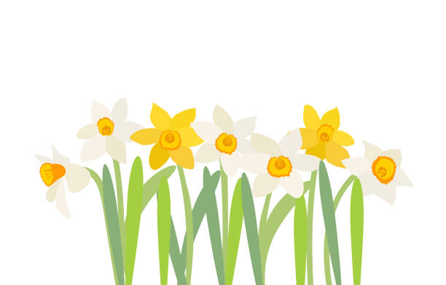
All Saints’ Church of England Primary School
Vicarage Road, Newmarket, Suffolk CB8 8JE
Special Edition Newsletter
Celebrating Spring Term 1– March 2023
Together. included ∙ inspired ∙ involved

We had a wonderful start to 2023 with a jam-packed half term filled with learning and fun together. Here is just an overview of some of the highlights.
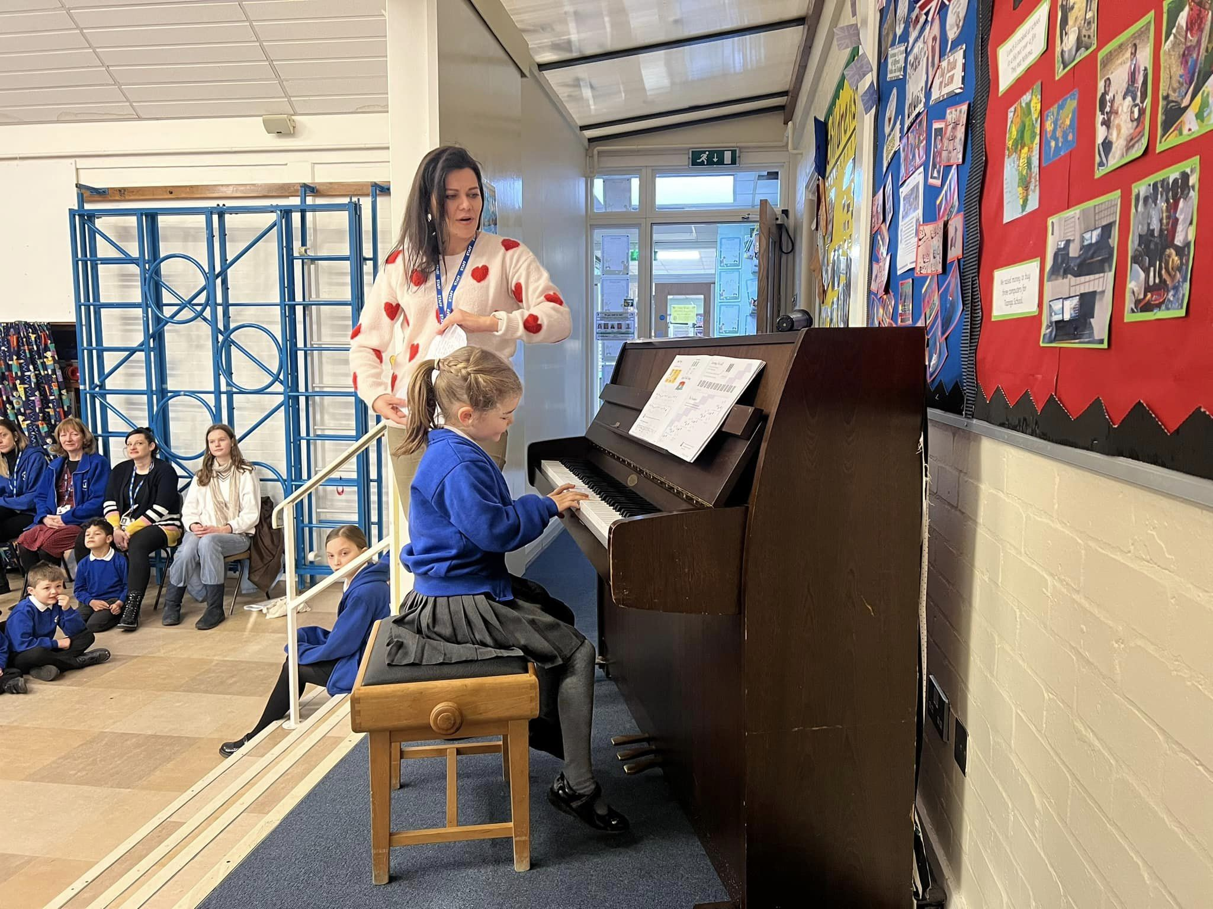
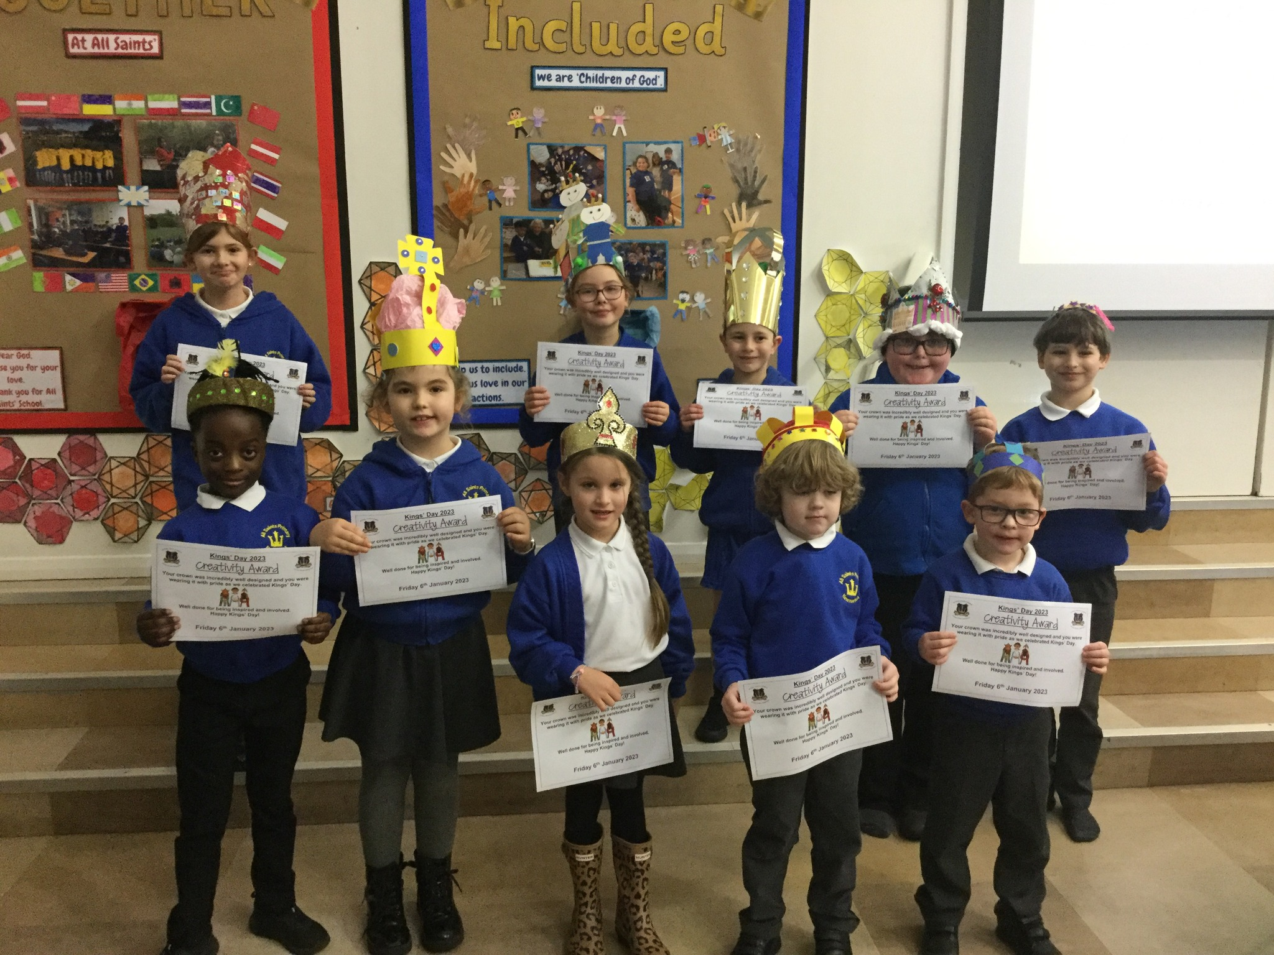
Kings Day

Our term began with a special Kings’ Day celebration. The children certainly wore their crowns with pride on that day and we celebrated their creativity with their designs.
We were immensely proud of our ‘Collective Worship Crew’ who led us in our Worship that day
Music Assembly

We love our half-termly Music Assemblies at All Saints’. Each class has the opportunity to perform to the whole school, parents and families the end-product of their curriculum unit that half term.
These special assemblies have a real celebration feel to them and it is amazing to see the children progress each half term.

This half term we had an extra treat as our children that are currently learning to play the piano in lunchtime and after school lessons also performed superbly.

Our Year 4 children are currently learning to play the flute through and we very much enjoyed their performance as they have really progressed as musicians and initially found it quite challenging to get a sound from their flutes at the start of the year.

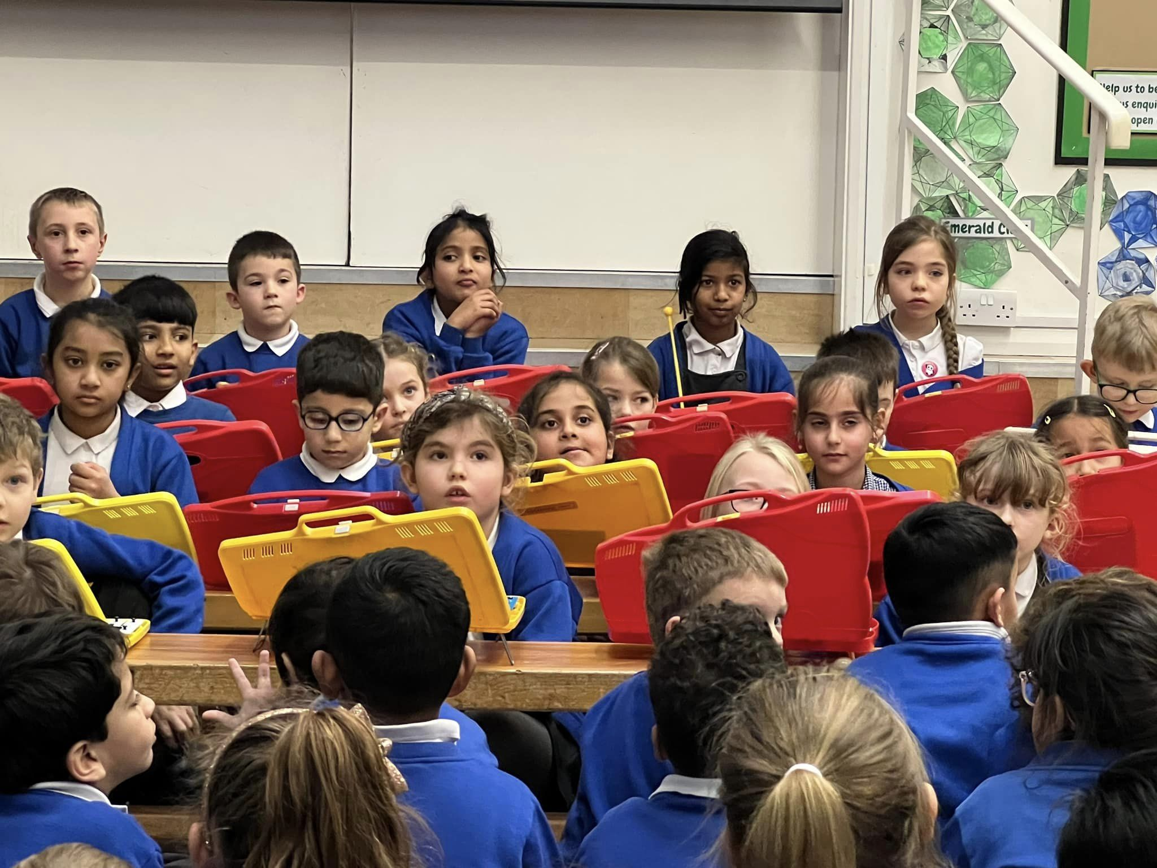

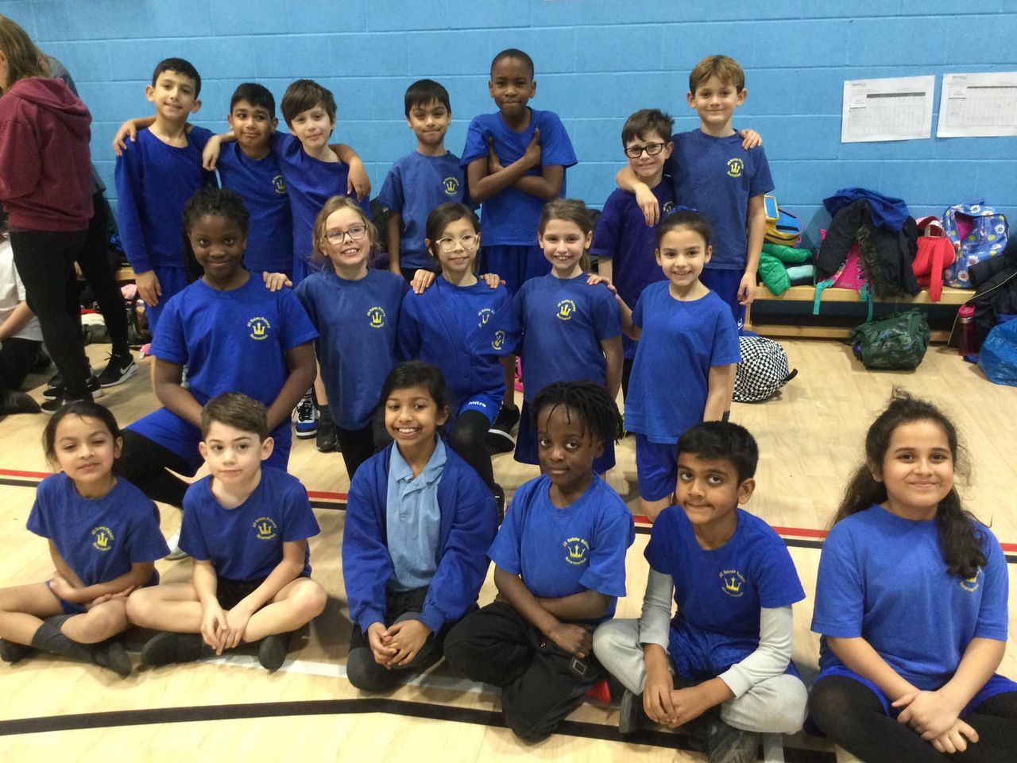
Sporting Achievements
Some of our children from Year 3 and Year 4 represented the school at an athletics competition with lots of other local schools, their smiles showed how pleased they were with their sporting achievements.

Whilst on the subject of supports, we celebrated our Year 5 and Year 6 football team this half term who won against local schools and even attended finals for Suffolk County where they finished 4th!

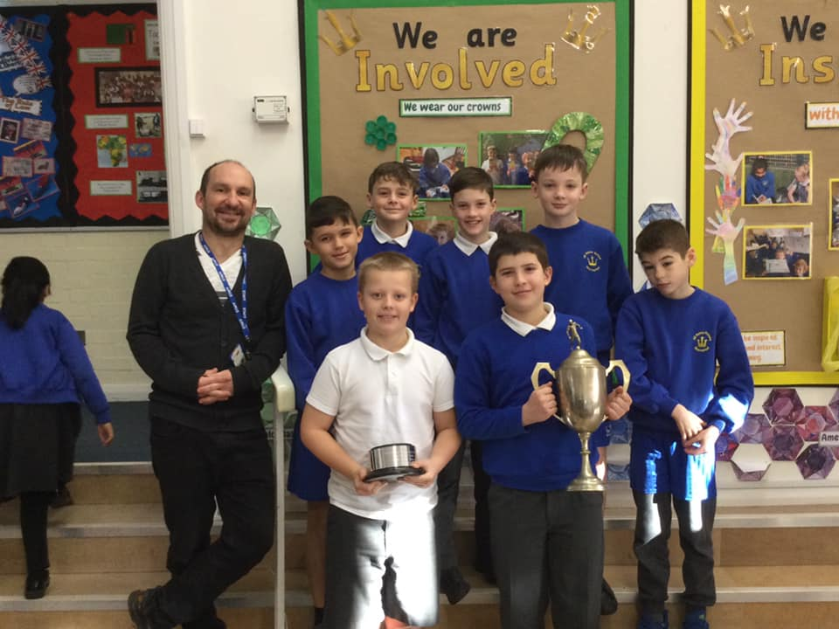

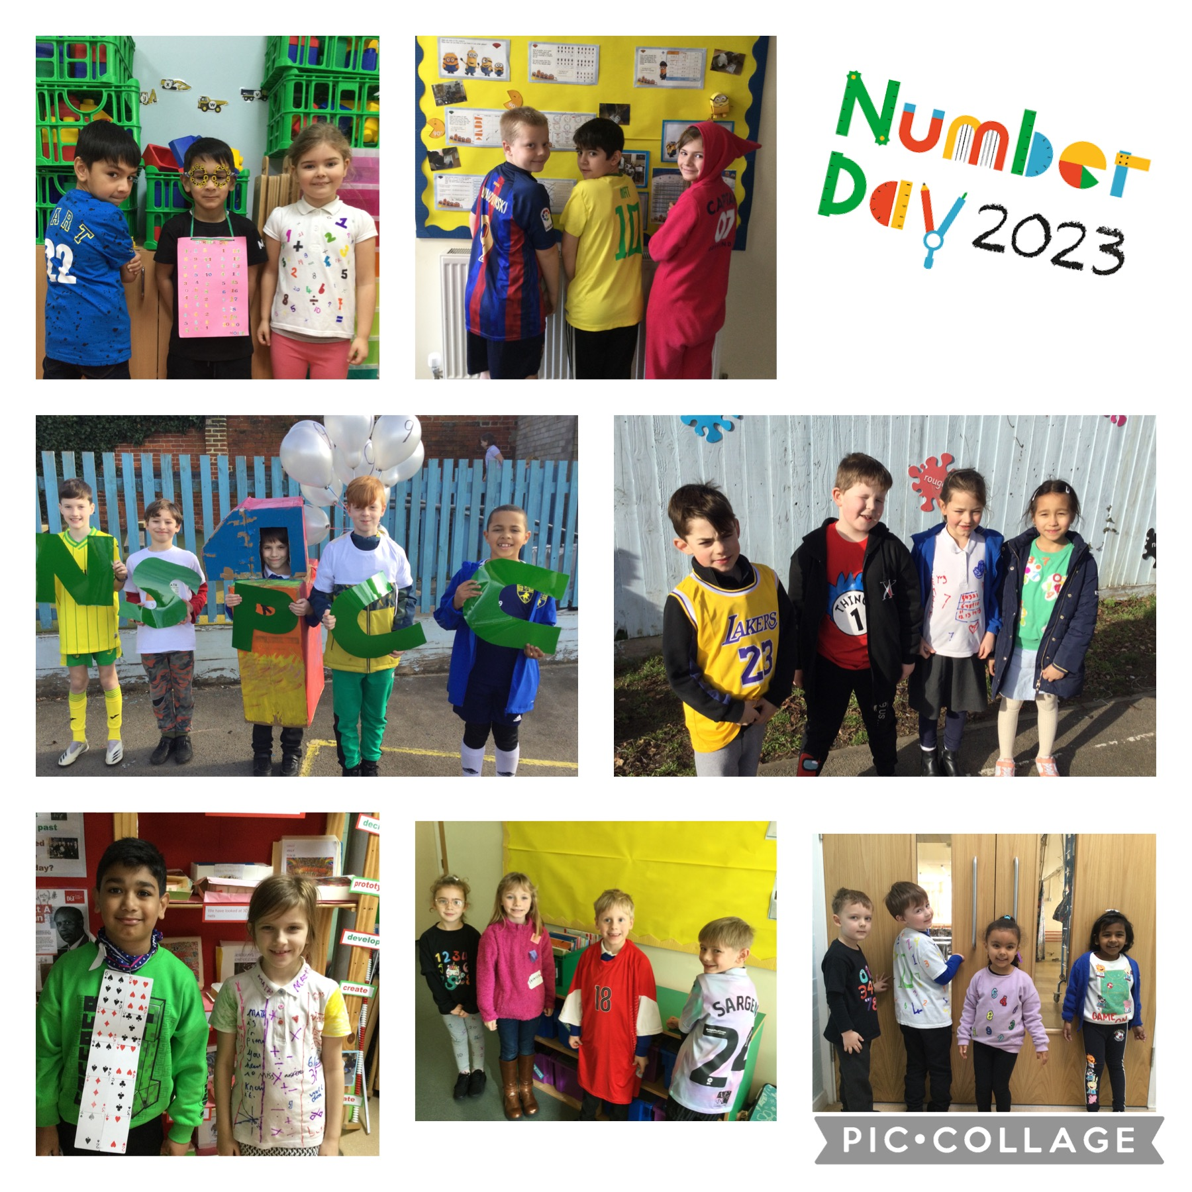

Number Day for NSPCC

What an amazing Number Day we enjoyed at All Saints’. We had great digit outfits, fun maths activities, number cupcakes for lunch and a super number-based Bible Collective Worship with Mrs Matter- it was brilliant.

We continue to keep the profile of maths high in our school and this was an exciting way to do that. Our families were also invited to maths workshops called ‘Croissants and Calculations’ which hopefully they found informative.

Childrens’ Mental Health Week

The half term ended with a week full of events as part of Children’s mental health week. We followed the theme of ‘Let’s connect’ and encouraged our whole community to make meaningful connections all week long.
Here is how we did that:
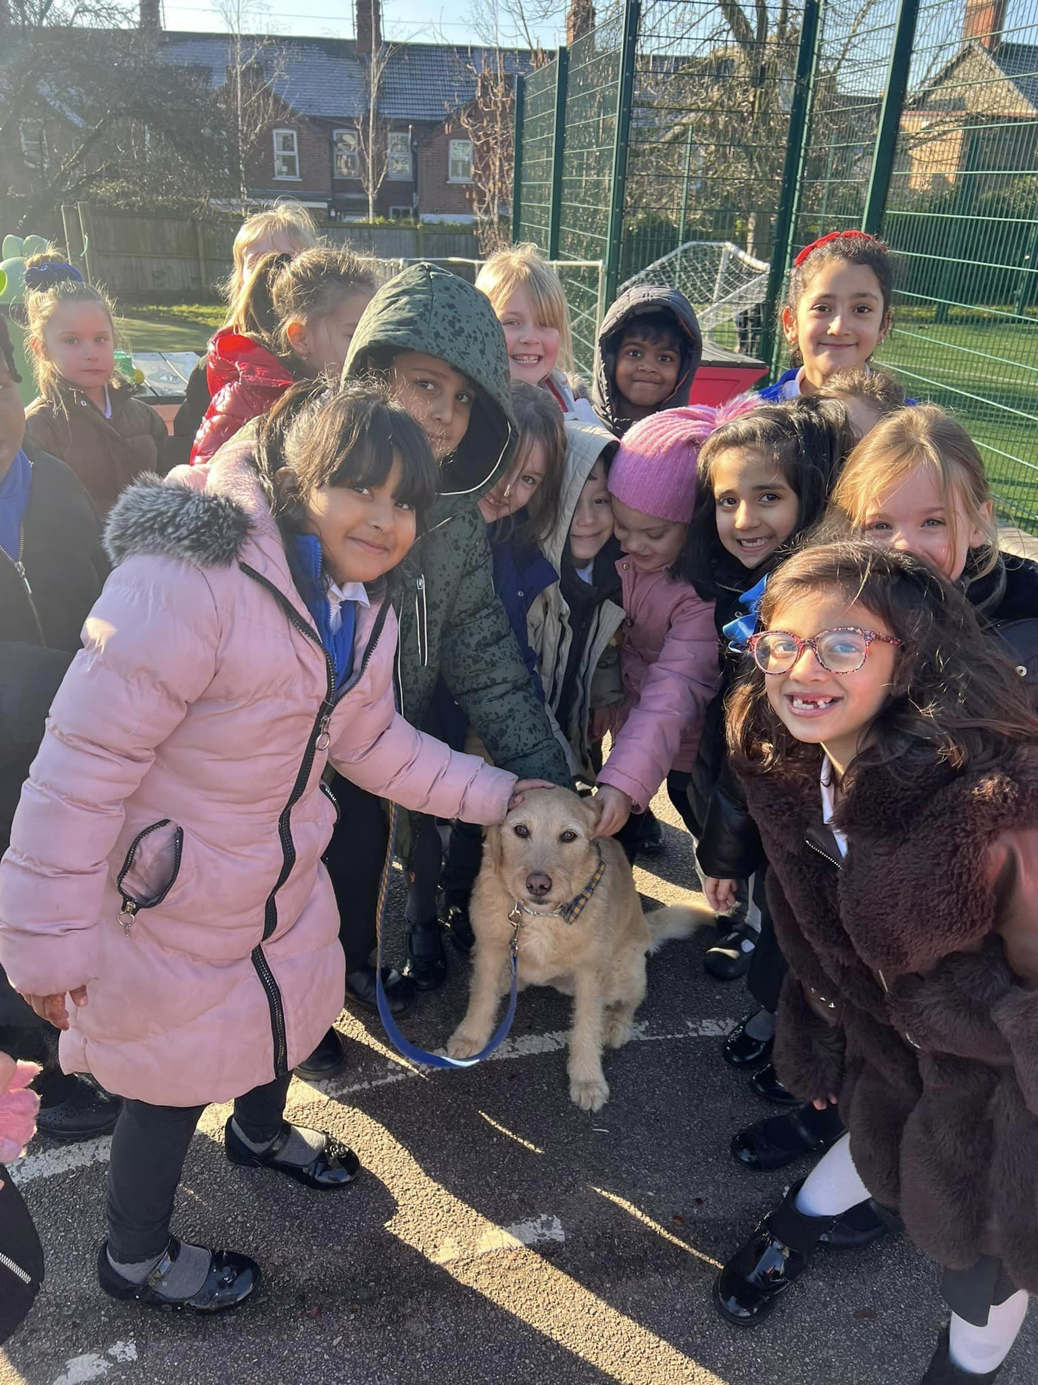
Musical Monday
Music in class
Music outside – with a whole school dance off @ the end of breaktime
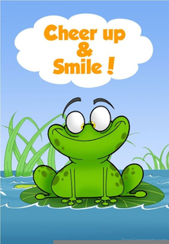
Cheer Up Tuesday
Year 1 made us smile with their class assembly
Children were also encouraged to bring a joke to share with their friends in class that day.

Wellbeing Wednesday
Special Assembly
PAT (Pets as therapy) Dog, Charlie visited our school.

Friendship Thursday
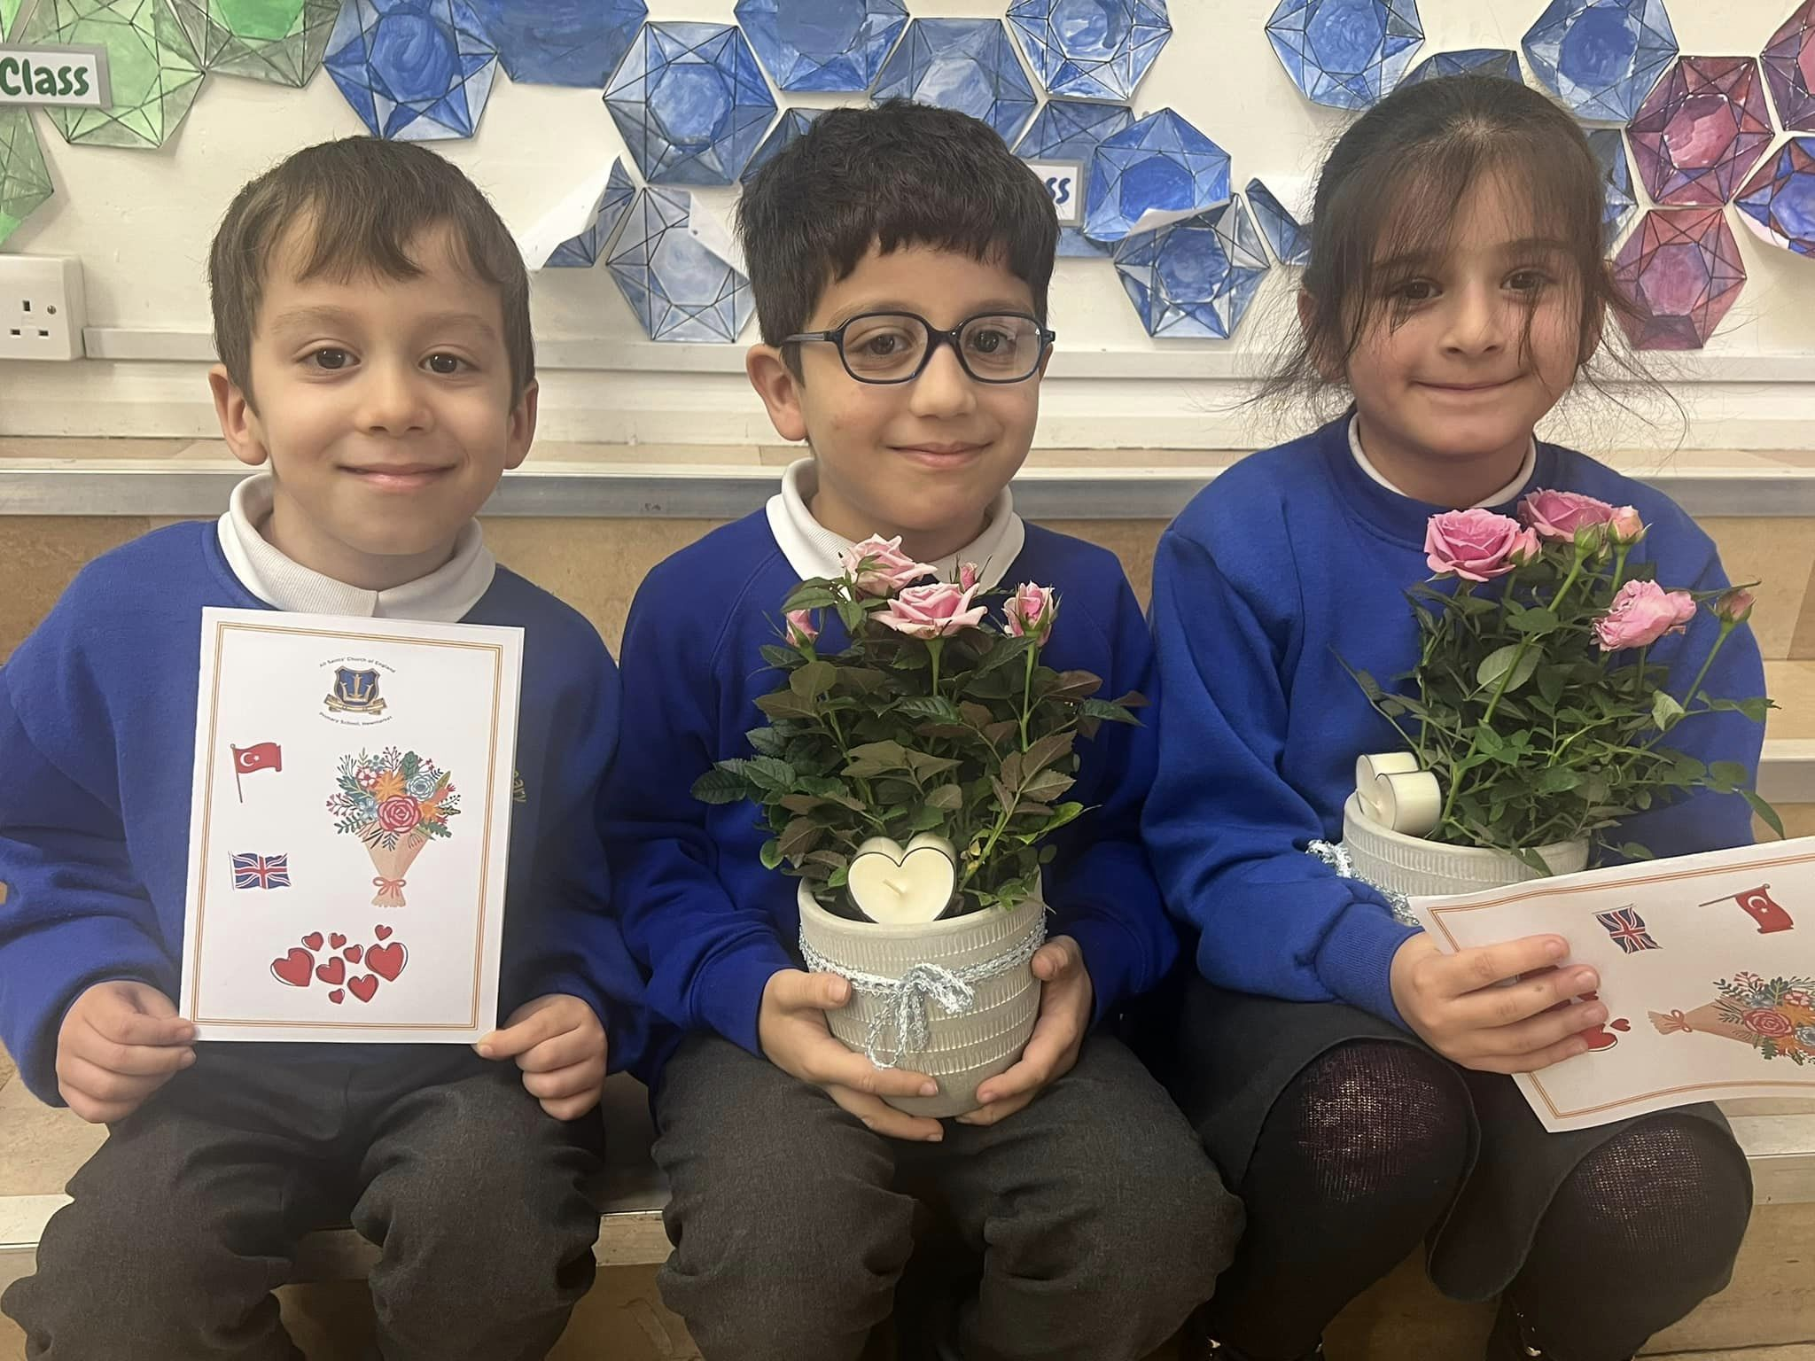
The PTA organised a Valentines Disco after school for us all to enjoy. We also had a special Collective Worship where we talked about the earthquake in Turkey and Syria. Some of our families have lost loved ones their so we presented them with a special memorial rose, a candle and a card to assure them of our ongoing love, support and prayers.
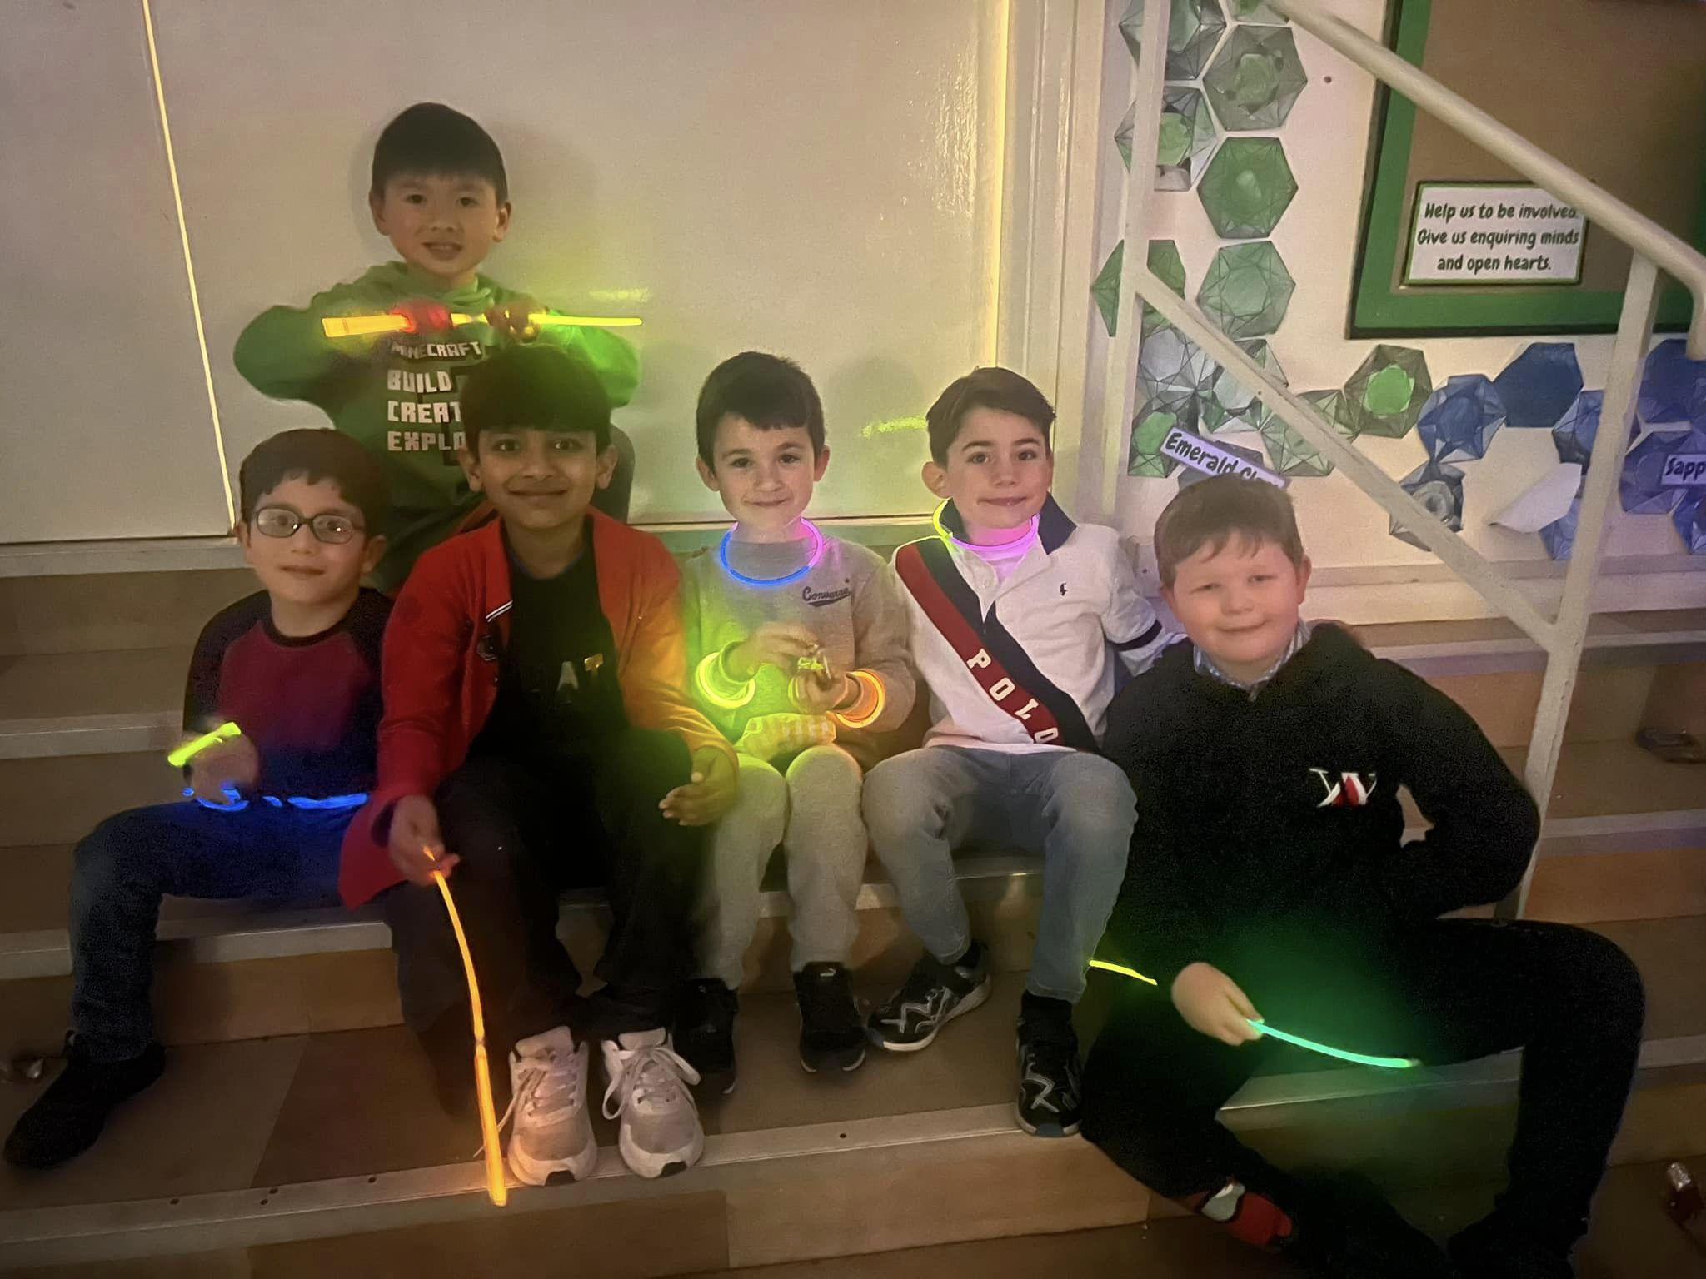
Feel Good Friday
‘Fearfully and Wonderfully Made’ Day for Muscular Dystrophy
We all wore BRIGHT clothes to raise awareness of Muscular Dystrophy. One of our children in reception has this condition and therefore we wanted to support his family in their fundraising efforts for Muscular Dystrophy UK.

