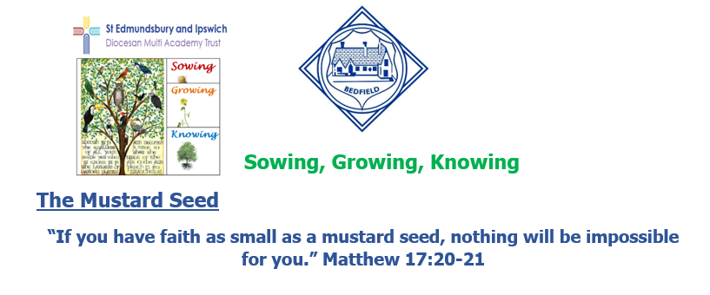

Bedfield C of E Primary School

MAT Newsletter November 2023

Surviving the floods
It was all hands-on-deck in the communities in and around Bedfield with tractors and land rovers on rescue missions to get children home from school during the floods on 20th October in the wake of Storm Babet. Many were stranded in cars for many hours in frightening circumstances whilst trying to collect siblings from the High School and were so grateful to the many people who stood in with offers of help with transport and shelter.
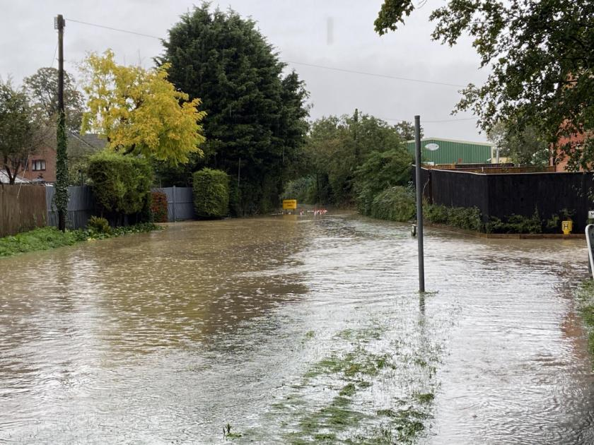
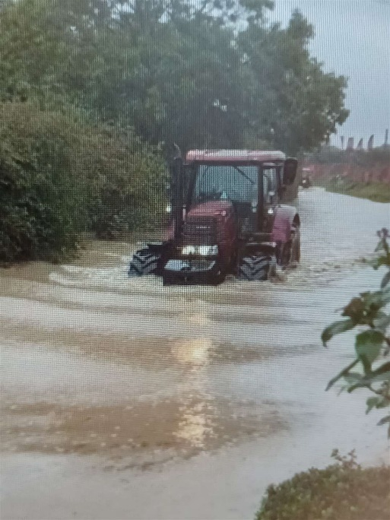

Curriculum Enrichment
We had planned a day of history trips learning about Victorian toys, Romans and Mayans for the 2nd November but unfortunately, due to Storm Ciaran, both our school and our partner school at Bedfield had to cancel.
The trip is now postponed until 5th December 2023 when Years 5&6 will take part in workshops exploring the Mayans. They will create Mayan calendars, extend their knowledge of how the Mayan number system worked and question an authentic Mayan Archaeologist called Dr Diane.

Maths across the curriculum
At Bedfield, we chose three different curriculum areas to reflect Maths skills during Maths across the Curriculum week.
EYFS/Years 1&2
Maple Class used mathematical symbols < > and = to compare quantities of materials in Science. In Art they created repeating patterns using printing blocks. In PE the children played a team game using numicon to count in 10s placing numbers in hoops and then subtracting from each other. They had to count in 10s to find the total left and then order the quantities left in the hoops using < >=.
EYFS children baked ladybird cookies. They measured quantities to make them and counted the numbers of spots on each side of the ladybird’s bodies.

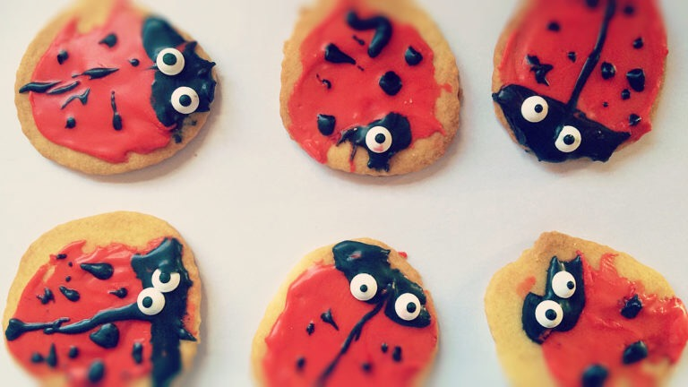

Years 3 &4
Ash Class made times tables flowers.
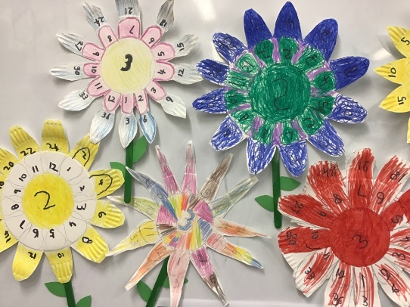

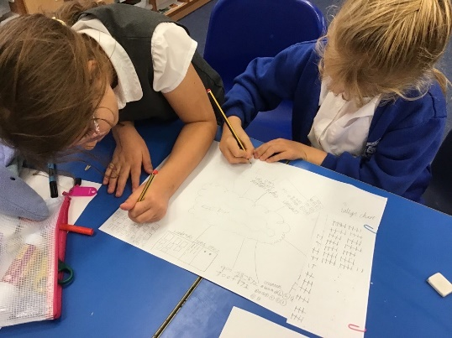
They also found lots of different ways to represent numbers of bones in chosen animals in Science…
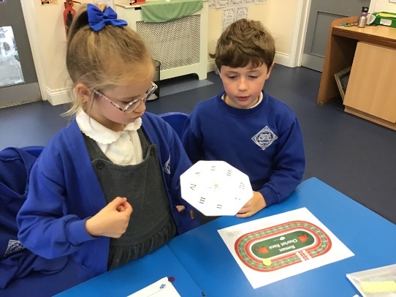
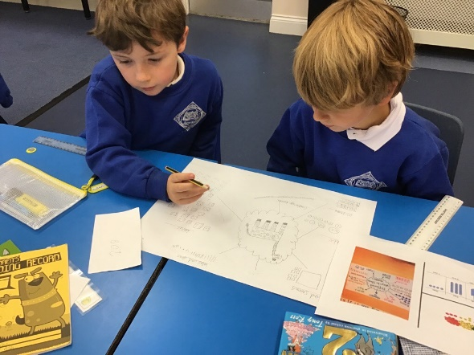
… and applied their knowledge of
Roman Numerals to play a Roman
Chariot Board game.

Years 5 & 6
Oak Class researched famous mathematicians, learnt about the Ancient Egyptian Number system and created art inspired by Ellsworth Kelly.
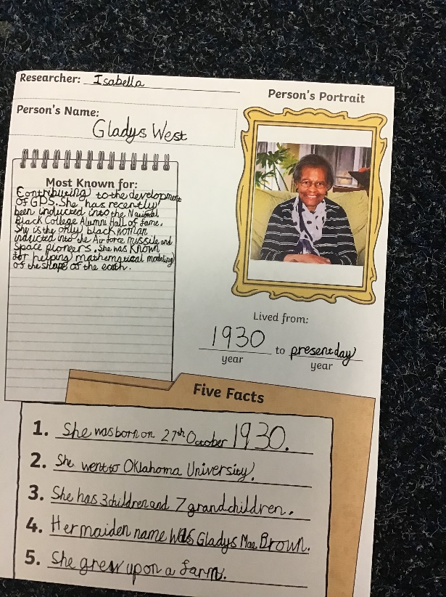
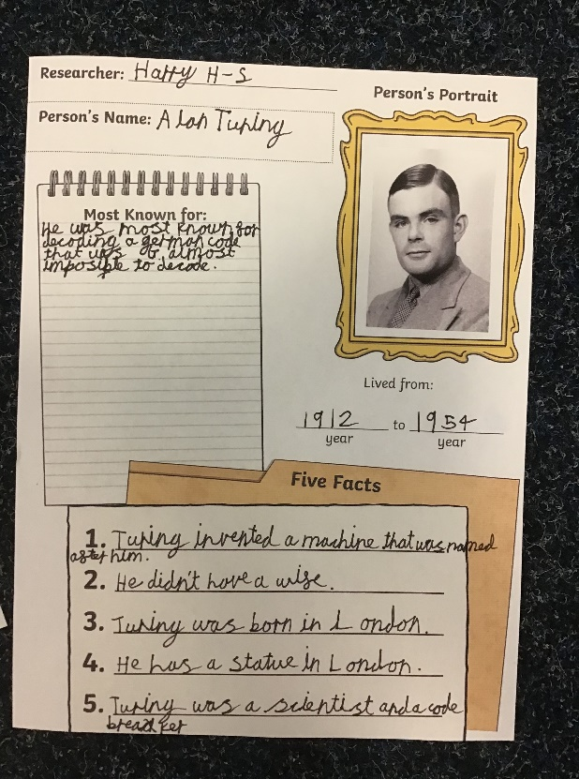

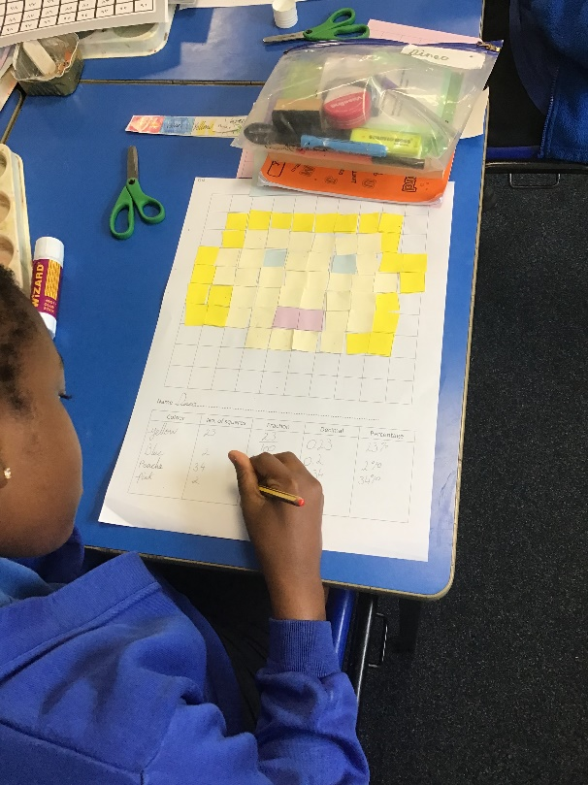
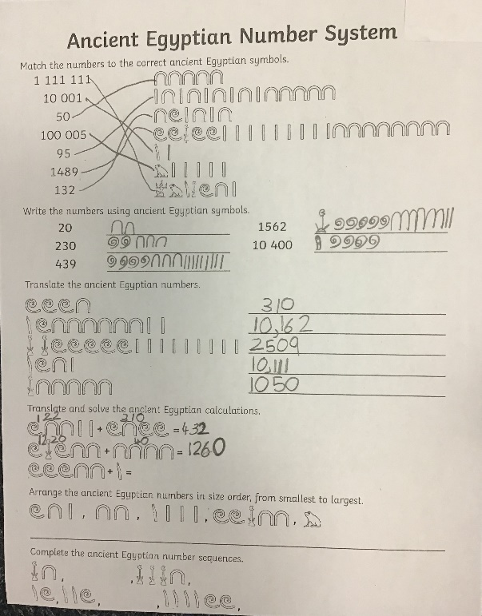

The children found out that they could apply a range of mathematical skills to different subjects they are learning during Maths across the Curriculum week.

