Whole School News Letter November 2023
It has been a busy start to the new school year and we have already taken part in the following enrichment activities:
‘We do more’
Boys football tournament Under 8’s Cross Country Race at Hadleigh Christmas Song recording at St Matthews Church with MAT pupils Butter Bear visit Weekly PAT dog visits MacMillan Coffee Morning Messy Church worship Rev. Geoffrey collective worship Harvest Festival at St. Peter’s Church FIND charity donations Police Officer visit PE Enrichment – Dodgeball morning
Coming up: Girls Football at Ipswich Town Owls Residential Trip Pantomime trip Science Dome
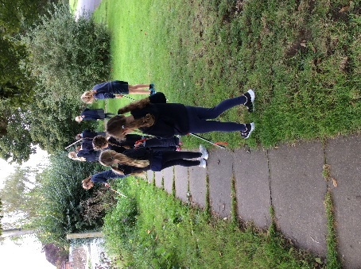
Eco Council
Litter pick October 2023
Eco Council did a litter pick around the school playground and community play area. We found all sorts of rubbish including plastic bottles, food wrappers and crisp packets which the children were amazed to note that people had not put in the bins.
Robins Class

What a very busy half term we had before the holidays.
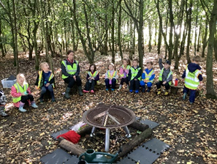
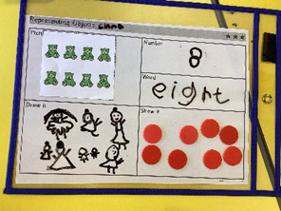
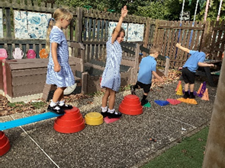

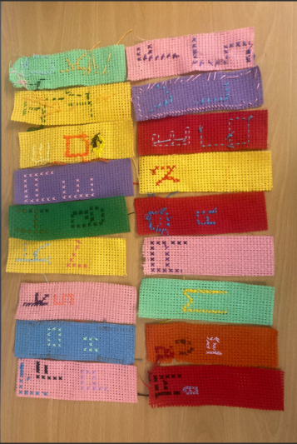
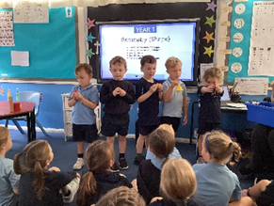
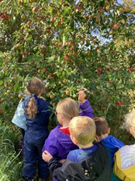
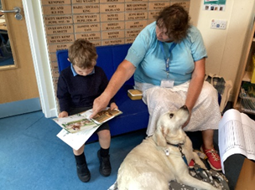
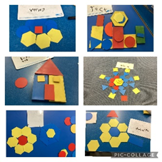
From Badgers

These bookmarks were our DT project from last term. We worked very hard to sew our initials on to them. Don’t they look amazing!

From Owls

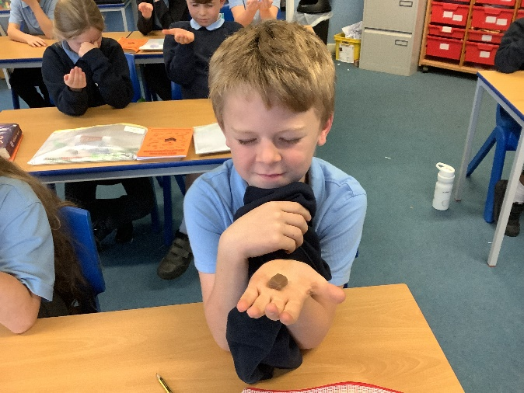
Our art work developed over a few sessions to create these wonderful prints.

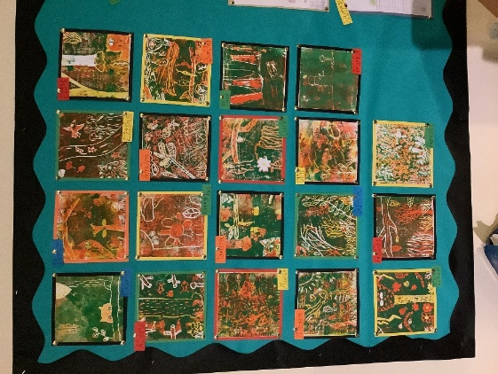

Maths in the Curriculum

Counting Ducks in the Outside Area
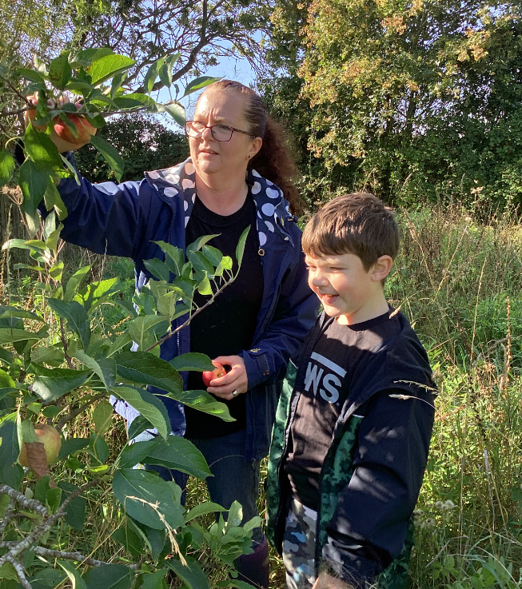
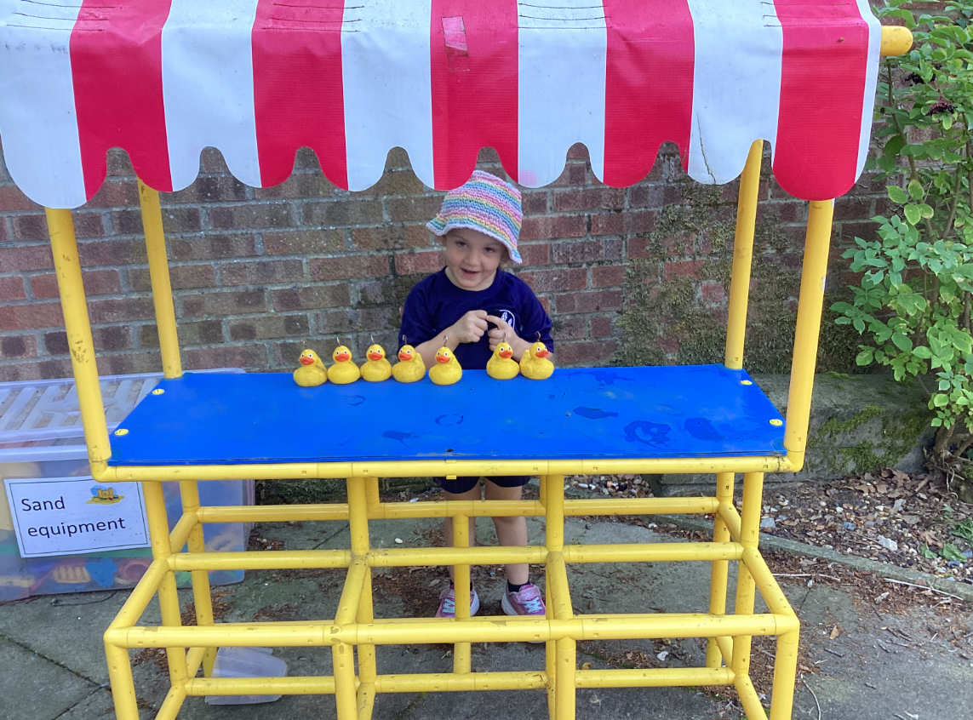

Counting in threes in continuous provision.

Counting apples in Forest school
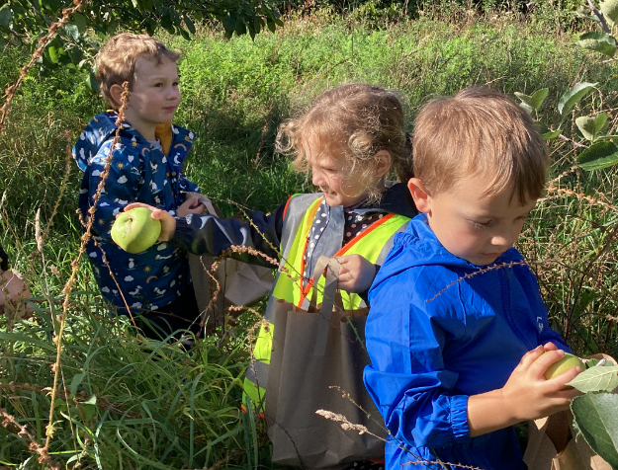

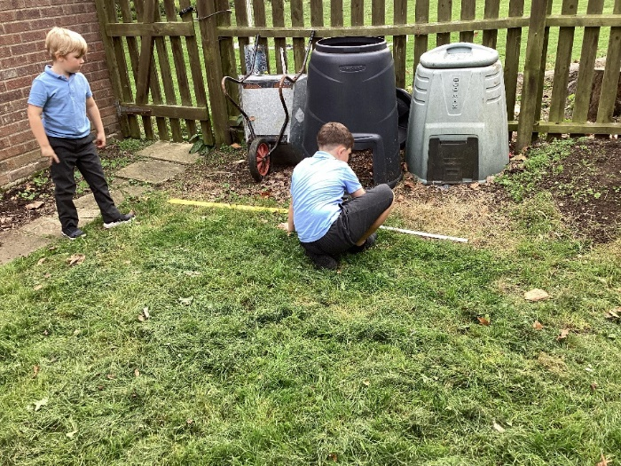

Measuring the Outside area so we know how many sleepers we need for our project.

