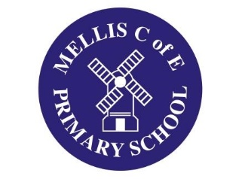
DMAT Website Article from Mellis CE Primary Spring Term 2023

Epiphany Door Blessings at Mellis!
A long standing tradition at Mellis has been for our Year 6 children to design and produce Epiphany door blessings! A tradition originating from parts of Italy, France and Spain, each year people chalk the letters ‘CMB’ and year above door frames to bring good luck to those inside! There is some contention as to the meaning of CMB; some hold it stands for Caspar, Melchior and Balthasar, a.k.a. the Three Wise Men while others say it is a Latin blessing – ‘Christus Mansionem Benedicat’ – or ‘Christ Bless this House’!
In either case, a lovely tradition that marks an important – and arguably overlooked – day in our calendar!
