News From St Mary’s School
As the weather has warmed up, there have been lots of things going on at St Mary’s! Eco Club have been busy creating a bug hotel for the school field. The children collected leaves, stones, pine cones and sticks. Our year 6 head boys and girls were really helpful with supervising the younger children and carrying the heavier items. Great job Eco Club!
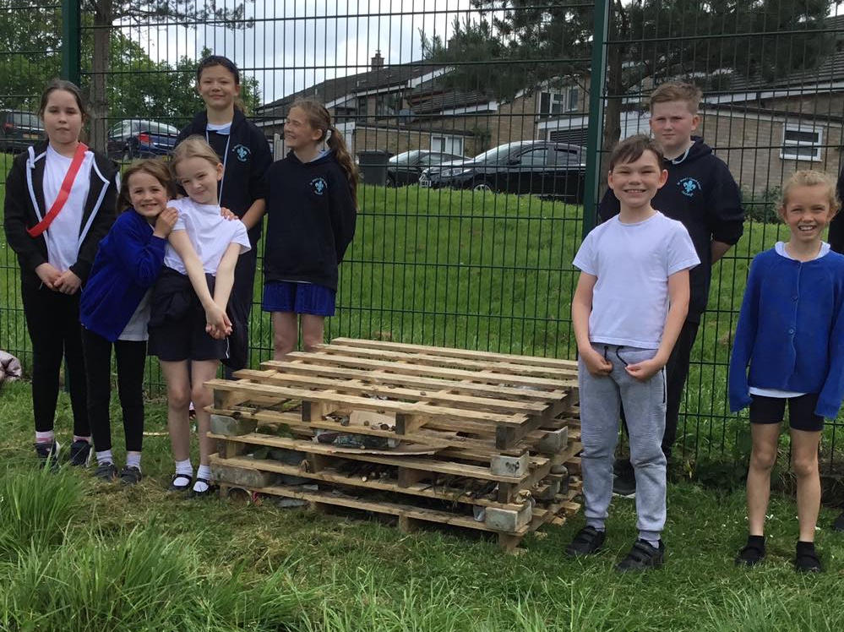
‘Discovery at the Deanery’ is our school in the woods and the children in the Early Years and Year 1 have been visiting regularly. They have enjoying a range of activities, including den building, “dandy” lion making, hammock swinging, ladder climbing, bow and arrow firing and wild flower planting. The children had a go at making ‘smell cocktails’ using things we found in the woods and some special ingredients from the herb garden and they had a cocktail party and cake to celebrate the birthday of our wonderful friend Grasshopper Girling! The children have been visited by a new friend, a very jumpy squirrel they named Steve.
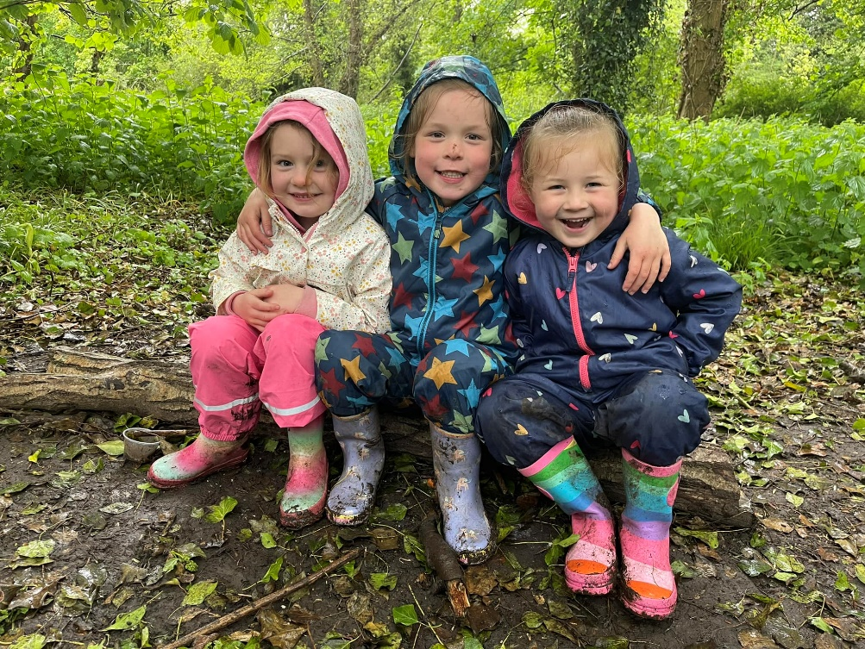
We had a fabulous afternoon in the education tent at the Hadleigh Show. Many thanks to all those involved in organising this huge community event. It was lovely to see so many people admiring the artwork from all the local children. Well done to all the children across St Mary’s School for getting two 3rd place awards and a 5th place award in the art competition. Mrs Coghill’s amazing forest animal masks were very popular! It was great to see lots of children walking around the Show with their animal masks on!

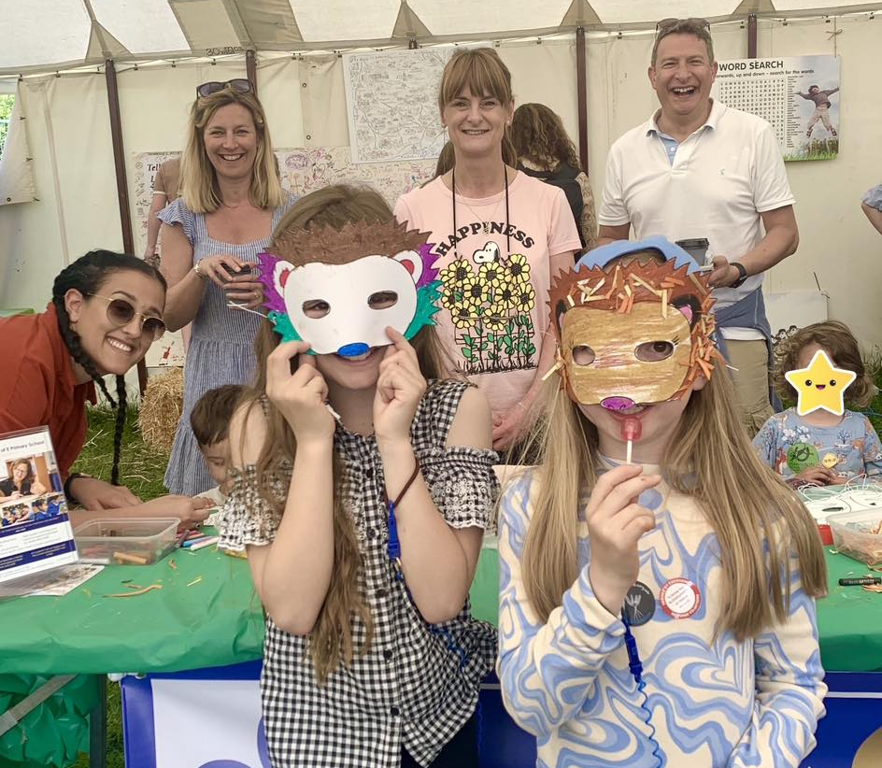

We had the pleasure of taking 6 energetic year 4 girls to a fun football festival at Ipswich Town football club! We had a great afternoon, full of smiles and lots of tackling! The girls’ attitude and teamwork were awesome and they are real role models for other pupils.
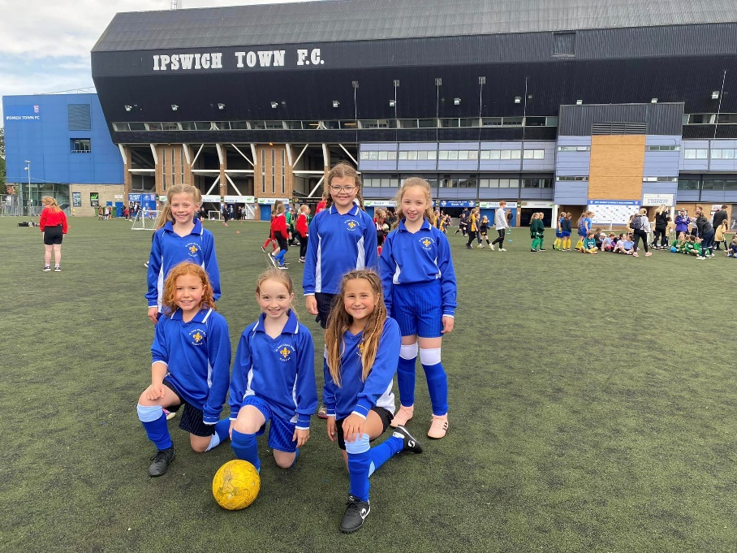
Well done to our amazing Year 6s for completing their SATs Week. The children have worked so hard in the lead up and have done themselves proud, trying their best and displaying a positive attitude. It was fantastic to all gather for some morning exercise and fun every day during the week. The children relaxed, smiled and supported each other while enjoying some extra breakfast in the sun. Many thanks to the Friends of St Mary’s School for funding the breakfast treats. Also, a huge thank you to Mrs Harvey for all her fun ideas and her energetic motivation alongside other helpful volunteers.
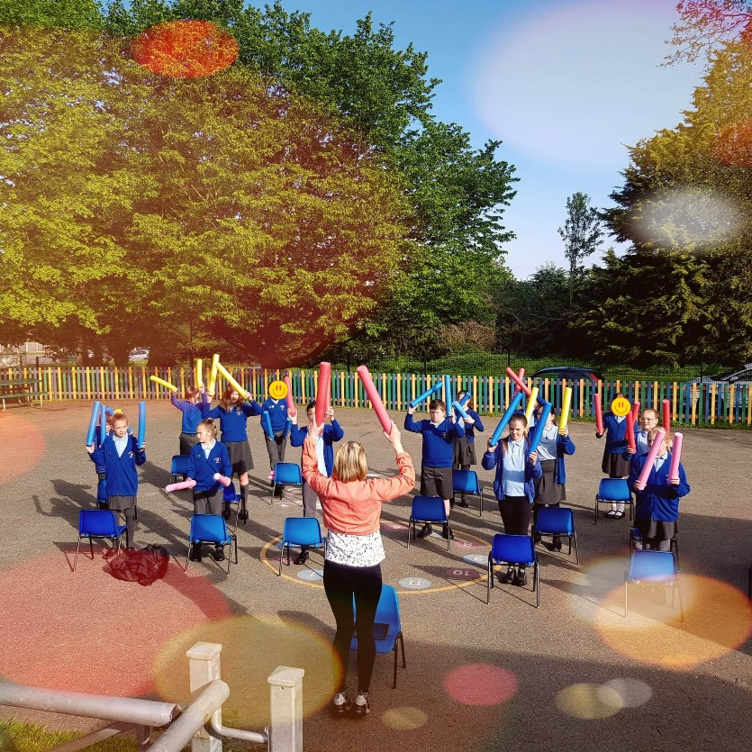
Today Year 3 and our Year 6 Heads and Deputy Heads went to Hadleigh Hall to celebrate a resident's 108th Birthday Celebration. The children sang Happy Birthday beautifully and presented birthday cards that the whole school had made. The children really made Bunny's afternoon, and the other residents we saw were thrilled to meet our pupils too! Bunny talked to the children about her life in the past, which was fascinating to find out about. All of our children were respectful and represented St Marys brilliantly; they should all feel very proud of themselves.
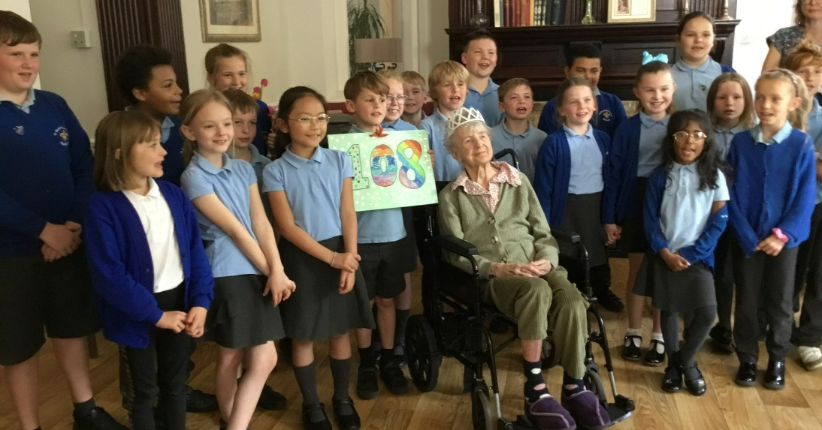
Nursery and Ash class made some new friends at Sydney Brown Court this week. We drew, iced biscuits and sang together! We had a lovely time and so did our new friends. The children will visit the residents again soon!
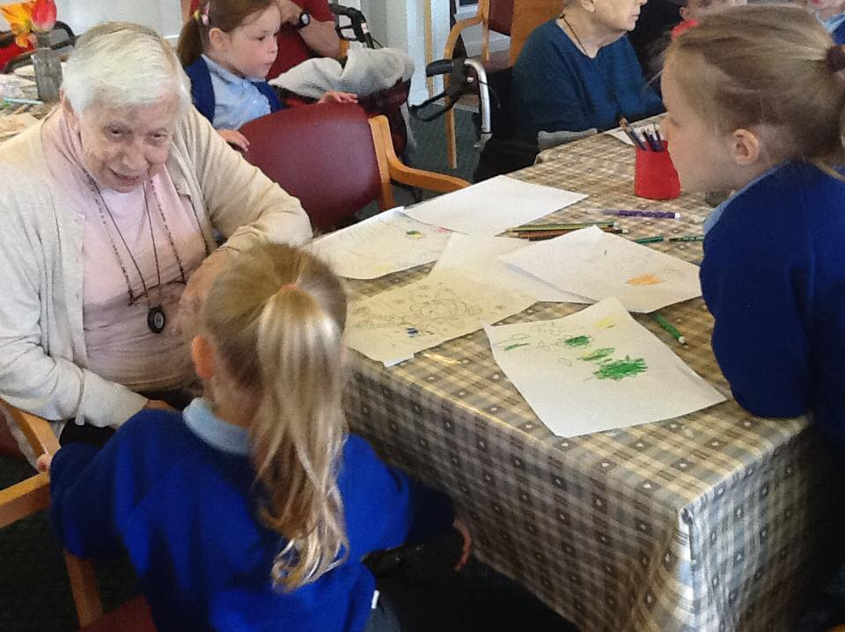
Our Coronation celebrations at school were really exciting! The children enjoyed a special day of biscuit decorating, hat making and cake! A special thank you to Mrs King for making our delicious cakes! Our whole-school picnic was disturbed by the weather but everyone gathered in the hall and had a lovely time.

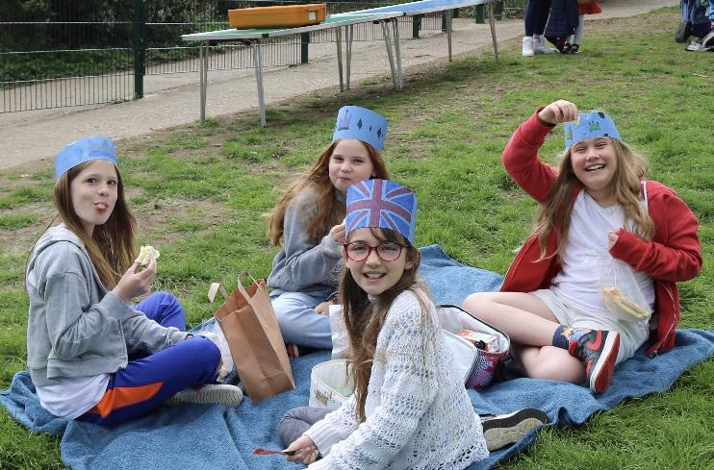
The whole of Key Stage 2 participated in our Spring Slam times tables competition over the course of a month. This involved 4 rounds of ever increasingly difficult times tables questions. The Grand Slam final saw 14 finalists complete a further 2 rounds for the titles of Grand Slam Champion. Congratulations to both our Lower Key Stage 2 and Upper Key Stage 2 champions. They were so speedy with their times tables and it was a magnificent achievement.
Year 4 really enjoyed their visit to Hadleigh Library. They enjoyed looking at the books and more children now have a library card that they can use to borrow the lovely books on offer. The children were really polite and respectful of the library, the books and the librarians. Many thanks for the help from the librarians and the lovely welcome they gave us.
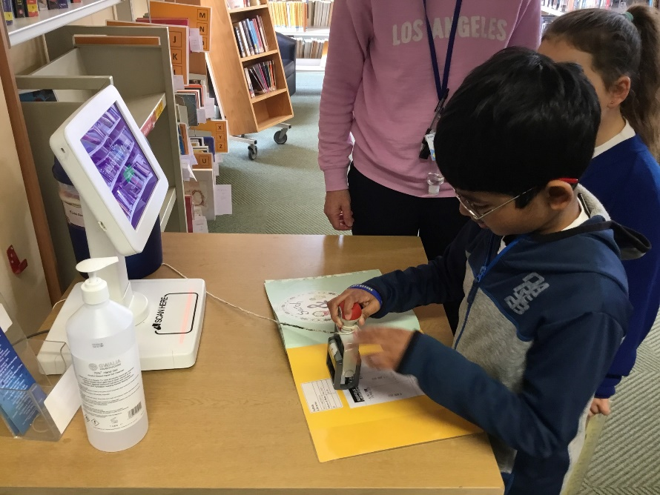
April is the month dedicated to Military Children. At St Mary's, we showed our support for Military Children throughout April and dedicated Friday 21st April as a dress down day. We encourage the children to come to school wearing something purple, as this is the colour of the "Military Child", and we raised money for SSAFA, who provide vital support to military personnel and their families. We were also very lucky to have two visitors – WO2 Mills and Lance Corporal Fisher, who conducted a special assembly for Military Child Month. The children enjoyed learning about different aspects of the military and watching their friends have a race getting into a special protective suit. We were also set a creative challenge to design an item for the soldiers in the Hacker Space at Wattisham Flying Station to make using their amazing 3D printers – it’s a great project to fire the children’s imaginations. Thank you to our visitors and to all the children for getting involved and celebrating Military Child Month!
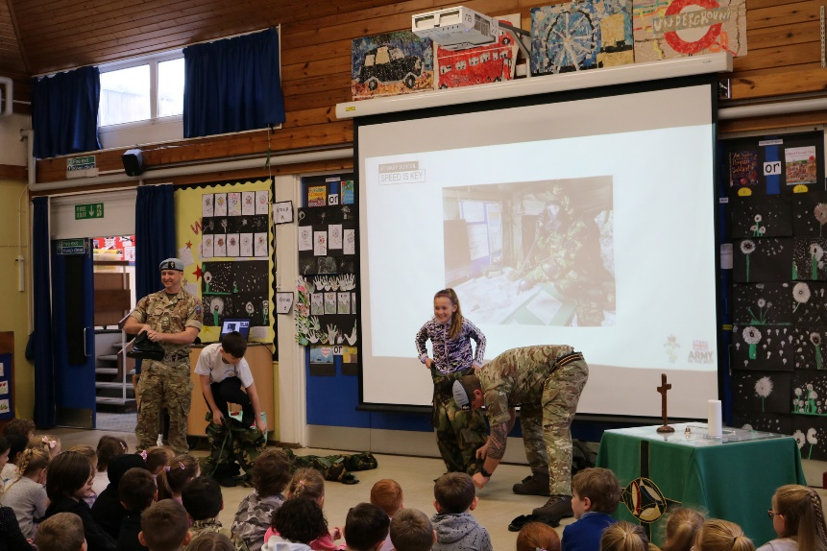
Twelve members of Chestnut class spent two days cycling around the roads in Hadleigh completing Bike-Ability! They all had a great time and enjoyed learning how to ride their bikes safely. From road safety to bicycle maintenance, this is a really valuable course. Many thanks to their amazing instructors and our staff cycling expert Mrs Morris for supporting them.
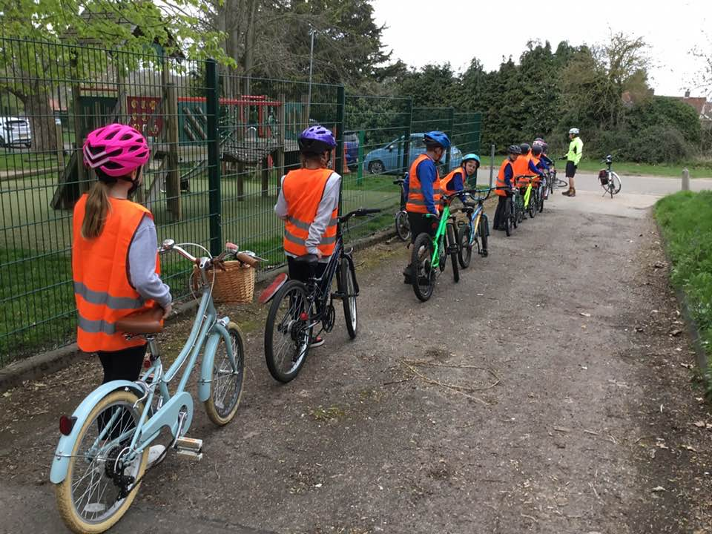
Our Code Club is now really well established. The children have been really engaged and are enjoying learning new skills. A huge thank-you to Mr Blows for showing the children how to begin coding a game using Scratch. It’s amazing to see what the children can achieve – the games and stories are really exciting to see. Soon the children will begin learning to code with Python as well.
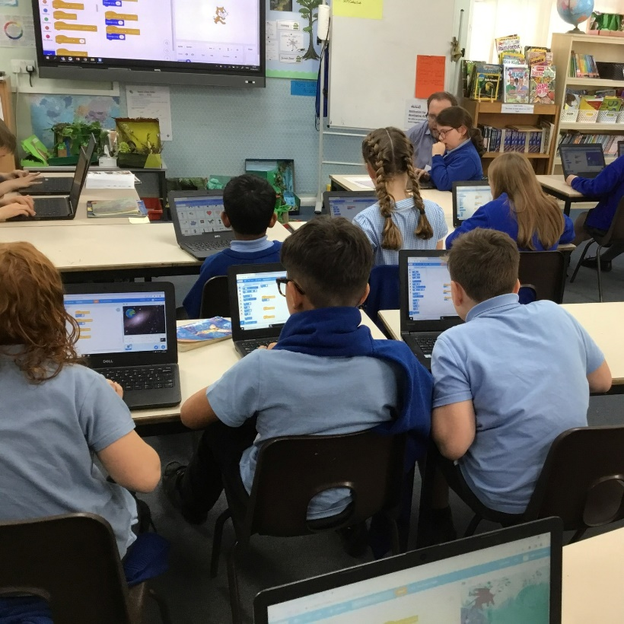
Help your child grow from ‘seedling’ to ‘sapling’ at our new toddler sessions!
Enjoy a chance to meet other parents with toddler aged children in a warm, relaxed and safe environment. Children can explore our nursery classroom and courtyard area; a place for messy play including sand and water and a fabulous mud kitchen!
We look forward to seeing you from 9:00am – 10:00am and 2:30pm – 3:15pm on Mondays to Thursdays. Please contact the school for further information.

