**News from Stoke by Nayland C of E Primary School**

Stoke By Nayland celebrated the Kings Coronation with a party for the whole school organised by our lovely parents.

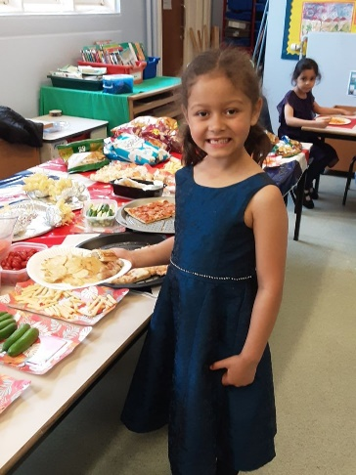

The children also learnt how to Maypole dance and then joined the Village Celebrations to show everyone their skills over the Coronation weekend.   During the party the children got to play lots of party games and learnt about different parts of the Coronation ritual.

