News from Stoke By Nayland C of E Primary School

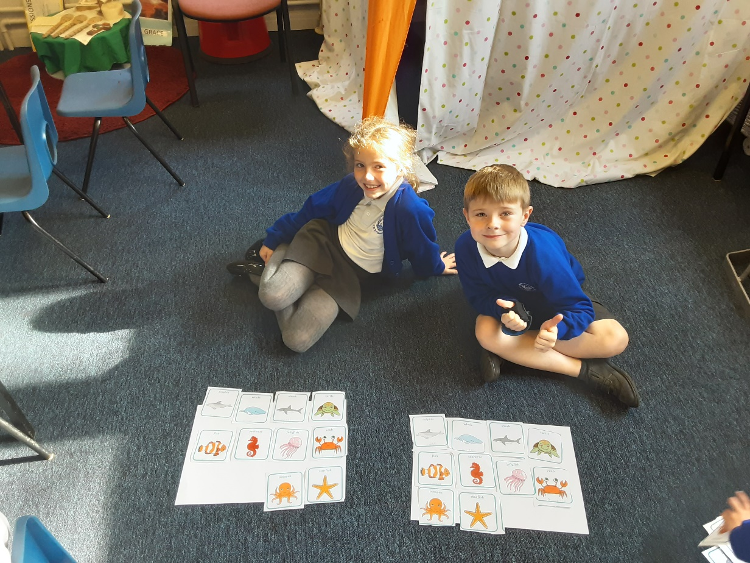

We have been developing our confidence in using and applying our maths this term and had a very exciting day using the film Finding Nemo. During the day the children investigated different maths problems including symmetry, reflection and position. They ordered numbers up to 10000 and explored the concept of greater than and less than. EYFS and Key Stage 1 focused on counting fish and maths stories. They also explored repeating patterns made of fish and cooked fish shaped biscuits. The children enjoyed measuring and mixing and some of the older children also increased the quantities in the recipe to make more.

