**Article for the website**

**Tudor CE Primary School**

**Fish Display.**

This term every child in school has decorated and produced their own fish for our new entrance display. This has taken inspiration from the book ‘Only One You’. The message of this book is that ‘There is Only One You’ so go out and make the world a better place’.

We hope you enjoy seeing our new display and appreciate the message it conveys.

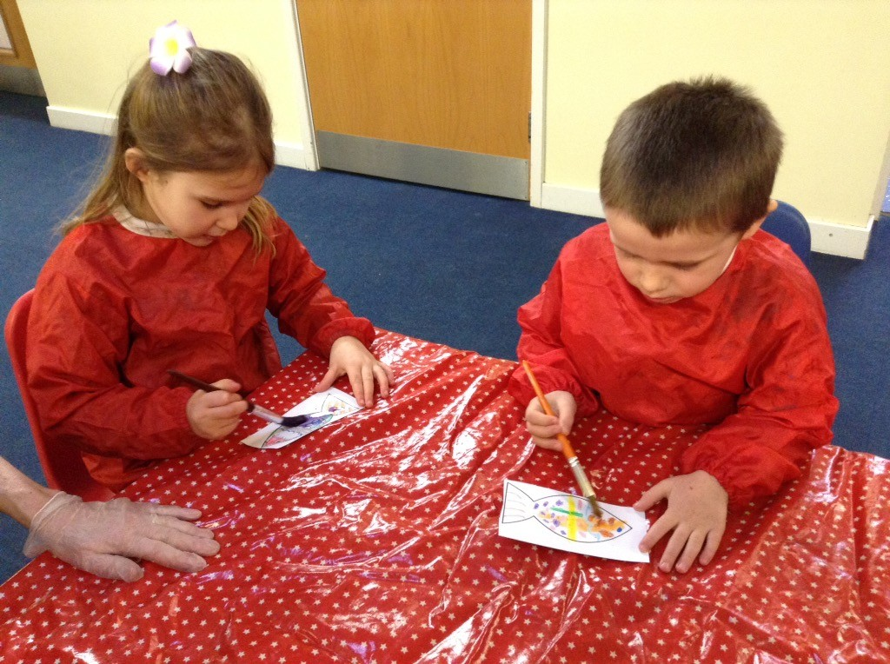

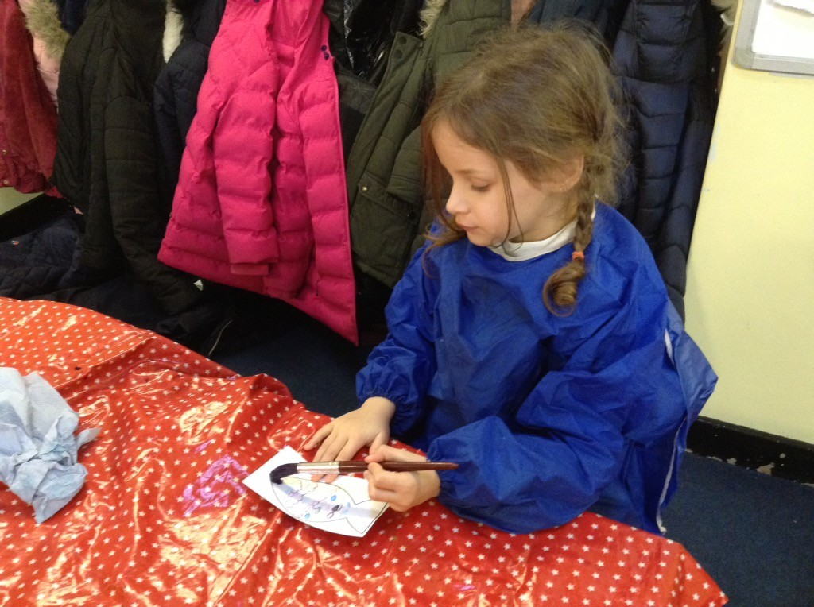

This is the finished display!

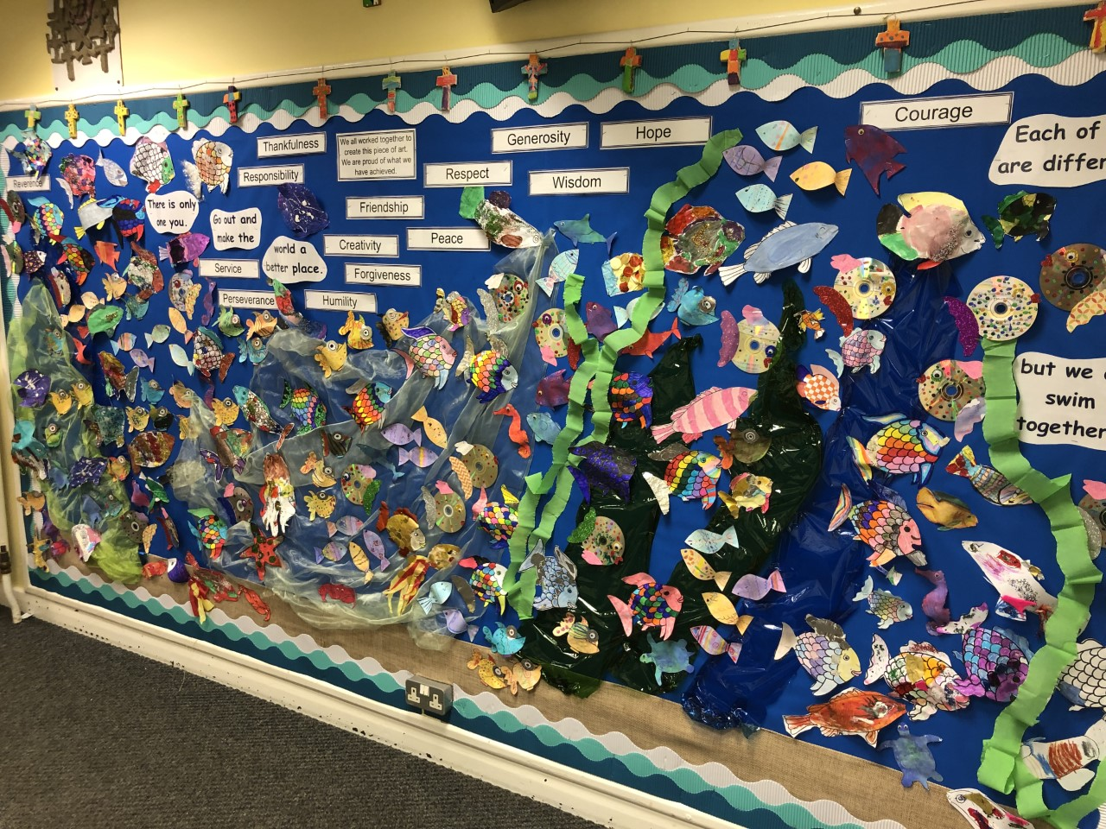

**Welcome to Tudor CE Primary School’s Newsletter.**

We hope you enjoy seeing and reading all the many activities that have taken place so far this term at Tudor CE Primary School in Sudbury.

It has been really busy and the children have enjoyed so many different opportunities.



**New Technology.**

Over the Christmas break every classroom has had a new screen installed in their room. This is for the teacher to use in their teaching but it is also interactive so the children can use them too.

We are very grateful for them and have already put them all to great use.

Many thanks to Mrs Crane for organising these for us! There is even a new screen in the hall so you will all see it when you are next in for an event.

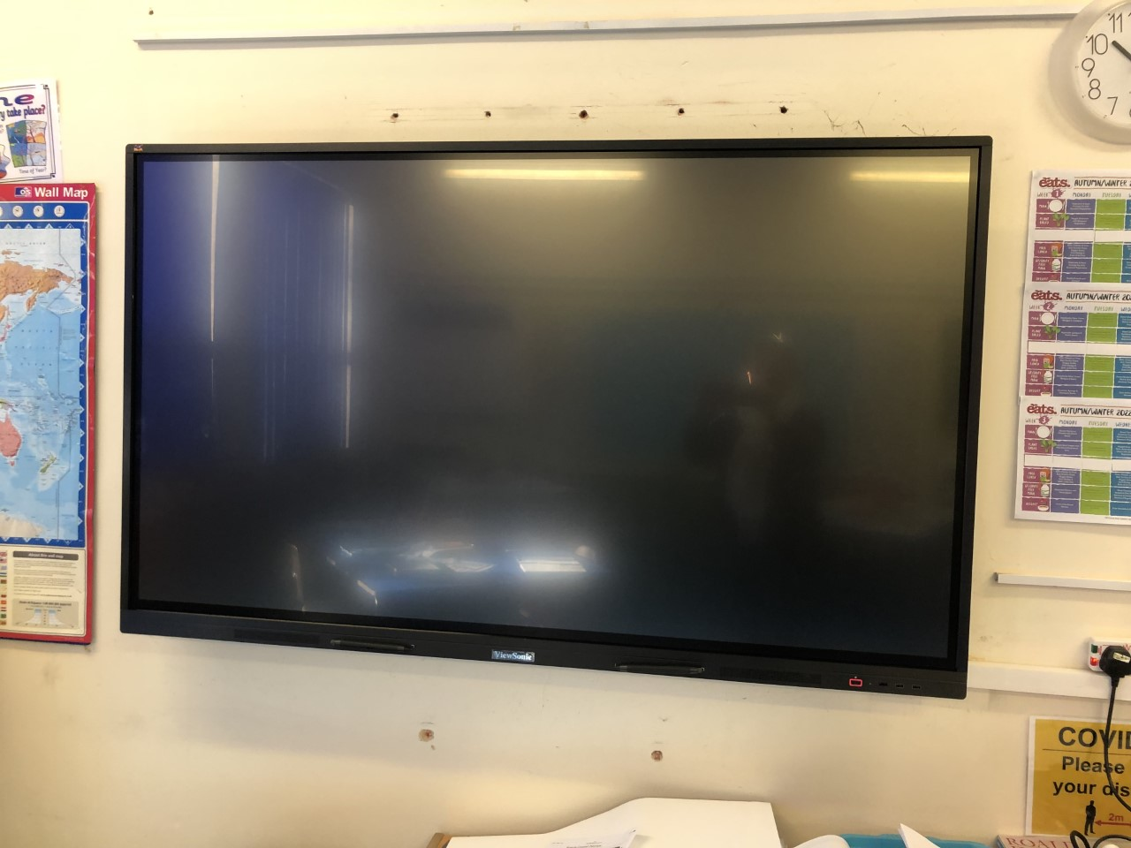

**A Huge Thank You!!**

The members of the Friends of Tudor group were extremely busy over the half term completely renovating the pond area. They used some of the funds raised so far from all the events and have transformed this area for the children.

We cannot say how grateful we are for all their hard work! The children have enjoyed seeing the new pond.

I am sure you will all agree how great it looks. We look forward to the frogs and other wildlife in the pond.

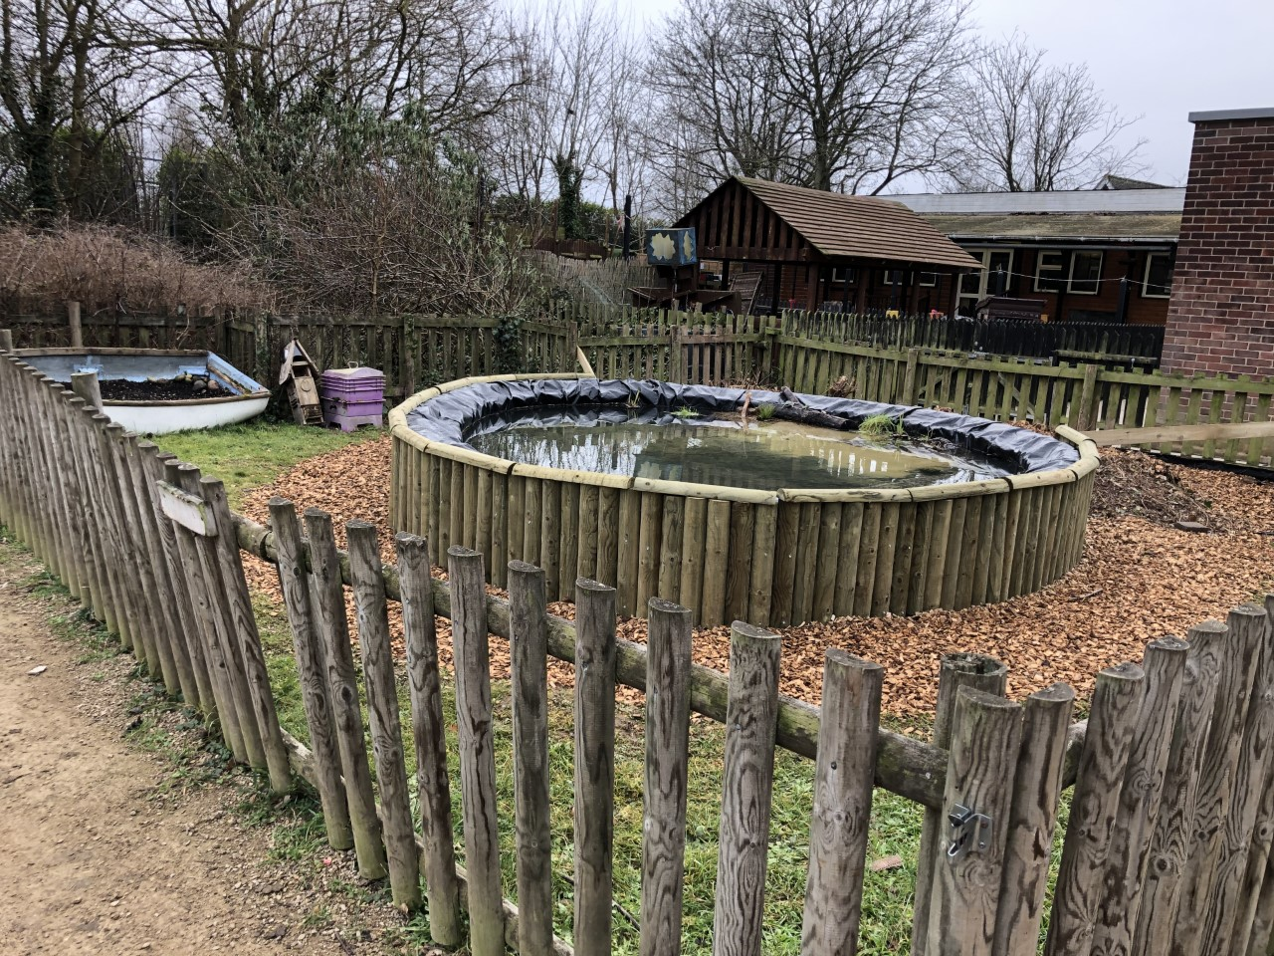

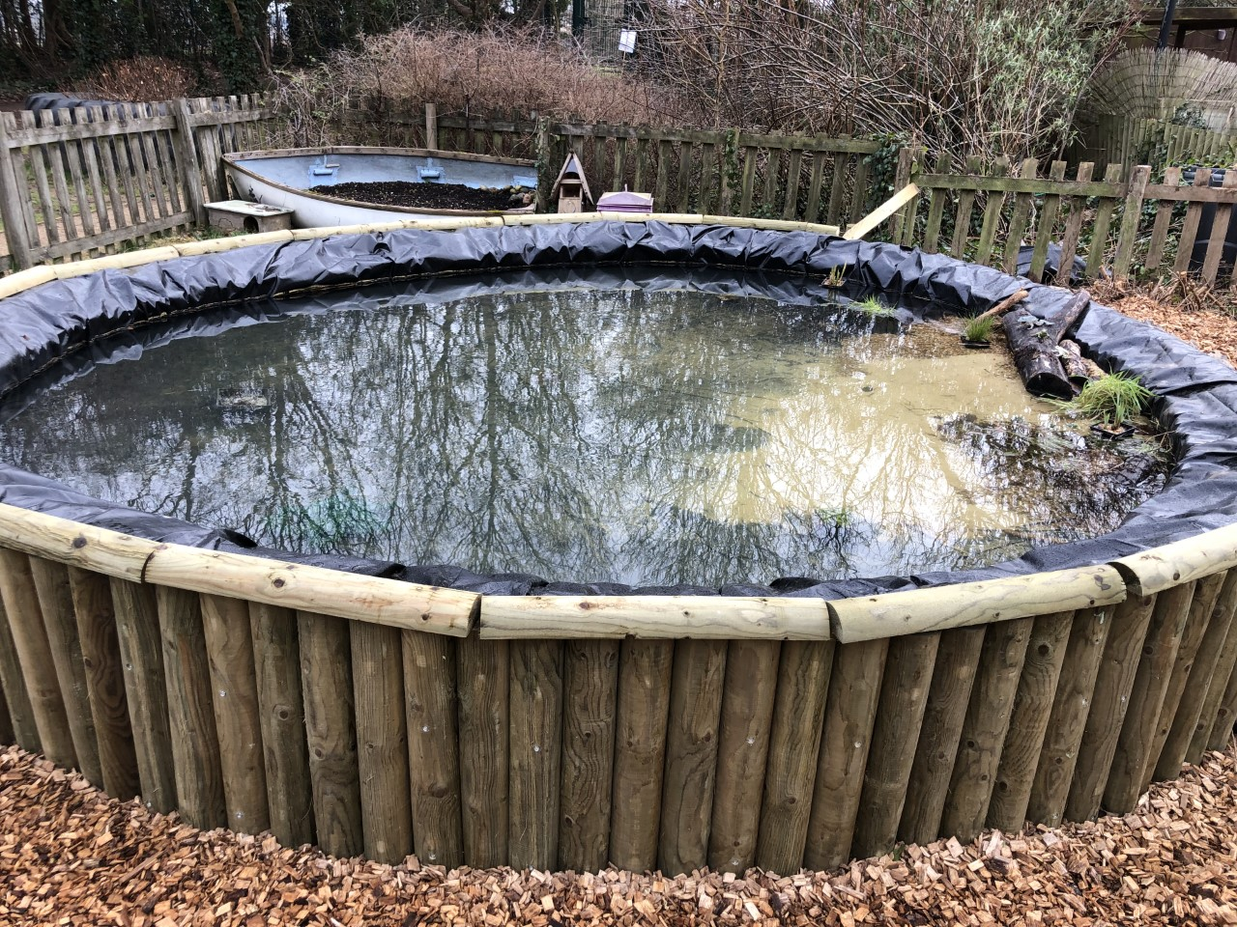

**The Boy, the Mole, the Fox and the Horse.**

The children enjoyed a day off timetable this term thinking about the messages from this book and film. They also enjoyed creating some beautiful art work.

Each class took a slightly different focus.

It was great therapy for the children to think about kindness, courage and bravery and friendship and love.

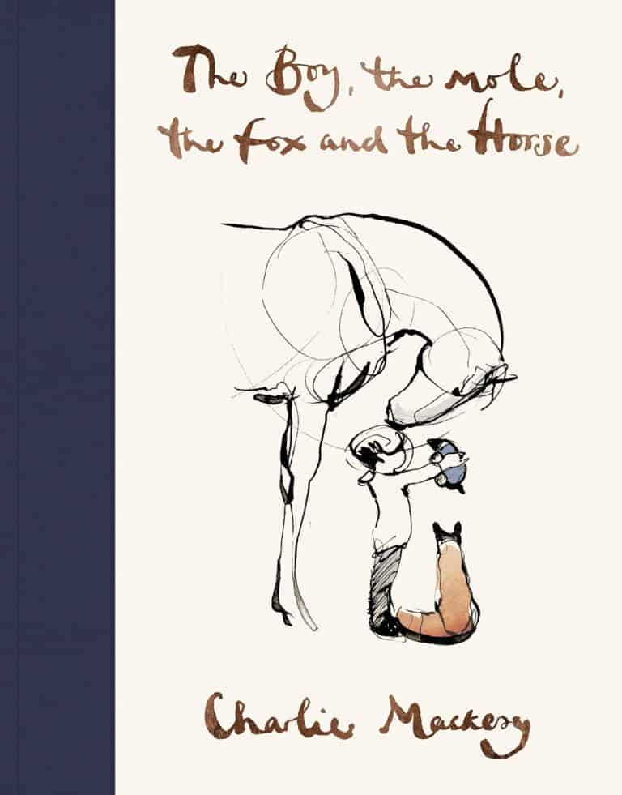

If you haven’t had chance to see the film or read the book I thoroughly recommend it to you all.

**UKS2.**

The children had great fun doing some marbling as the cover for their sketchbook.

Here are some of them.

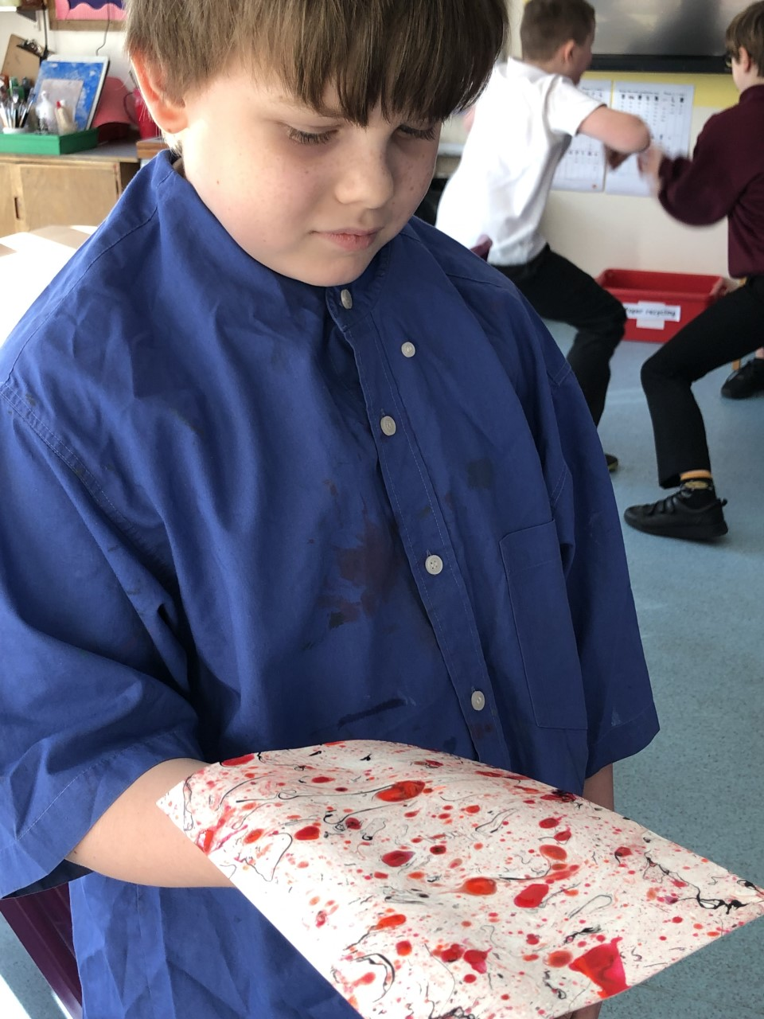

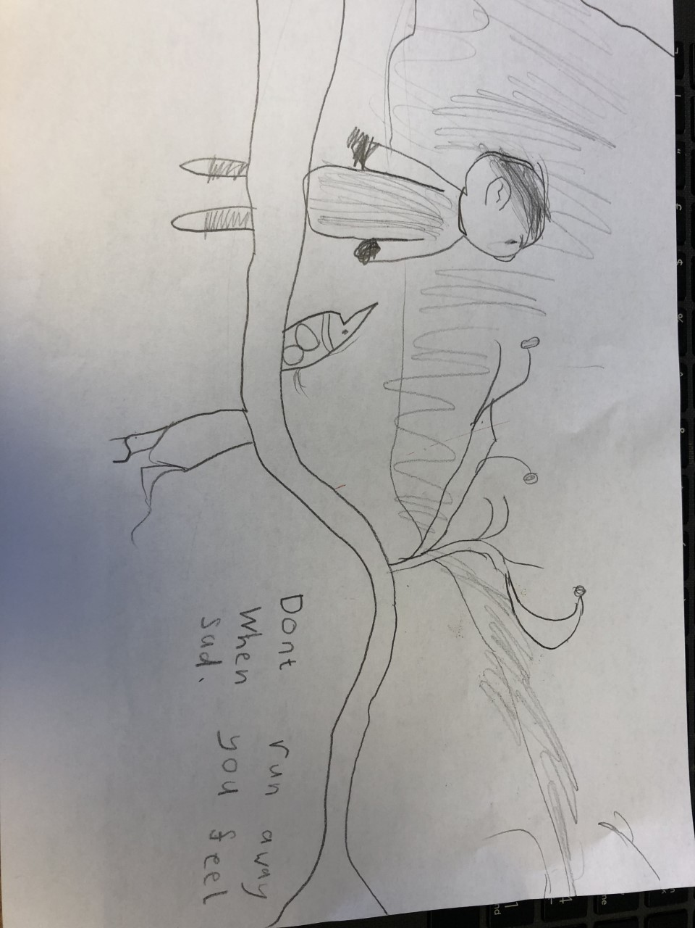

**EYFS.**

The children thought about kindness and created some beautiful hearts with their acts of kindness inside.

I am sure you will be impressed by their thoughtfulness.

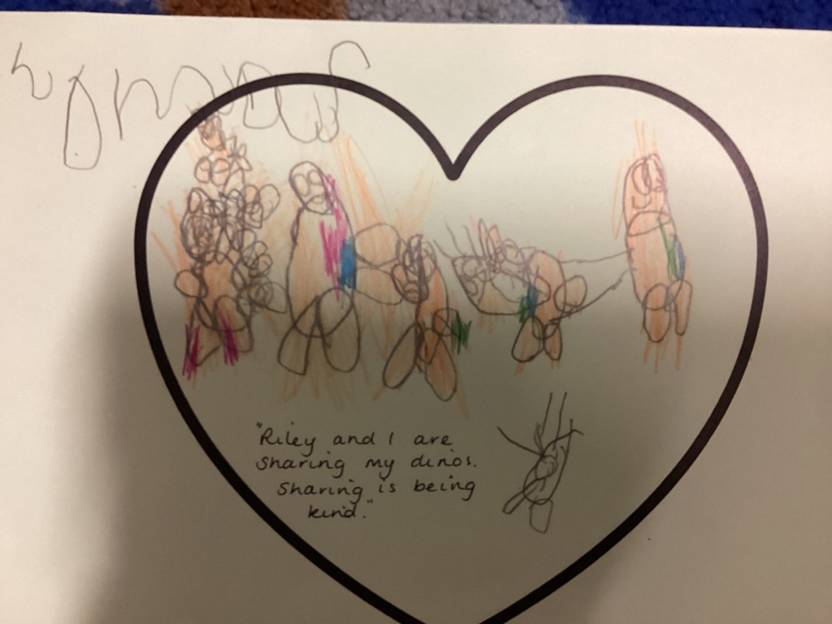

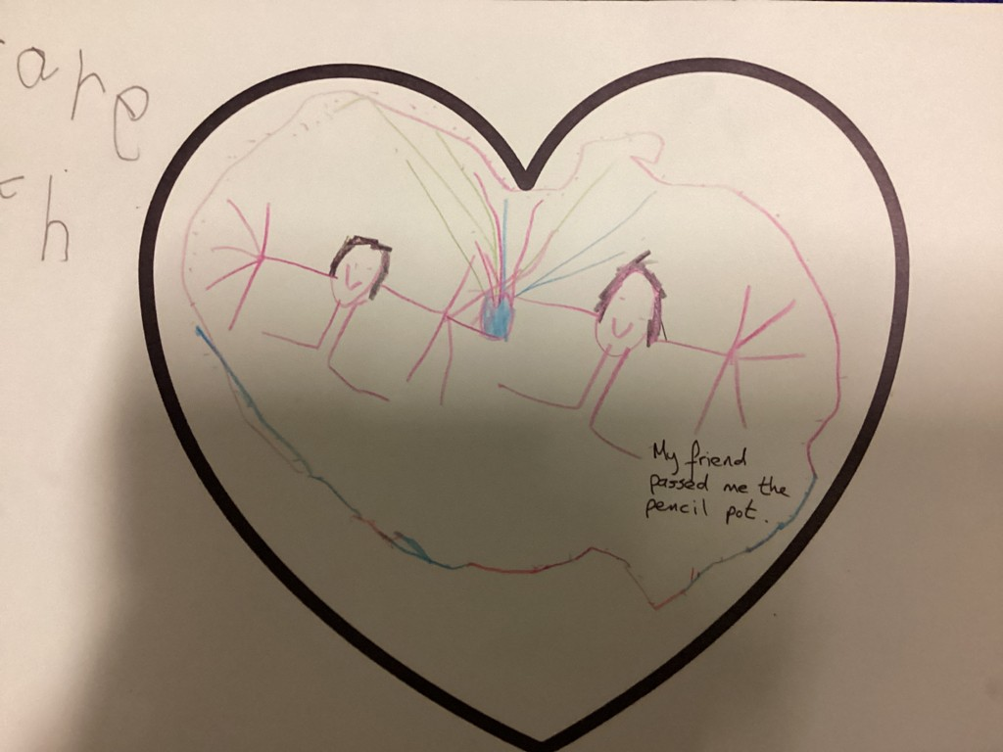

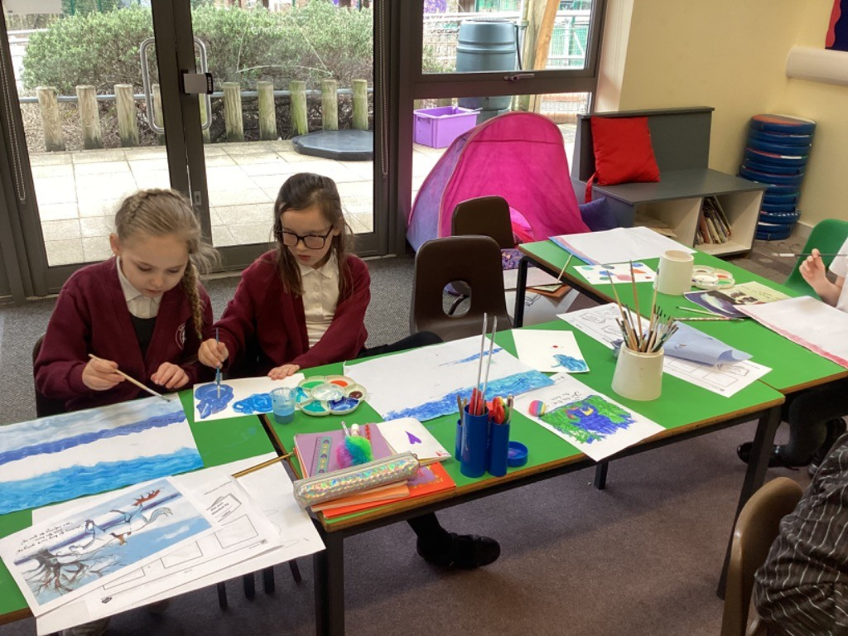

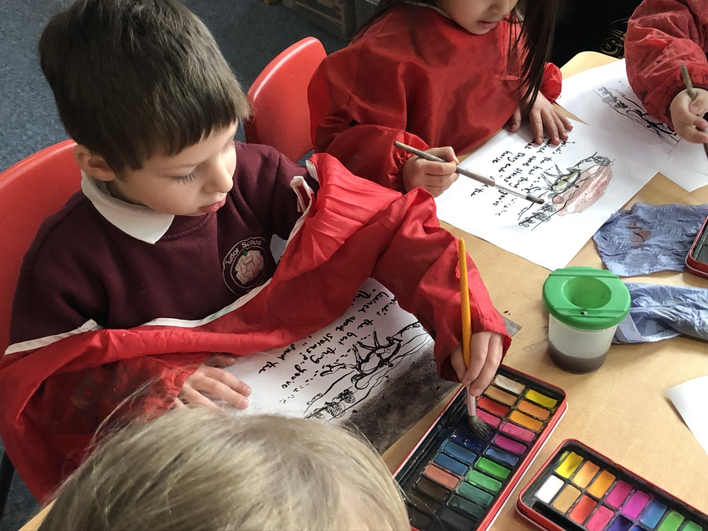

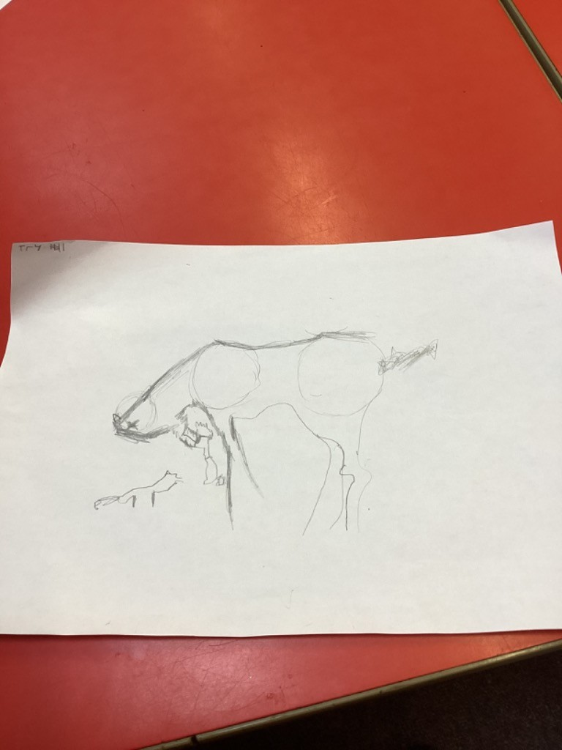

**Key Stage 1.**

The children had a great day thinking about their own inspirational quotes and of course drawing and painting.

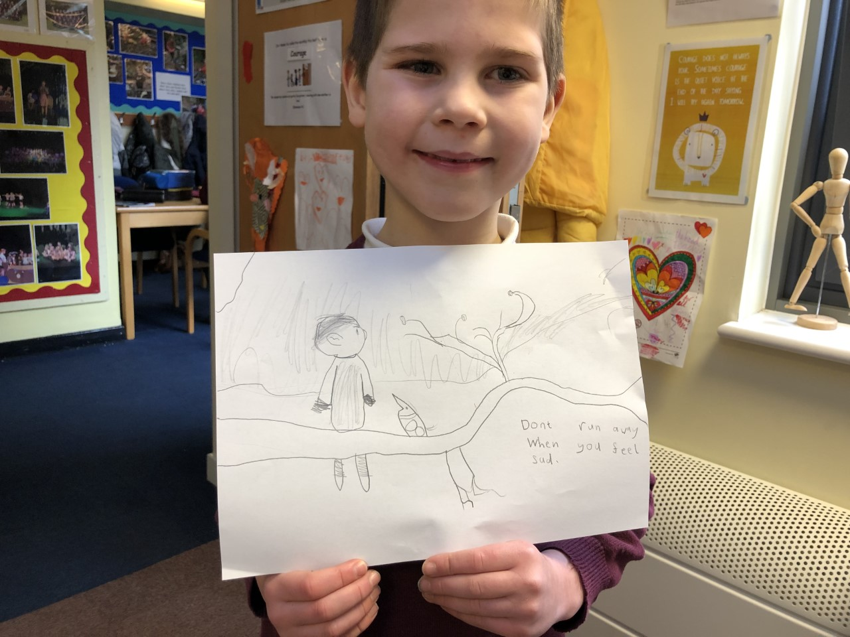

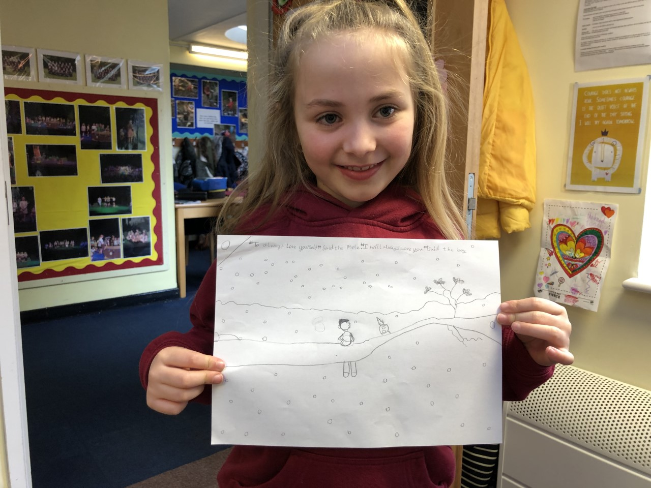

**Tudor Football Team.**

The Tudor team are back!!

We are enjoying matches on a Friday after school. So far we have played 2 matches. We won one and lost the other one.

We were very proud of all our players who played skilfully, energetically and fairly.

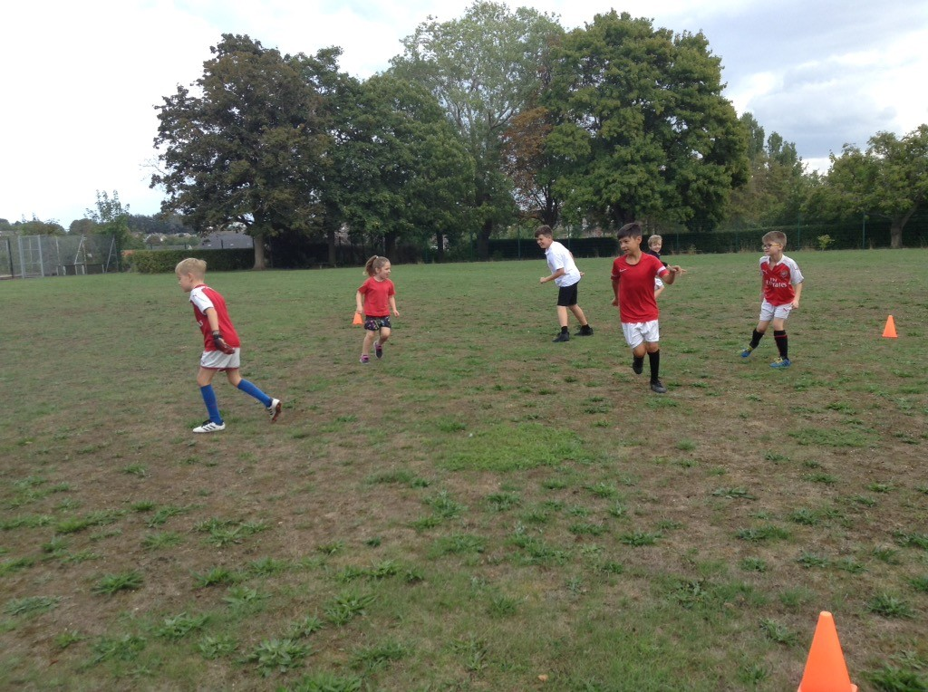

Reflective Area Prayers.

The reflective area at Tudor often is a place of quiet thought and prayerfulness.

In response to the Turkish disaster we asked the children if they would like to write some prayers.

Here are a few. They were very thoughtful.

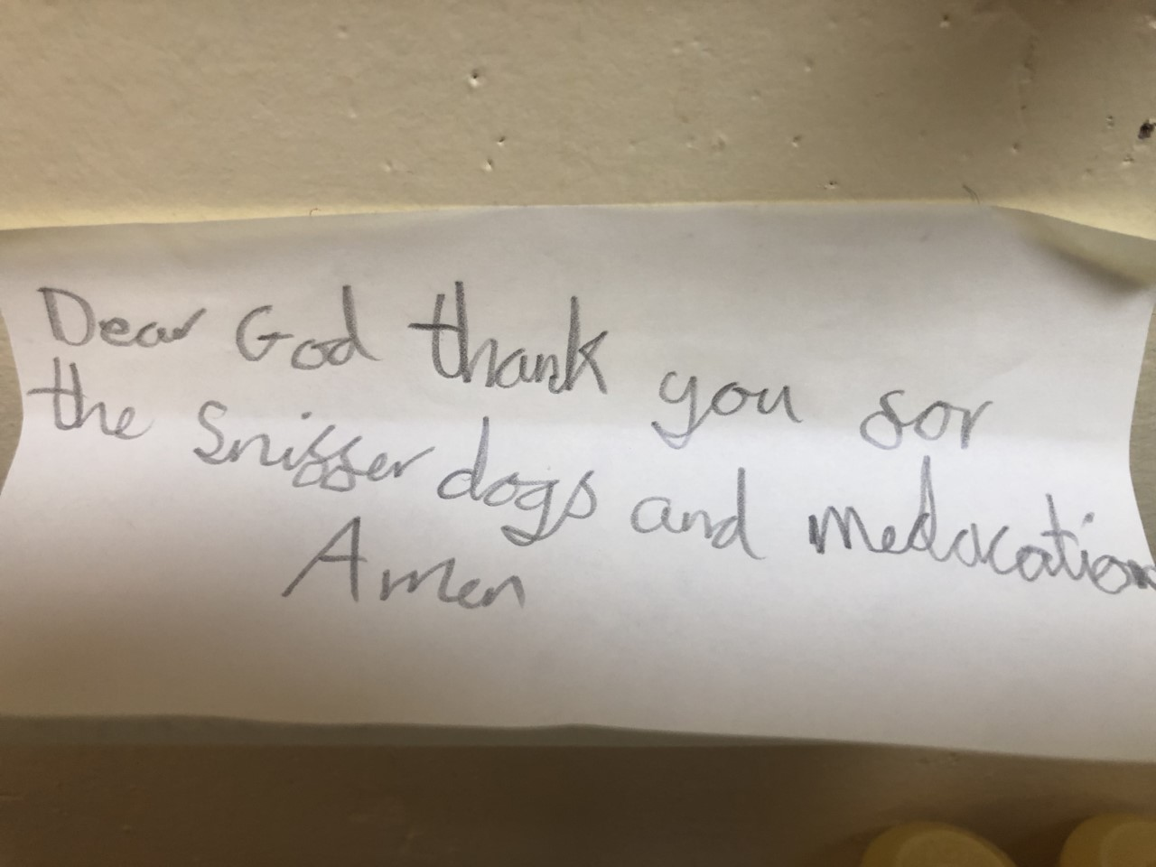

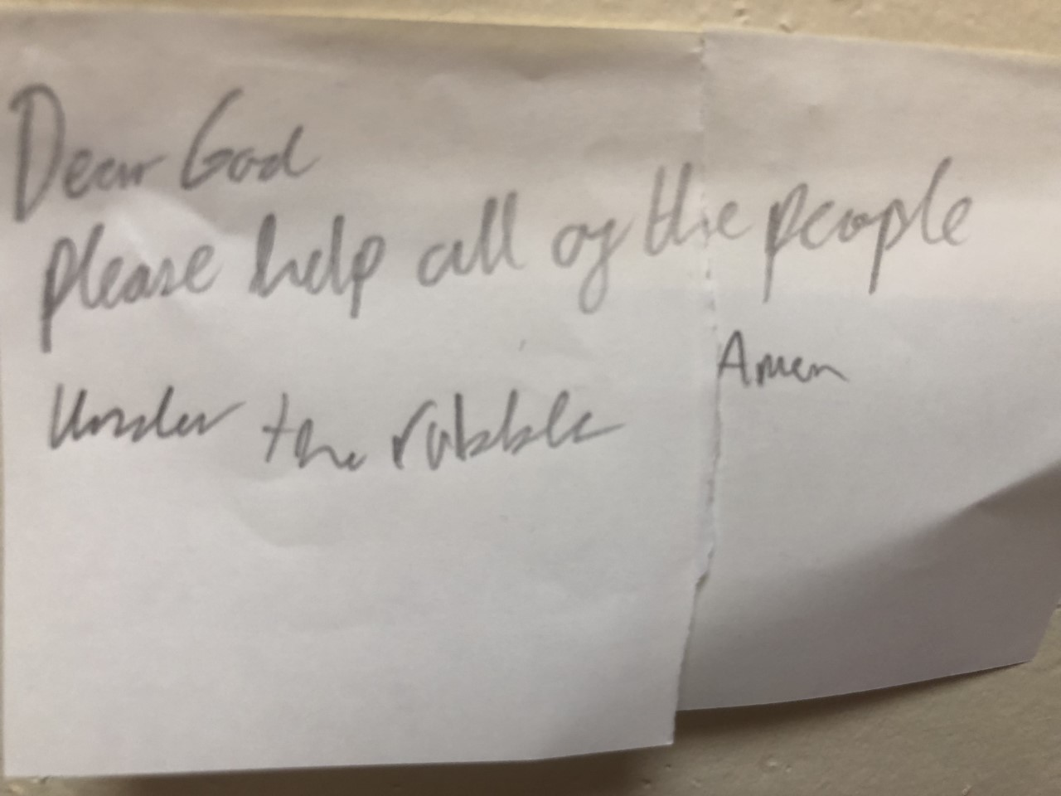

**Huge Congratulations!**

Some of our children asked if they could help raise money for the Turkey Disaster relief.

Asli, Millie and Sophia worked really hard organising a Teddy Bear’s Picnic for the last afternoon before the half term.

We raised an enormous £600.

This will go to the Red Cross appeal.

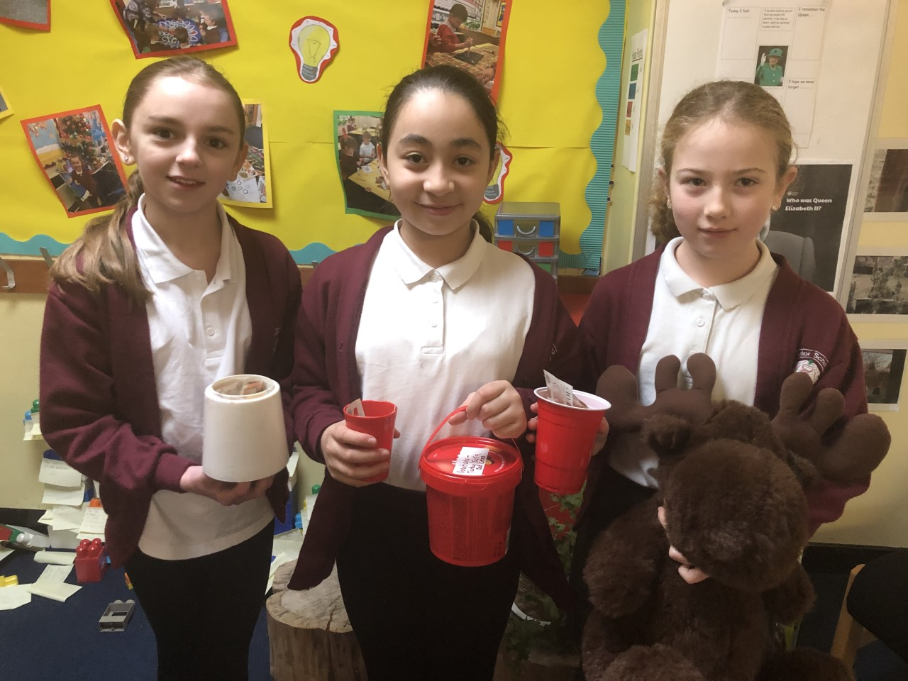

We had huge donations of cake also from our wonderful parents!

**Reading Bingo stars!**

Some children have completed their reading Bingo challenge.

Congratulations to Thomas and Annabelle.

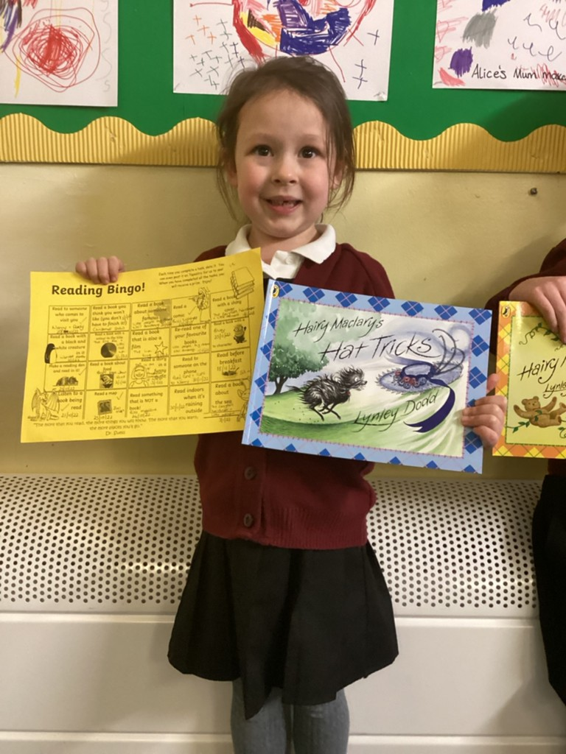

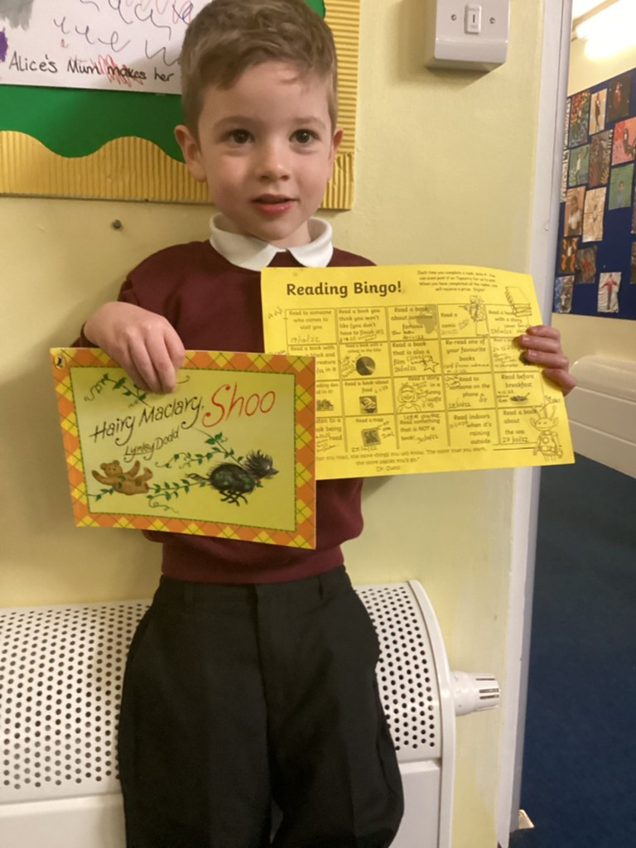

**Huge Congratulations.**

We have to congratulate Izzy, Brooke, Oscar and Fred on their amazing cake sale last Friday.

They were raising money for the Seesaw animal rescue centre and managed to raise a wonderful total of £200. This is great news and I am certain the centre will be very grateful for their efforts.

Thanks also to everyone who came and supported this event.

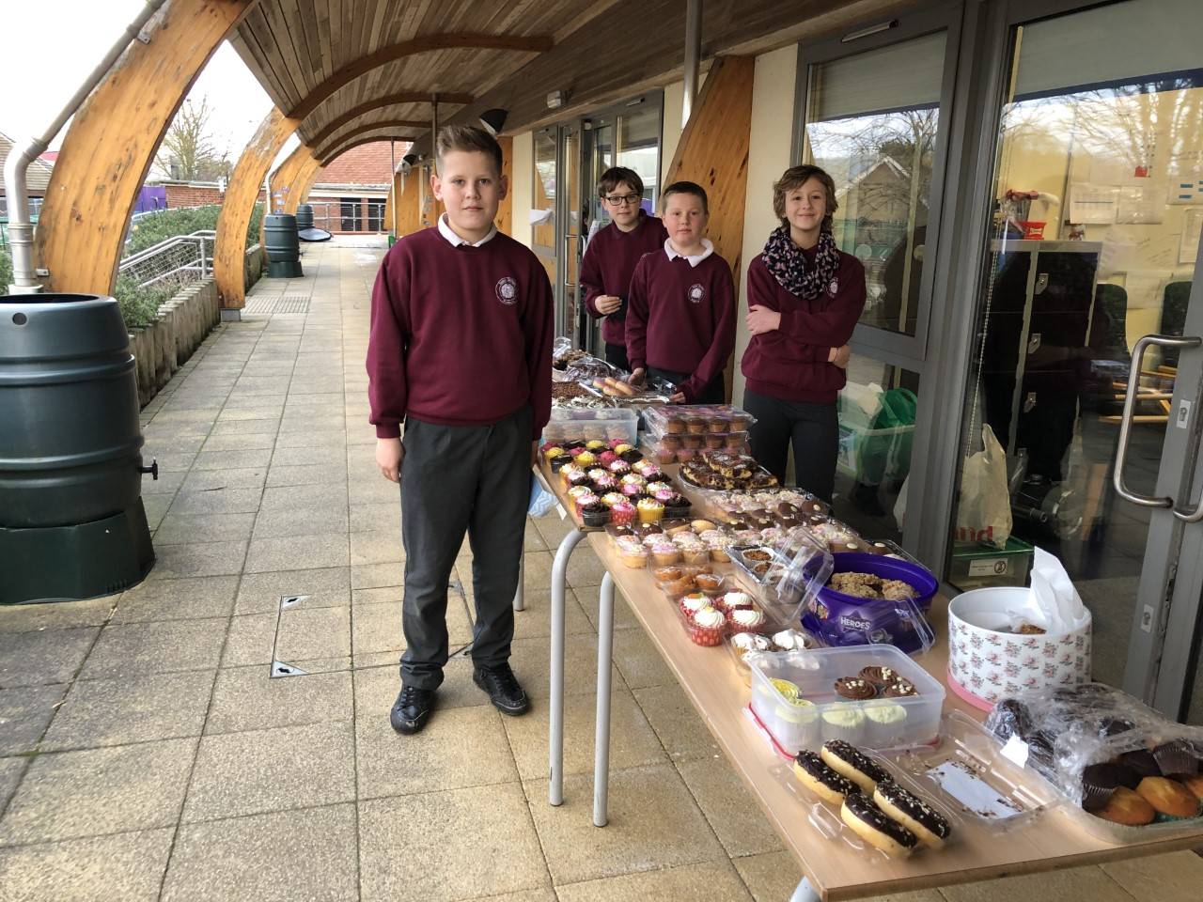

**Hengrave class.**

The children in Hengrave class and Hardwick class watched a short animation about Austin’s Butterfyl which teaches the lesson of continued imporovement and never giving up and settling. The children then set about drawing one of the characters from the story, the horse. They produced some excellent drawings and didn’t give up and kept trying to improve them. I am sure you will agree they are excellent!

