**The Association of Bramfield, Brampton and Ringsfield Church of England Schools**

**Executive Headteacher: Mrs Victoria Allen**

**Head of Schools: Linda Ashford, Ali Thomas, Steven Jeal**

**Twinning of Brampton**

**Train Stations**

We started the project to twin Brampton train stations over a year ago. Tyne Valley Community Rail Partnership informed us that Brampton station in Cumbria (over 300 miles away) had been adopted by their local primary school: Lanercost C of E Primary School. They suggested that we could take part in a similar project in Suffolk. We were very keen and worked with the Chairman of East Suffolk Lines Community Partnership to create a banner at Brampton Station in Suffolk.

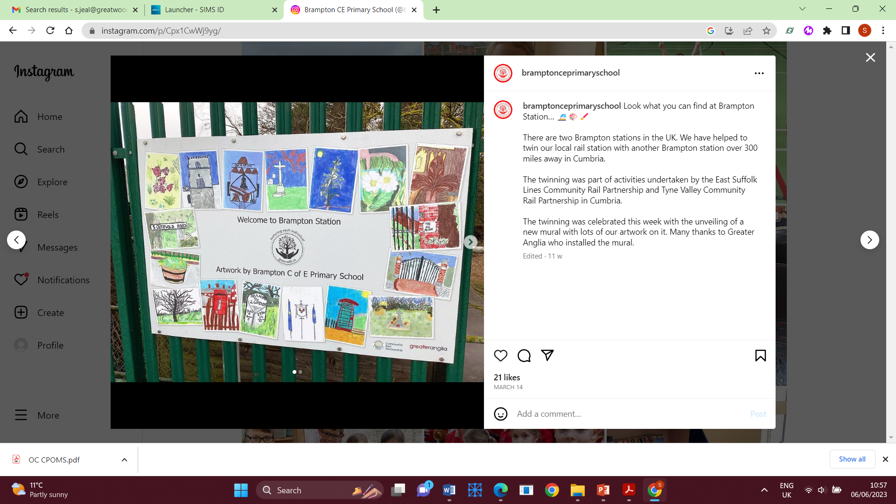

We wanted the banner to show the beauty of Brampton so we took the children on a local walk through Brampton and the children took photos with I-pads. Using the photos, the children worked collaboratively to create their own pictures to represent Brampton in Suffolk.

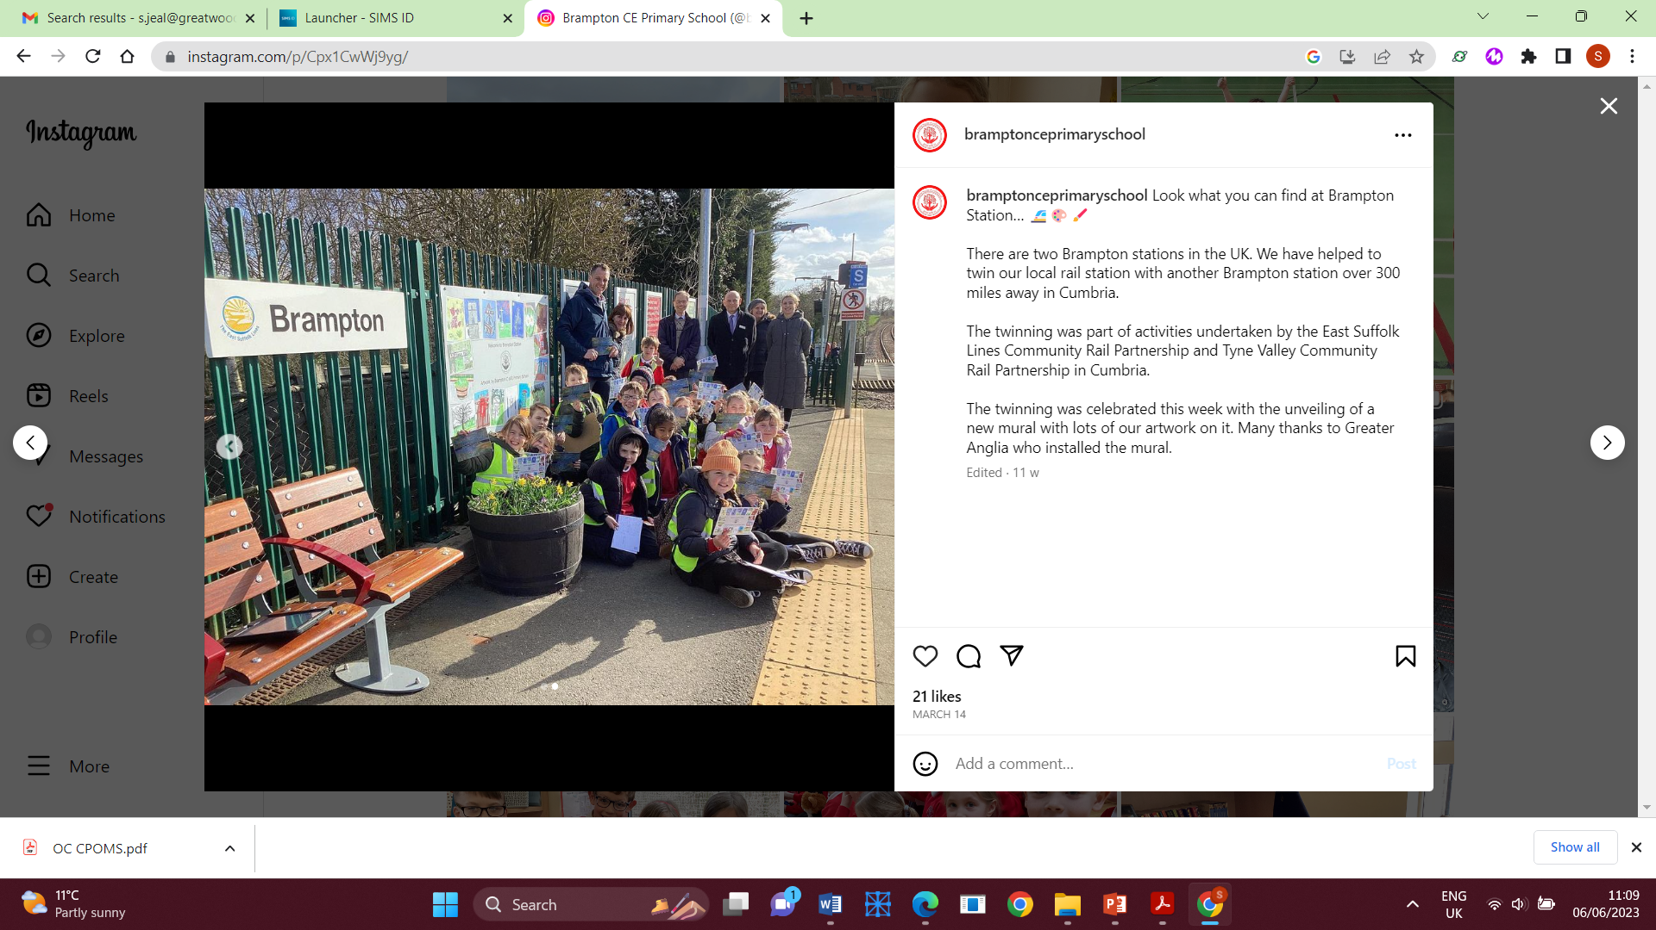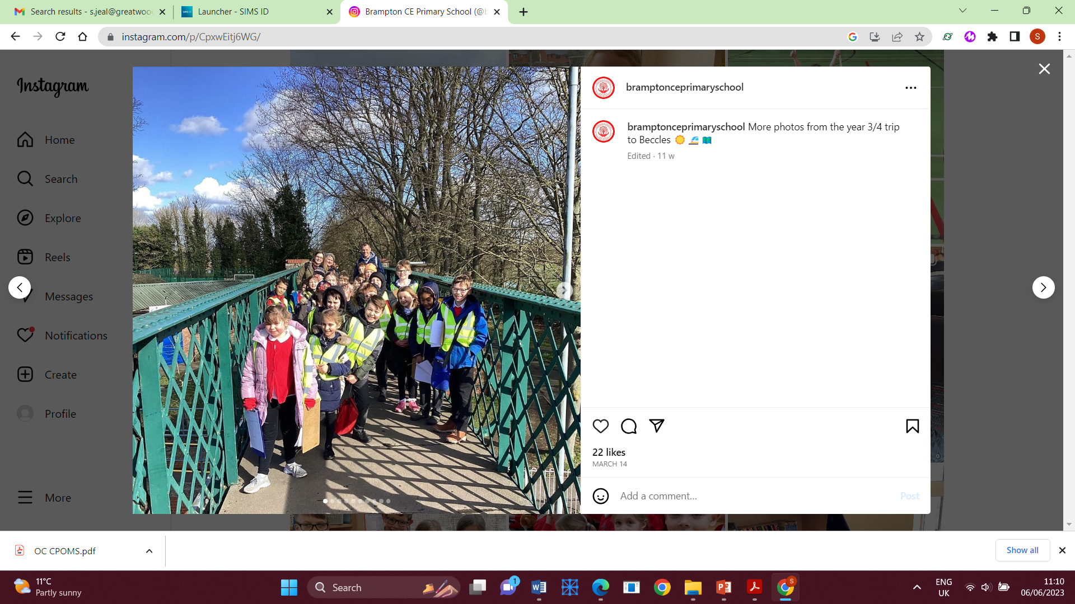

We have also linked up with Lanercost C of E Primary School, we received postcards with an image of the mural that they created. Our children were extremely excited to receive their postcards. It has given them the chance to connect with someone from another part of the UK. Our banner has been made into a postcard so or children are excited to reply. As part of the project East Suffolk Lines have kindly made the banner into a postcard and provided stamps so the children can reply. Additionally, year 3/4 hchildren received a free train journey. They travelled by train from Brampton to Beccles and spent the day exploring a local town, drawing sketch maps, completing traffic surveys and asking the general public questions about the town.

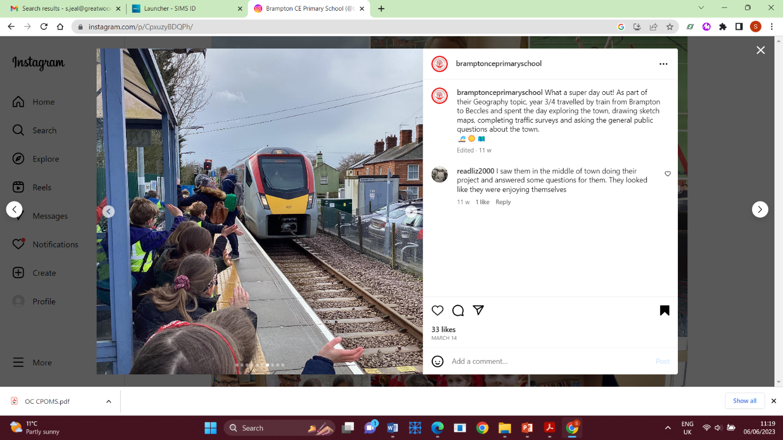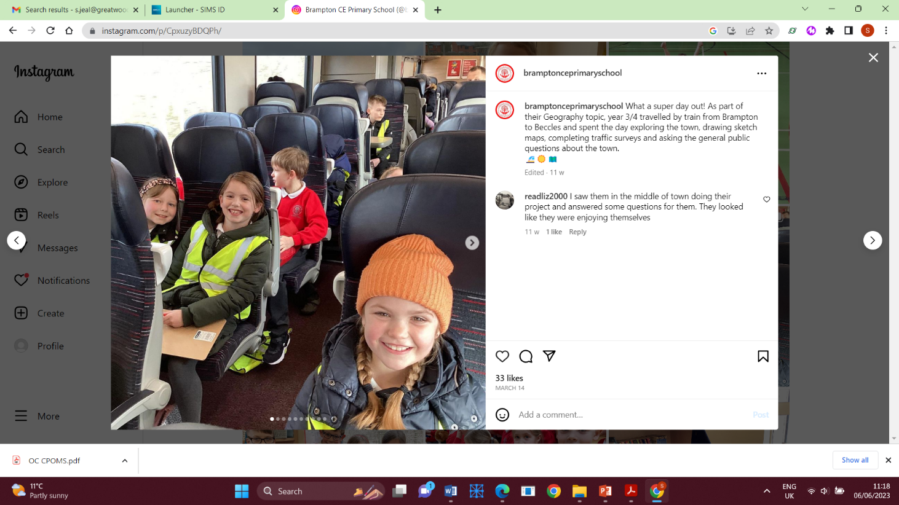

Overall it has been a pleasure to work with both Tyne Valley and East Suffolk Lines community partnership. The project has given the children a purpose and audience for their art work and allowed them to connect with of children from another region in the county.

We hope our banner will be enjoyed by passengers that pass through Brampton train station for many years to come.

