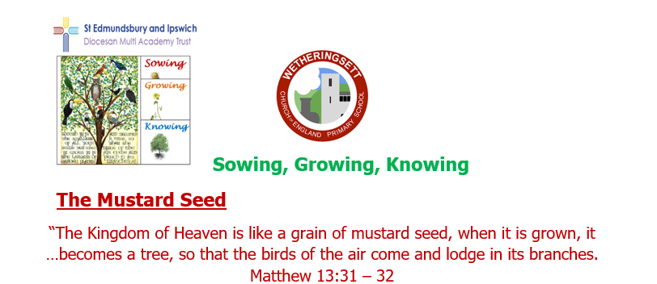

Wetheringsett C of E Primary School

MAT Newsletter

Surviving the Storms
A huge community effort helped some of our families survive the floods on 20th October in the wake of Storm Babet. Our hearts and warmest wishes go out to all the families who have had to relocate and start the process of repairing and refurbishing their homes. We hope they will all be home and dry soon.
School closed when roads became impassable in the wake of Storm Ciaran 2/11/23 but staff still managed to get through flooded roads the next day and school could be opened again.
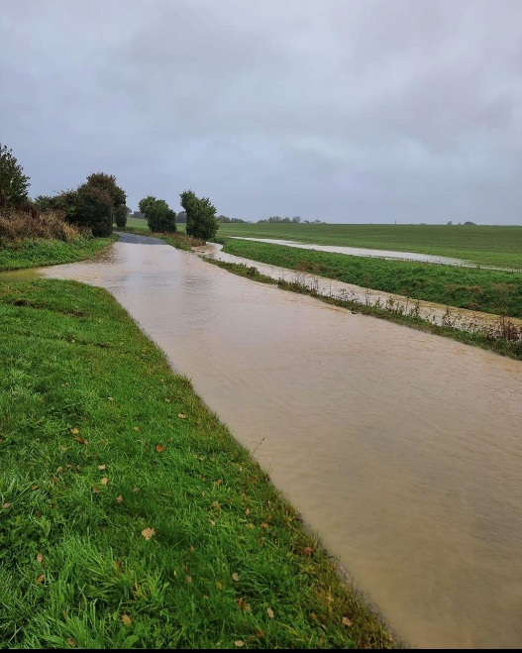
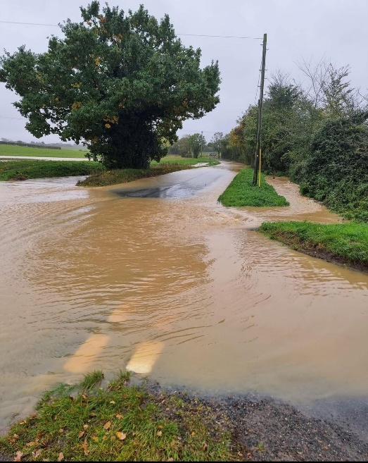

Curriculum Enrichment
We had planned a day of history trips learning about Victorian toys, Romans and Mayans for the 2nd November but unfortunately, due to Storm Ciaran, both our school and our partner school at Bedfield had to cancel.
The trip is now postponed until 5th December 2023 when Years 5&6 will take part in workshops exploring the Mayans. They will create Mayan calendars, extend their knowledge of how the Mayan number system worked and question an authentic Mayan Archaeologist called Dr Diane.
Maths across the curriculum
EYFS/Years 1&2
During the week beginning 9th October 2023, Reception and children in Years 1 & 2 in Lime Class looked at 2D shapes and linked it to artwork. They created different sized concentric Kandinsky circles in primary colours. They then used their measuring skills to make bread rolls linked to the story of The Little Red Hen.
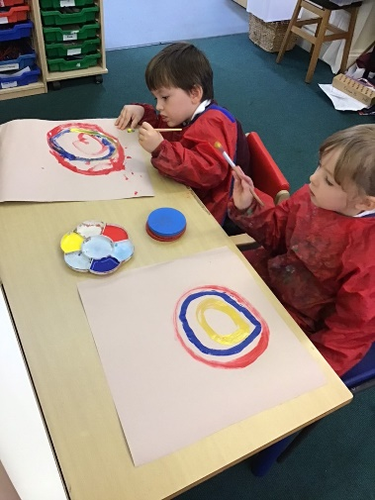
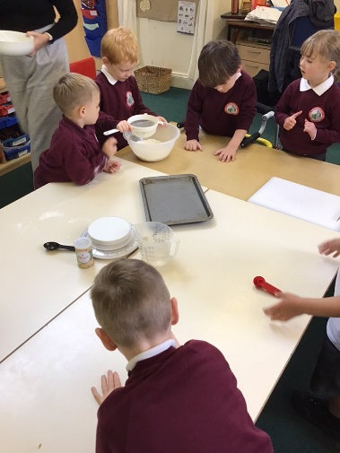

Years 3&4
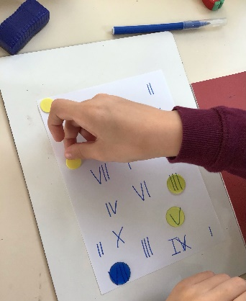
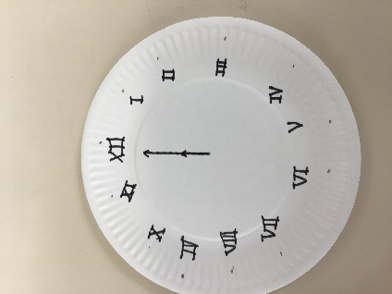
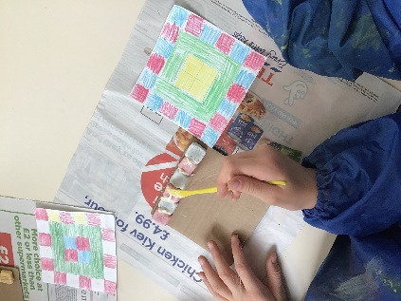
Sycamore class linked their Maths to historical learning about the Romans, making clocks with Roman numerals, creating mosaic patterns and placing Roman sites on a map using coordinates.
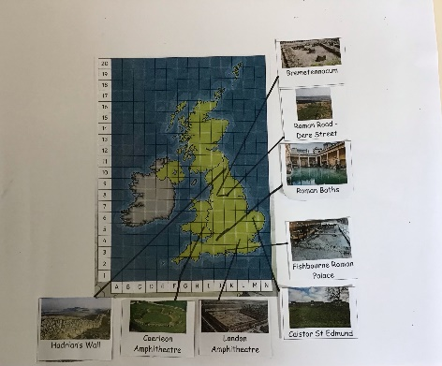
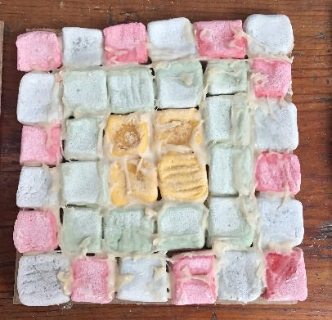

Years 5&6
Chestnut Class worked with felt tip pens to draw symbols- this was a Maya maths activity where they learnt the Mayan number system up to their use of 3-digit numbers and then wrote calculations for each other to solve. Some children wrote explanations with diagrams on how the Mayan number system worked. The children also created 2D shapes on coloured paper and positioned them to make one class piece of artwork in the style of Paul Klee. This was linked to their class art topic of compositional collage.
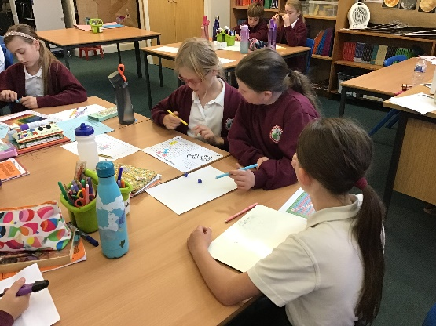
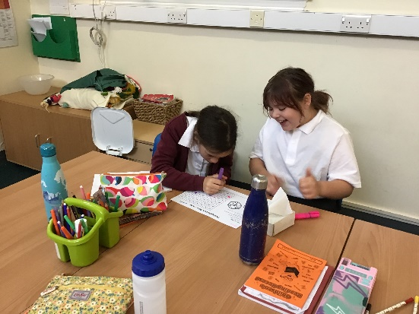

A wonderful week was had by all, realising that Maths can be demonstrated in many ways across curriculum subjects.

