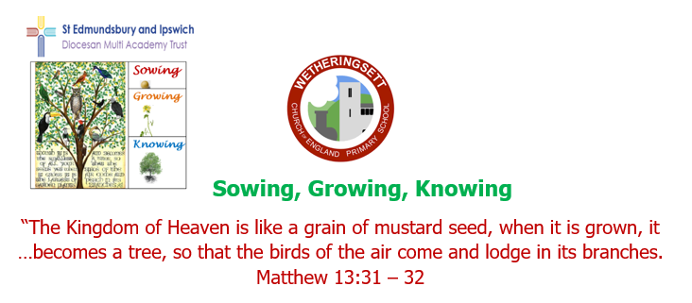
Wetheringsett C of E Newsletter Summer Term
During a busy summer term, we stopped, like the rest of the nation, to celebrate the coronation of King Charles III. In preparation, pupils made bunting and were set the challenge of creating replicas of the new monarch from hard boiled eggs and designing and baking resplendent coronation cakes.

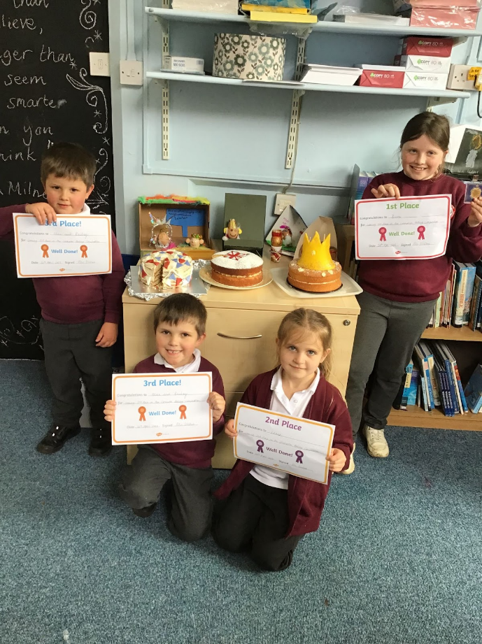
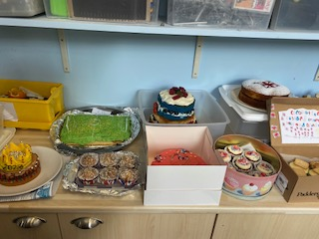
The cakes were judged not only on the creativity of their designs, but also on the taste of final products!
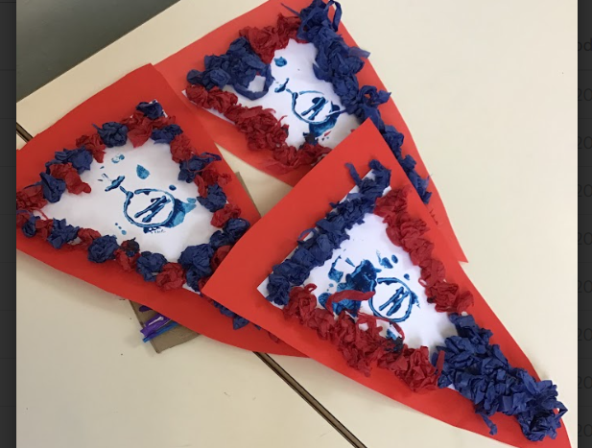

The proud winners ensured their entries were tasty and reflected royal designs fit for a King and Queen. There were crowns, union jacks and read, white and blue icing on their cakes.
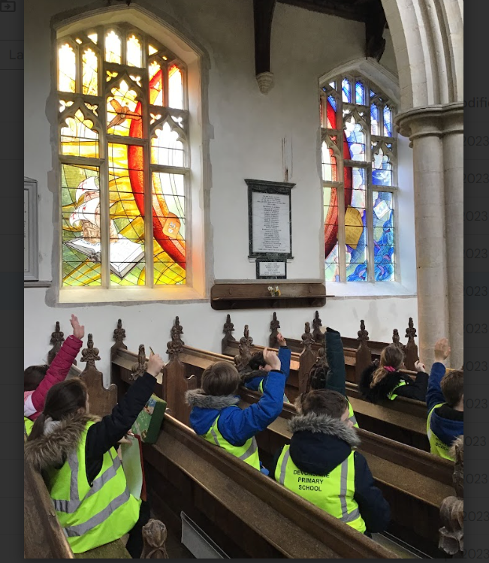
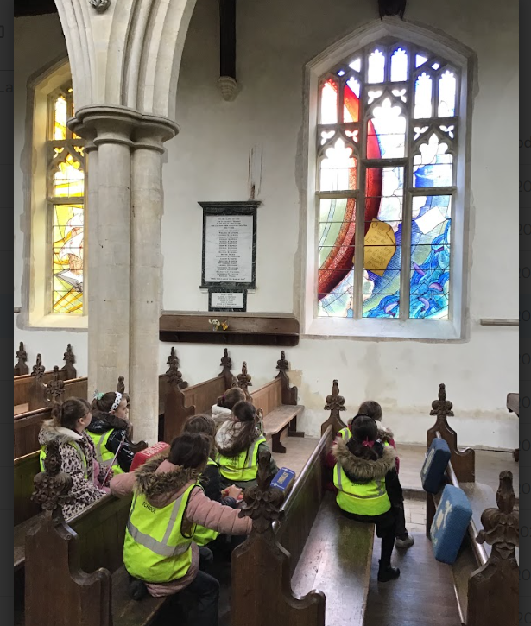
The children have been inspired by the beautiful stained- glass windows newly installed in All Saints Church Wetheringsett, celebrating the local explorer, Richard Hakluyt. They created their own window designs and Bishop Mike had the difficult task of judge winning submissions from each class! The children were able to describe how the parable of The Mustard Seed, which represents our school, are reflected in the windows – growth, nature and birds feature in their work.
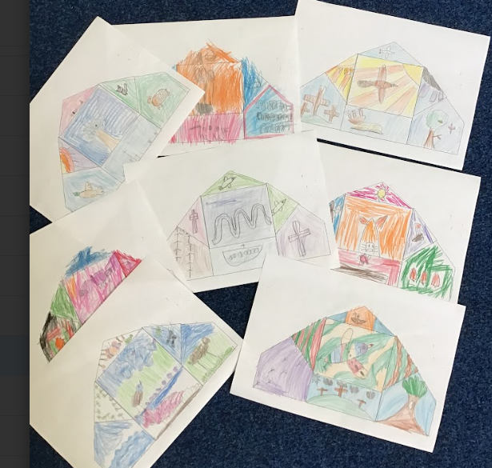
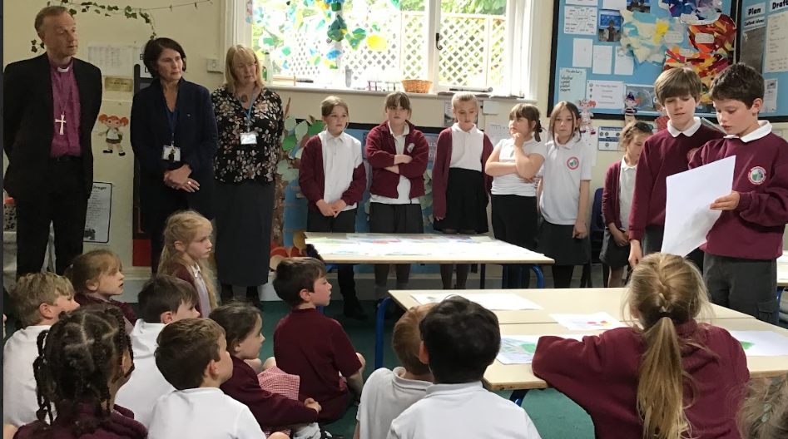
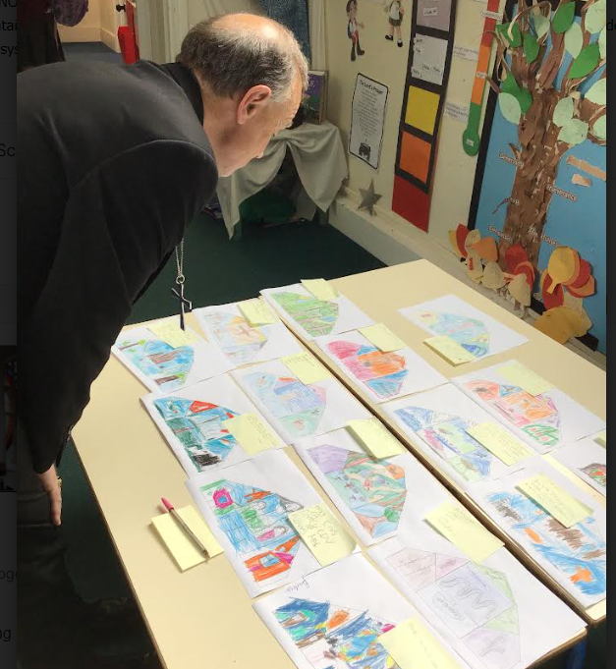

The children will cut out sections of their designs on plastic film so their work can be mounted on windows at school, letting light reflect through them and brightening the colours they have used.
We all can’t wait to see them.

